TRIBOLIUM INFORMATION BULLETIN

Number 21

March, 1978

Forward ………………………………………….……………………………………… i

Announcements ……………………………………………………………………….. ii

Notation of Stock Lists ……………………………………………………………….. v

Stock Lists …………………………………………………………………………… 1

New Mutants ………………………………………………………………………….. 88

Notes-Research ……………………………..…………………………………… 89-166

The effect of simulated Spaceshuttle noise on the noise on the development and the genetic behavior of Tribolium confusum Duval – preliminary result. W. Briegleb ………………………………..………………………………… 89

Studies on the biology, behavior and susceptibility of surviving population of Tribolium castaneum Herbst and Trogoderma granarium Everts exposed to insecticides in godowns. B.S. Chahal and Benudhar Borah ……………. 93

Sparing effect of radiation dose protraction in Tribolium confusum. C. Cheng and H.S. Ducoff ……..………………………………………………………... 95

Stain penetration of Tribolium confusum eggs. F.V. Dunkel and P.K. Harein …………………………………………………………………..……………….. 97

Survival of Tribolium confusum exposed to 14 MeV neutrons. Stephen D. Egbert ………………………………………………….……………………... 101

Variability of egg cannibalism of Tribolium castaneum due to mating status of adults. Duwayre C. Englert and Katherine Grinde Parkin …...………….. 103

The genetic architecture of egg laying of virgin females of Tribolium castaneum scored in standard and conditioned media. A. Gallego ……. 107

The influence of single-sex culturing on activity and longevity of an inbred strain of Tribolium castaneum. Batia Lavie and Niva Stern ..................... 114

Laser ray effect on Tribolium confusum Duv. Julieta Ramos-Elorduy de Conconi, Ma. Luisa Hernandez Ibarra, Mario Ramirez-Martinez and Jesus Siqueiros Beltrones ………………………………………………………... 120

The effect of stress environments on heterosis of larval weight in Tribolium castaneum. S.S. Rich and A.E. Bell …………….……………………... 131

Syndromes and frequency of embryonic lethality in some mutants of Tribolium castaneum. K. Sander and W. Schuch ………………………………….. 134

A gynandromorphy in Tribolium castaneum. J. Sandahl and A. Sokoloff .. 136

Split prosternal process (Spp), a sex linked dominant mutation with possible lethal or semilethal effects in Tribolium anaphe. A. Sokoloff and J. Spedding ………………………………………………………………………………… 139

Evolutionary trends in Tribolium. Alaxender Sokoloff ………………….. 141

Relationship between body size and cell number in Tribolium. Alaxender Sokoloff and Pamela D. Raymond ………………………………………… 146

An evaluation of the relationship between body size and cell number in Tribolium castaneum. M. Hani Soliman and S. Rose …………………… 148

Longevity and oviposition rate in Tribolium castaneum; Rubner’s hypothesis and natural selection. F.J. Sonleitner …………………………………..… 150

Isozymes of Tribolium. Eliyahu Sverdlov and David Wool …………….. 155

Development and reproduction of Tribolium confusum on wheat media of different nutritional value. V. F. Wright, P.K. Harein and E. De Las Casas …………………………………………………………………………………… 161

On the control of acaroid infestations in Tribolium cultures. A.E. Bell …… 165

Notes-Technical ………………………………………………………………………… 167

Rearing of spider beetles. I Huber …………………………………………… 167

Bibliography

- Anatomy, Histology and Morphology …………………………………… 168

- Behavior ……………………………………………………………………. 169

- Insect Tissue Culture and Embryology …………………………………. 170
NEW MUTANTS

Report of A. Sokoloff

T. anaphe

Split prosternal process (Spp). Sex-linked dominant with possible semilethal or lethal effects in homozygous condition. See note by Sokoloff and Spedding.

NOTES - RESEARCH

Briegleb, W., Deutschs Forschungs – und Versuchsanstalt fur luft- und Raumfahrt E.V. Institut fur Flugmedizin, (with the technical assistance of Friedgard Schuster).

* The effect of simulated Spaceshuttle noise on the development and the genetic behavior of Tribolium confusum Duval – a preliminary result.

Introduction

For a better estimate of the side effects for genetic experiments on board the U.S. Spaceshuttle the influence of lift-off noise of the shuttle on different developmental stages of Tribolium confusum has been tested. Similar experiments have also been conducted by other authors with insects and other small animals yet evidently not with the high fidelity of the simulated frequency spectrum of a starting rocket as in our experiment (Anikeeva, et al., 1971; Beischer et al., 1970; Kidwell, et al., 1968; Pfister, et al., 1967). Moreover, the results of the earlier experiments were in part controversial (Kidwell, et al., 1968).

influence of lift-off noise of the shuttle on different developmental stages of Tribolium confusum has been tested. Similar experiments have also been conducted by other authors with insects and other small animals yet evidently not with the high fidelity of the simulated frequency spectrum of a starting rocket as in our experiment (Anikeeva, et al., 1971; Beischer et al., 1970; Kidwell, et al., 1968; Pfister, et al., 1967). Moreover, the results of the earlier experiments were in part controversial (Kidwell, et al., 1968).

Materials and Methods

According to the anticipated noise of the shuttle (Moos, 1977; NASA-ESA, 1977), different stages of the beetle were exposed to a spectrum of 26 frequencies of approximately equal noise pressure from 31.5 – 10,000 Hz with the intensities of 137.2 (space-lab) and 145.6 (palette) dB each for 2 minutes (Moos, 1977). Environmental condition during the test were 22.5⁰c, 62% rel. humidity and 0.959 Bar atmospheric pressure.

Test animals were taken from highly inbred line (12 single pair passages) which frequently has an anomaly level of approximately 1% comparing rough anomalies, such as split, shortened or blistered elytra, or lacking extremities etc. (see Briegleb et al., 1975). Culturing conditions were 28 + 5% rel. humidity; nourishment was 90% wheat flour, 5% oat flour, and 55 dried powdred brewery yeast “PYM”. Four developmental stages were exposed :

- 30 day old wild-type imagoes (A),
- 2 day old pupae (B),
- 20 day old larvae (C)

222 animals in 24 single boxes were divided into exposure, the second group was subjected to the expected noise within the spacelab, and the third group to the expected noise in the spacelab palette (see Table 1). The subjects and controls wre transported to the test facility over 600 km by car; during this time the climatic conditions were not controlled.

Test parameters were the inductions of teratogenic and genetic anomalies caused by the applied noise. Identicals of the 24 subjects and controls were put to 12 panmictic cultures which gave rie to the F₁s. The wild-type imagoes of the F₁s were reduced to 30 individuals per strain which gave rise to F₂s (see Table 2).

Results

A killing or the individual existence or developmental endangering effect of the applied noise has not been detected for the developmental stages A and D. On the other hand, there was an insignificant (small number of individuals) increase in all groups of stage D.

In the same way, but with a statistically significant difference with respect to normal cultures, (P > 99.73%), there was a general increase of anomalies in all F₁s of the three parental groups (see Table 1). That means the transport conditions, presumably temperature (see Slater et al., 1963), have induced strong disturbances within the genetic material, which may be also in the sense of modificatory effects (plasmatic inheritance). The significantly higher number of anomalies (P > 99.73%) within the B and C-strains against the rest may be caused by teratogenous parents which by mistake were not separated from their F₁s. So, a teratogenic or even phenocopy effect of the transportation conditions has to be taken into consideration.

We found the only indication for an effect of noise application within the F₂s (see Table 10. While the anomaly rates within the four controls were decreased to > 2%, the rates for the progenies of the exposed parents of the C and D-strains were elevated only significantly (P > 99.73%) for the D strains.

Unambigous genetic determination of the anomalies was not possible as in our 0-g simulation experiments (Briegleb, et al., 1975; Briegleb et al., in prep.). In most cases, the abnormal phenotypes seem to be polygenic in character, together with different penetrance of the participating genes.

Discussion

The hint of a mutagenic effect of the applied noise for the larval stage would mean an irritability of the germ chain mitoses. Because of small numbers, this result should be tested again, for example by setting single pairs from the exposed animals. The negative results of previous rocket experiments (see for example Glembotskii, 1970; Taylor, 1977; and most noise experiments on the ground are against the relevance of our result.

The strong increase of the anomaly rate of F₁ in all strains demands the strict observance of temperature during transport outside the laboratory.

Literature cited

1. Anikeeva, I.D., Moskvitin, E.V. 1971. Results of the combined action of vibration and gamma irradiation of Chlorella. Kosm. Biol. Med. 5 : 85-87.

2. Beischer, D.E., Cowart, G.S. 1970. Exposure of Escherichia coli to low frequency vibrations. NASA-CR-109494.

3. Briegleb, W., Neubert, J., Schatz, A., Sinapius, F., 1975. Influence of simulated weightlessness on the rate of anomalies of the flour beetle Tribolium confusum. In : Life Sciences and Space Research XIII. Sneath, P.H.A. (Ed.). Berlin, Akademie-Ver-lag.

4. Briegleb, W., Neubert, J., Schats, A., Schuster, F. Induction of teratogenic and mutagenic effects by simulated weightlessness in the flour beetle Tribolium confusum Duval (Insecta)? In preparation.

5. Glembotskii, Ia. I. 1970. Genetic research in space. Cosm. Res. 8 : 567-575.

6. Kidwell, F.J., Kidwell M.M. 1968. Evidence against the mutagenic effects of vibration on Drosophila melanogaster. J. heredity 59 : 231-234.

7. Moos, K. Schallbelastungstest. DEVLR-BPT, internal document No. B-TF 667 with testorder SN l/id553, 1977

8. NASA-ESA Spacelab Accomodation Handbook, Issue 1, 1977

9. Pfister, A.M., Bregliano, J.P., Deltour, G., Kaiser, R. 1967. Contribution to the study of the genetic effects of mechanical vibrations in Drosophilla melarogaster. Rev. Med. Aeronaut. Spat. 6 : 21-23.

10. Slater, J.V., Rescigno, A., Amer, N.M., Tobias, C.A. 1963. Temperature dependence of wing abnormality in Tribolium confusum. Science 140 : 408-409.

11. Taylor, G.R. 1977. Survey of cell biology experiments in reduced gravity. In NASA-TM-X-58191 (Conf.: Bioprocessing in Space, Houston)

Table 1. Result of test of application of noise to different developmental stages of Tribolium confusum with respect to their filial generations F₁ and F₁. There is no difference in the anomaly levels between subjects and controls in the F₁; for other differences of F₁s see text. The F₂-progeny of the exposed larvae show an increased anomaly level which is significantly only for the D-strains (P > 99.73%).
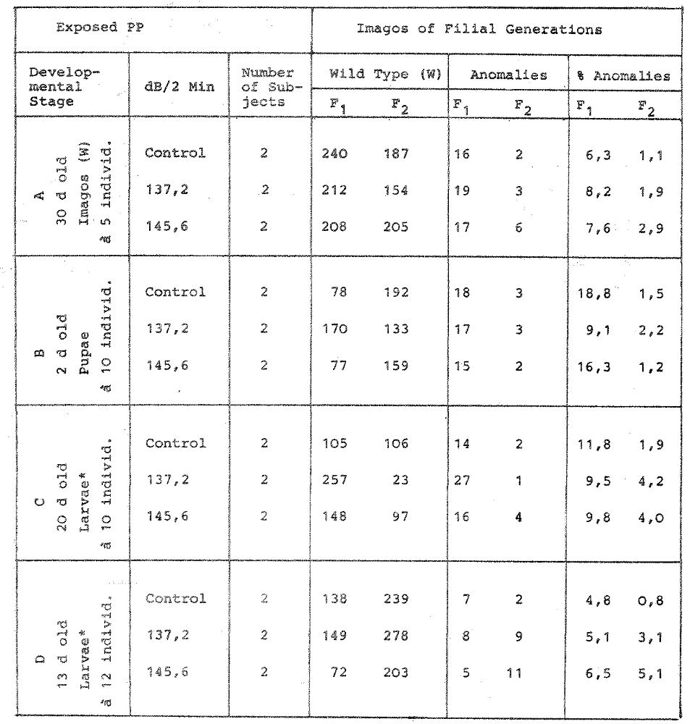

* Age includes development within the egg.

Chahal, B.S.¹ and Borah, Benudhar², Dept. of Entomology, Punjab Agricultural University, Ludhiana, 141 009, India.

* Studies on the biology, behaviour and susceptibility of surviving population of Tribolium castaneum Herbst and Trogoderma granarium Everts exposed to insecticides in godowns.

The rented warehousing godowns (which are not scientifically built) at Jagraon (Punjab, India) remained continuously infested with T. castaneum and T. granarium for the last 6-7 years despite repeated applications of malathion, dichlorvos and aluminium phosphide (AIP) recommended for the protection of food-grains. The surviving population (P-strain) remained under continuous insecticidal stress in these godowns. During the present investigations, this population (F₁ generation of P-strain) was compared with population (N-strain) which received no insecticide for at least 2 years. Their biology, behavior and susceptibility to malathion, dichlorvos and AlP were studied in the Department of Entomology, Punjab Agricultural University, Ludhiana.

There was no difference in the durations of oviposition, incubation, larval, pupal, adult stages and total life cycle of P-strain and N-strain of both T. castaneum and T. granarium. However, longer pre-oviposition period and less viability of eggs were observed in P-strain of T. castaneum than in the N-strain. On the other hand, fecundity of P-strain of T. granarium was significantly higher than N-strain while the per cent viability of eggs was less in P-strain. In spite of 1-2 additional larval instars in P-strain of T. castaneum, the duration of eggs to pupae did not differ significantly from that of the N-strain. However, in T. granarium, there was no difference in the number of larval instars or the duration from egg to pupal stage. The males outnumbered the females in both the strains of T. castaneum and T. granarium. However, in F₁ generation of T. granarium (P-strain) the sex ratio was 50 : 50. Innate capacity to increase ‘r_{m}’, was equal in P-strain and N-strain of both the insects but F₃ population of T. granarium (P-strain) had higher values (0.092) than F₁ generation of P-strain (0.072) and N-strain (0.0715) which may be attributed to higher fecundity and viability of eggs. The differences in the population build-up of P-strain and N-strain of T. castaneum and T. granarium in wheat (Kalyan Sona) was non-significant. The phototactic behavior, speed of movement, downward and horizontal dispersion of P-strain and N-strain of both the insects were also found to be non-significant.

Surface spraying with 0.5% each of malathion and dichlorvos @ 1 litre sprayble material per 30 m³ could only partially check reinfestation from T. castaneum and T. granarium in hired godowns. No doubt, malathion proved better chemical for the control of T. granarium while DDVP for T. castaneum. Fumigation with AlP @ 35 tab./28 m³ (1 tablet = 3 grams) with 5 days exposure was effective in controlling T. castaneum in stores. However, AlP @ 69 tab./28 m³ with an exposure period of 5 days failed to achieve complete mortality of T. granarium. Fumigation of bagged wheat grain covered with tarpaulin with AlP @ 4 tab. / tonne (59 tab. / 28 m³) proved better than the treatment without cover even with a higher dosage of 69 tab / 28 m³.

Laboratory trials with malathion, DDVP and AlP on the susceptibility of both strains of T. castaneum and T. granarium showed that there was no appreciable difference in the susceptibility of both strains, the tolerance factors for T. castaneum being 1.146x to 1.644x for malathion, 1.255 to 2.018x for DDVP and for T. granarium being 1.168x to 2.307x to malathion and 1.104x to 1.608x to DDVP. Similarly in case of AlP two strains of T. castaneum showed no difference, the tolerance ratio being 0.817x to 2.801x. However, P-strain of T. granarium has developed tolerance to phosphine, the ratio of the various grub-instars being 11.679x to 40.695x. Both the strains of T. granarium responded to other fumigants like ethylene bromide and ethylene dichloride and carbon tetra-chloride mixture in a similar way, the ratio being 1.380x and 1.212x, respectively. This further proved the development of resistance to phosphine in the population of T. granarium collected from the warehouse godowns which is probably the first record.
1. Professor of Entomology (Extension), Department of Entomology, Punjab Agricultural University, Ludhiana, Punjab.

2. Ex-Ph.D. Scholar, Dept. of Entomology, PAU Ludhiana, Punjab, India. Now working as Assistant Prof. of Entomology, Department of Entomology, Assam Agricultural University, Jorhat, Assam, India.

CHENG, C. AND DUCOFF, H.S.
DEPARTMENT OF PHYSIOLOGY & BIOPHYSICS
UNIVERSITY OF ILLINOIS
URBANA, ILLINOIS 61801

* Sparing effect of radiation dose protraction in Tribolium confusum.

Repair of radiation damage is indicated when the severity of biological damage is decreased by fractionation or protraction of the irradiation. The split-dose technique, in which two equal doses are administered with varying interfraction intervals, has been used to determine the kinetic of repair in Tribolium (e.g., Yang & Ducoff, Radiat. Res. 46 : 290-300, 1971; Griffiths & Ducoff, Internat. J. Radiat. Biol. 24 : 203-206, 1973) as well as in cultured mammalian cells, intact mice, and fish. Protracted irradiation at low dose rates, however, maximizes the amount of repair obtainable, because repair of sublethal damage proceeds during the exposure. We have compared the dose-survival response of T. confusum McGill Black to ¹³⁷cs -radiation administrated at either 750 rad / minute or 11.5 rad / minute. The lower rate was achieved by means of a lead attenuator; dose rates were determined by ferrous sulfate dosimetry. The beetles were kept in polystyrene vials with perforated caps, and maintained at 30⁰c and approximately 60% RH in white flour supplemented with 4% (w/w) brewer’s yeast. Beetles were sexed as pupae and irradiated 2 to 6 weeks later; survival was scored 35 days after irradiation.

Both sexes exhibited a marked dose rate effect, as shown in Table 1. The estimated LD_{50/35} was similar for both sexes, but the sparing effect of protraction was distinctly greater for females. These data provide a baseline for further studies of factors modifying repair in Tribolium, and or repair mechanisms in general.

Table 1

LD_{50/35} of gamma-irradiated McGill Black adults (krad)

 | Males | Females
750 rad / min | 6.3 | 6.1
11.5 | 10.3 | 11.1

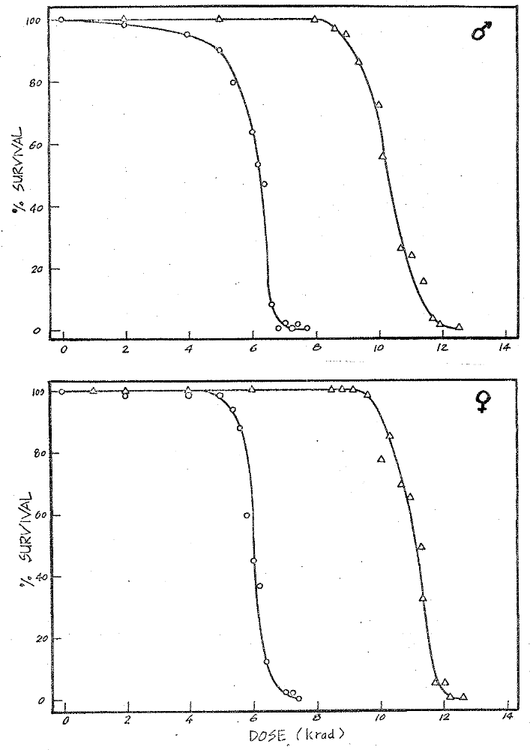
Fig. 1. Gamma-ray dose response of young adult T. confusum McGill Black. Circles, 750 rad / min; triangles, 11.5 rad / min.

DUNKEL, F.V. and HAREIN, P.K.
DEPARTMENT OF ENOMOLOGY, FISHERIES AND WILDLIFE
UNIVERSITY OF MINNESOTA
ST. PAUL, MINNESOTA

* Stain penetration of Tribolium confusum eggs.

Studies of the high morality but extremely short sensitive period of Tribolium confusum exposed to the unsaturated fatty acid 2, 4-hexadienoic acid (sorbic) suggest that events involving water penetration of the egg shell may be related to this toxicity (Dunkel et al. 1977). To test this hypothesis, a dye procedure was developed which indicated changes in water penetration of the egg shell. Interference with normal embryonic development by the straining procedure was compared with eggs not exposed to stain.
Eggs were oviposted in whole wheat flour + 5% brewer’s yeast by 1 + 0.25 month old mated females during a 2 hour period. Eggs were then removed from flour with a 40 mesh sieve, exposed to CO₂, -10⁰c, or no treatment and immersed in 0.045% aqueous malachite green (pH = 3.01). After 24 hours, eggs + stain solution were poured on filter paper in a Buchner funnel and rinsed with distilled water. Rinse water was applied to center of funnel and removed with vacuum. Eggs then adhered to the paper in a circular pattern which facilitated counting. Paper + eggs were placed in a Petri dish and dye penetration of the chorion and viteline membrane was recorded. Throughout embryogenesis, eggs were maintained at 25⁰ + 0.5⁰c and 75 + 1% RH.
At the end of embryogenesis larval development was easily observed but hatching did not occur spontaneously in water-exposed eggs whose chorion had been allowed to dry and harden (Stanley and Grurdemann, 19660. Many shells had to be manually cracked to correctly record the degree of development. Eggs in which the dye had penetrated did not develop. The color of the stain inside the eggs was not visibly altered, indicating that in eggs with a waxy layer and / or vitelline membrane not capable of blocking dye molecules, the buffer system within the egg is not sufficient to alter the pH of the stain solution which crossed the eggshell.
To insure that normal embryonic development was not impaired, the hatch rate of dye treated and untreated eggs was compared (Table 1). The mean hatch rate for T. confusum has been reported as 80.90% at 29⁰c and 705 RH (Sokoloff and Ho, 1962). Under conditions described here the mean rate is 75.86%. There was no significant difference (a = 0.05, using the model X_{ij} = µ + r_{i} + e_{ij}.) in % hatch between eggs exposed to stain and those not exposed to stain. There also was no significant difference (a = 0.05, using the model X_{ij} = µ + r_{i} + e_{ij}.) between % of eggs in which stain penetrated the waxy layer-vitelline membrane when exposed to toxic agents without wax solvency properties CO₂, -10⁰c, or to no treatment (Table 2).
Of the undeveloped eggs examined, a mean of 15.0% of the eggs had yolk cells and embryo stained. Many characteristics contribute to the mean 20% of T. confusum eggs which do not hatch such as lethal mutants and physical damage by parents as well as lack of fertilization. Fertilization in other species initiates closing of the porous vitelline membrane (Ercelik et al., 19730. The unhatched eggs which were penetrated by the dye in the present study may represent that proportion of eggs in the sample which were unfertilized and those which did not have sufficient time after fertilization before dye application to develop the water-impermeable vital-line membrane.
Our results lead us to conclude that (1) immersion in 0.045% aqueous malachite green (pH = 3.01) does not interfere with embryonic development of T. confusum and (2) lack of water impermeability of the egg shell of T. confusum is not associated with embryonic death.

Literature Cited

Dunkel, F.V., DelasCasas, E. and Harein, P.K. 1977. Pattern of sorbic acid sensitivity in Tribolium confusum embryos. Trib. Info. Bull. 20 : 98-101.

Ercelik, T.M., Adams, T.S., Holt, G.G. and Nelson, D.R. 1973. Differentiation of eggs with dominant lethal mutations from parthenogenic, unfertilized, and viable eggs in Trichoplusia ni (Lepidoptera : Noctuidae). Ann. Entomol. Soc. Amer. 66 : 292-97.

Sokoloff, A. and Ho, F.K. 1962. Productivity of Tribolium castaneum and Tribolium confusum in various media. Trib. Info. Bull. 5 : 40-2.

Stanely, M.S.M. and Grundmann, A.W. 1966. Effects of moisture on the chorion of eggs of Tribolium confusum (Coleoptera : Tenebrionidae). Ann. Entomol. Soc. Amer. 59 : 233-34.

Table 1. Effect of malachite green on hatch rate of Tribolium confusum and comparison of stain penetration with lack of embryonic development.

Sample #ª | Not exposed to stain % hatch | exposed to stain^{b}
Sample #ª | Not exposed to stain % hatch |  | % eggs not developed
Sample #ª | Not exposed to stain % hatch | % hatch | stain penetrated | stain not penetrated
1 | 80 | 78 | 2 | 20
2 | 81 | 76 | 4 | 20
3 | 65 | 72 | 3 | 25
4 | 90 | 86 | 2 | 12
5 | 88 | 82 | 4 | 14
6 | 73 | 64 | 8 | 28
7 | 54 | 62 | 10 | 28
_
X + S.E. 75.86 + 4.87 74.29 + 3.36 4.4 + 1.17 21.00 + 0.91

a. n = 50
b. exposed at 1 + 0.75 hr. postovipostion

Table 2. Effect of toxic agents without wax solvent properties on penetration by malachite green on undeveloped Tribolium confusum eggs.

Agent | Lenth of exposureª (hours) | Sample # ^{b} |  | % eggs not developed
Agent | Lenth of exposureª (hours) | Sample # ^{b} | % hatch of eggs exposed to stain | stain penetrated^{c} | stain not penetrated
CO₂ | 0.016 | 1 | 63 | 0 | 37
-10⁰c | 0.500 | 1 | 54 | 8 | 38
 |  | 2 | 10 | 2 | 88
 | 48.000 | 1 | 0 | 4 | 96
 |  | 2 | 0 | 6 | 94
 |  | 3 | 0 | 8 | 92
 |  | 4 | 0 | 14 | 86

a. exposed at 1 + 0.75 hr. postovipostion

b. n = 50
_
c. X + S.E. = 6 + 1.75

EGBERT, STEPHEN D.
Nuclear Engineering Program
and Department of Physiology and Biophysis
University of Illinois
Urbana, Illinois 61801

* Survival of Tribolium confusum exposed to 14 MeV neutrons

It is desirable to compare biological responses to different types of ionizing radiation, particularly those that have different linear energy transfer (LET) and relative biological effectiveness (RBE) values. This is necessary to determine the relationship that the LET or RBE have to other factors such as repair, split dose effect, and hyperthermia effects.

The sensitivity of adult confusum to x-radiation and fission neutrons has been previously examined^{1,2} using the LD_{50/35} as the criterion to measure the response to an acute exposure.

In order to determine the response of T. confusum to 14 MeV neutrons a preliminary experiment was designed, using small groups of beetles each of which received a different dose of neutrons. 14 MeV neutrons are attainable from a neutron generator by the deuterium-tritium fusion reaction. The neutrons have an LET that is sufficiently different from that of fission neutrons, so that we anticipated a different value of RBE.

An inbred strain designated “Ebony” was used. The neutron dose was measured by the copper foil method. This method involves measuring the ⁶⁴cu produced in the reaction ⁶⁵cu (n, 2n) ⁶⁴cu with fast neutrons. The LD_{50/35} was 4200 rads for males and 3800 rads for females. Table contains the results of this experiment and compares them with previous studies.

TABLE 1
 | LD_{50/35} (rad) |  | RBE
 | Male | Female | Male | Female
x-ray¹ | 5100 | 5100 | 1.0 | 1.0
fission neutron¹ | 2150 | 2050 | 2.4 | 2.5
14 Mev neutron | 4200 | 3800 | 1.2 | 1.3
gamma ray, 0.661 Mev² | 6200 | 6200 | 0.82 | 0.82
gamma ray, 0.661 Mev |  | 6000 |  | 0.85

In general, the LET of electromagnetic energy (x- and y-rays) decreases with increasing energy, and RBE increases with increasing LET. The RBE values of 80 to 85% for ¹³⁷Cs gamma rays compared to 280 kvp X-rays are typical of those reported for a large variety of biological systems. The relationships between energy and LET or between LET and RBE are more complex in the case of particulate radiations, and RBE of neutrons is greater at low doses. The 14 MeV neutrons have lower LET than the less energetic fission neutrons, however, and the finding of an RBE greater than 1 but much less than that of fission neutrons was expected. From these results, it appears that lethal response of Tribolium to 14 MeV neutrons will be modifiable, but to a lesser extent than in the case of x- or y-radiation, by anoxia during exposure or by dose-fractination.

REFERENCES

1. Glenn, N.D. and Ducoff, H.S., “Acute lethality after Fast-Neutron and x-Irradiation of Tribolium confusum”, Radiat. Res. 65, 120-129 (1976).

2. Lai, Ping-Kwong, “Effect of Hyperthermia on Radiation Damage d its Repair in Tribolium confusum”, Thesis, University of Illinois, Urbana (1977).

ENGLERT, DuWAYNE C. and PARKIN, KATHERINE GRINDE
DEPARTMENT OF ZOOLOGY
SOUTHERN ILLINOIS UNIVERSITY AT CARBONDALE
CARBONDALE, IL 62901

* Variability of egg cannibalism in Tribolium castaneum due to mating status of adults.

Differences between rates of cannibalism for female and male flour beetles have been reported for Tribolium confusum by Rich (1956) and for T. castaneum by Son-leithner (1961), however, no attempt was made to differentiate possible effects of mating status, even though the cannibalism rate for females of both species significantly exceeded that of the male. A preliminary study was initiated to examine the possible effect of mating status on egg cannibalism rate in T. castaneum.
Two genetic strains were examined, the Purdue + and Black Foundation Stock. All beetles were reared on standard culture medium (95% whole wheat flour plus 5% dried brewer’s yeast) in 20 ml glass coffee creamers. A Sherer-Gillett walk-in environmental chamber provided constant experimental conditions for temperature (33 + 1⁰c) and humidity (70 + 2% R.H.).
A density level of 8 adults per treatment creamer filled with 5 g medium was used for all groups examined. In each case, 100 eggs marked with neutral red dye (Rich, 1956) were introduced to the treatment creamer just prior to introduction of the adults being tested. The eggs were mixed with the medium so that as nearly a random distribution of the eggs could be accomplished as possible. Each adult genotype was exposed to each of the two egg genotypes for comparison of possible egg preference.
Mating status was identified in the following manner : previously mated – adult beetles had been allowed to mate for four days prior to testing, and virgin – no prior contact with members of the opposite sex before testing. In those treatment creamers where equal numbers of “virgin” females and males were used, introduction was made at the initiation of the exposure period. After 24 hours, all adults and eggs were recovered, and egg cannibalism rates were calculated using the formula of Sonleitner (1961).
The experiment was conducted using three creamer replicates per treatment group, the results of which are presented in Table 1. Although there is a degree of inconsistency in these preliminary data, there appear certain trends are present. Virgin females of both genotypes, when tested separately show a greater tendency to cannibalize b eggs than do their previously mated counterparts; this same trend is not clearly evident when + eggs are offered. Similarly, b virgin females appear to cannibalize more eggs than their + counterparts regardless of egg genotype. Overall, however, mating status did not appear to greatly influence egg cannibalism later.
As was found by both Rich (1956) and Sonleither (1961), females appear to be more voracious than males. Overall, when tested, there was no significant difference between the two genotypes for egg cannibalism, 7.29 + 1.44 for + beetles and 8.87 + 2.41 for b beetles.
Englert and Thomas (1970) and Englert and Raibley (1977) reported differences in egg cannibalism rates due to a single genetic marker, antennapedia, for adults for T. castaneum, but made no effort to differentiate between sexes or mating status. The latter, however, did attempt to correlate site of cannibalism with oviposition sites to show differences in total behavioral activity.
In comparing the recovery of the total number of unmarked eggs laid within the 24-hour testing period, differences were observed only in those treatments of virgin and previously mated females tested separately, with 47.5 + 5.9 and 71.2 + 7.0, respectively. No significant differences were observed in those instances when male were also present regardless of previous mating status (39.1 + 5.8 vs. 50.1 + 5.9), although again those females which had longer exposure to males laid more eggs. No difference in adult genotype was noted for net fecundity. It would appear from these data that the presence of males influenced only a slight reduction I overall egg cannibalism rate of all groups, yet had a significant effect upon net fecundity by their very presence, as might be expected.

LITERATURE CITED

Englert, D.C. and D.W. Raibley, 1977. Genetic analysis of egg cannibalism and oviposition sites for Tribolium castaneum. Canad. Jour. of Genet. Cytol. 19 : 119-124.

Englert, D.C. and W.H. Thomas. 1970. The influence of the homeotic mutation, “antennapedia”, on egg cannibalism in Tribolium castaneum. Trans. Ill, State Acad. Sci., 63 : 51-56.

Rich, E.R. 1956. Egg cannibalism and fecundity in Tribolium. Ecology, 37 : 109-120.

Sonleitner, F.J. 1961. Factors affecting egg cannibalism and fecundity in populations of adult Tribolium castaneum Herbst. Physiol. Zool., 34 : 233-255.

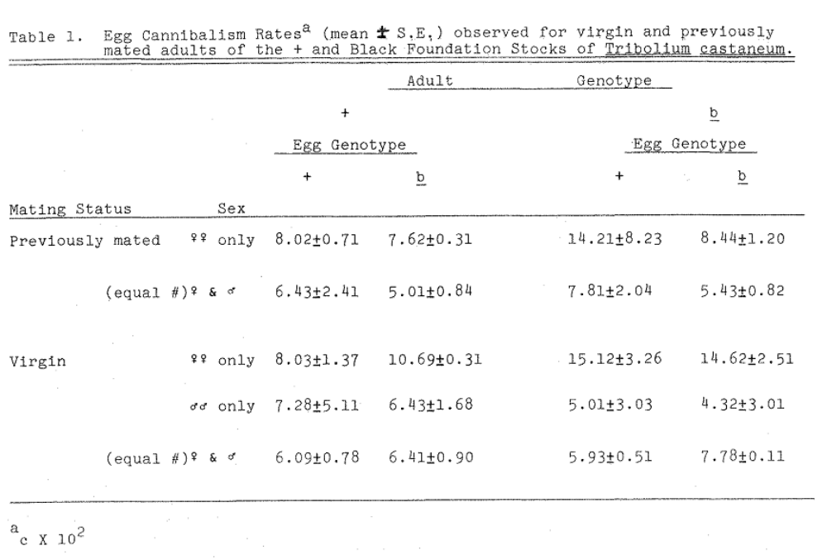

Gallego, A., Departamento de Genetica, Instituto Nacional de Investigaciones Agrarias, Avda. Puerta de Hierro, /N, Ma-drid, Spain.

* The genetic architecture of egg laying of virgin females of Tribolium castaneum scored in standard and conditioned media.

INTRODUCTION

The effect of conditioned medium (i.e. that which has been altered by the species for some time) on quantitative traits of Tribolium has often been studied with reference o the situation in which the populations are kept on standard medium (review in Sokoloff, 1974). It appears that no attempt has been made in order to estimate genetic parameters in these two environmental situations. On the other hand, artificially altered media have been used in the study of genotype x environment interactions in T. castaneum (Hardin and Bell, 1967; Costantino, Bell and Rogler, 1967). In these works, genetic parameters have been extimated; however, in none of them a naturally altered medium, i.e. conditioned medium, has been employed.

The present experiment studies the genetic parameters of egg laying of virgin females of Tribolium castaneum when kept on both conditioned and standard medium because of its ecological interest.

MATERIALS AND METHODS

i) Subjects

The Consejo population of T. castaneum (Orozco and Bell, 1974) has been used. The trait studied was egg-laying of virgin females individually scored in two consecutive periods from the 7th to the 11th (period 1) and from the 11th to the 15th day (period 2) after adult emergence. Two culture media were used : standard medium consisting of 95% whole wheat flour and 5% dried brewer’s yeast and conditioned medium, the same standard medium after being degraded for 30 days by a numerous population (about 30 adults/g) of T. castaneum.

ii) Experimental design

The basic experimental unit was started with a random sample of 167 insects of each sex, individually mated at random. From the offspring of these matings three groups (I, II, III) were formed, each group consisting of one individual of each sex per mating. Egg laying in periods 1 and 2 was scored in all females in the three groups. Individuals in each group were randomly mated in pairs; three females per mating were obtained whose egg laying in periods 1 and 2 was scored. This basic unit was replicated four times.

All individuals in a given group were subjected to the same treatment in both generations. Treatments differed according to the medium in which egg laying was scored. Females in group I laid in standard medium in both periods. Females in group II laid in standard medium in period 1 and in conditioned medium in period 2. Females in group III laid in conditioned medium in both periods.

RESULTS

Estimates of means and variance are shown in Table 1 for all treatments and laying periods. Data from both generations were pooled as the differences between them were found to be non-significant (P > 0.05).

Means and variance in periods 1 and 2 were not significantly different when the trait was scored in standard medium. On the other hand when the individual was kept in conditioned medium, the mean and the variance of egg laying are smaller than the corresponding values when the trait is scored in standard medium.

Estimates of heritability were obtained by daughter-dam regression (h²r) and full-sister correlation (h²s) analysis. Estimates were obtained for each experimental unit, treatment an period. Significant differences among estimates obtained by the same statistical procedure, between treatments, period or replicates, could not be found (P > 0.05). Correspondingly, pooled estimates are presented in Table 2.

The relative importance of the dominance and common environmental effects plus a fraction of the epistatic effects can be estimated by (h²s – h²r). In our case this difference is significant (P < 0.05) taking a value of 0.11 with an approximative standard error of 0.03.

A logarithmic transformation of the data did not affect the magnitude of the heritability estimates. It did result in similar values of the phenotypic variance of egg laying in different periods and culture media and consequently in similar additive genetic variances.

Genetic and phenotypic correlations between egg laying in the two periods and culture media were estimated (Table 3). All phenotypic correlations were not significantly different (P > 0.05). pooled genetic correlation estimate approach a unit value indicating an almost complete overlapping between the two sets of loci controlling egg laying in standard and conditioned media.

DISCUSSION

The difference between h²r and h²s can arise from either the existence of a non-additive genetic variance and / or the presence of a common environmental variance. The maximum value for each variance component measured as percentages of the total phenotypic variance were 22% and 5.5%, respectively.

The individuals of a full-sister group share the same environment during all their life time before the experimental treatment takes place (31 days). Therefore, the existence of some common environmental effect seems likely. On the other hand, it has been experimentally shown (Lopez-Fanjul and Jodar, 19770 that egg laying in standard medium behaves as a practically additive trait. One can then conclude that the difference h²r and h²s appearing in our experiment, in standard medium, should result from a common environment variance component which could be estimated by an appropriate experiment.

Referring to egg laying in conditioned medium the observed difference h²r – h²s can be explained by hypothesizing that some kin of non-additive variance arises from a change in the gene action of the loci which control egg laying in standard medium, or by activation of “new” loci with non-additive action. Alternatively, a common environmental effect may also be present and this could be experimentally checked. If there is a change in gene action the number of loci controlling the trait in both environments remains the same, the additive variance will be different in both media, which disagrees with our results. On the other hand, an activation of specific loci which control egg laying in conditioned medium can not be discarded although it is not likely, due to the fact that the genetic correlation estimates are close to unity.

In conclusion, an essentially similar set of loci seems to control egg laying in both standard and conditioned media. As far as the accuracy of our techniques permit, these loci appear to be of an additive nature.

REFERENCES

COSTANTINO, R.F., BELL, A.E. & ROGLER, J.C. (1967). Genetic analysis of a population of Tribolium. I. Corn oil sensitivity and selection response. Heredity 22, 529-539.

HARDIN, R.T. & BELL, A.E. (1967). Two-way selection for body weight in Tribolium on two levels of nutrition. Genetical Research 9, 309-330.

LOPEZ-FANJUL, C. & JODAR, B. (1977). The genetic properties of egg laying of virgin females of Tribolium castaneum. Heredity 39, 251-258.

OROZCO, F. & BELL, A.E. (1974). A genetic study of egg laying of Tribolium in optimal and stress environments. Can. J. Genet. Cytol. 16, 49-60.

SOKOLOFF, A. 1974. The Biology of Tribolium. Vol. 2. Oxford University Press, OXFORD.

TABLE 1
_
Means (x) and variance (v) for different treatment groups and laying periods.

Laying Period |  | Treatment Group
Laying Period |  | I | II | III
1 | x | 26.4 | 26.1 | 12.1
 | v | 201.9 | 206.4 | 38.2
2 | x | 26.5 | 9.6 | 8.3
 | v | 221.1 | 36.7 | 24.8

TABLE 2

Regression (h²r) and correlation (h²s) heritability estimates for different treatment groups and laying periods ⁽¹⁾

Laying period | Treatment Group
Laying period | I |  | II |  | III
Laying period | h²r | h²s | h²r | h²s | h²r | h²s
1 | 0.20 | 0.39 | 0.25 | 0.32 | 0.27 | 0.35
2 | 0.22 | 0.25 | 0.15 | 0.33 | 0.21 | 0.30

⁽¹⁾ Average standard error of the heritability estimates 0.05

TABLE 3

Genetic (r_{A}) and phenotypic correlations (r_{P}) between egg laying in periods 1 and 2 for different treatment groups.

 | Treatment Group
 | I | II | III
r_{A} + S.E. (r_{A}) | 1.14 + 0.05 | 0.87 + 0.03 | 0.72 + 0.06
r_{P} + S.E. (r_{P}) | 0.38 + 0.03 | 0.39 + 0.03 | 0.38 + 0.03

Batia Lavie and Niva Stern
Department of Genetics
The Hebrew University of Jerusalem
Jerusalem, Isreal

The influence of single-sex culturing on activity and longevity of an inbred strain of Tribolium castaneum.

A B S T R A C T

Single-sex male, single-sex virgin female and 1:1 sex ratio cultures of an inbred strain of Tribolium castaneum, were observed for nine months. Males were always considerably more abundant on the surface of the medium in the single-sex cultures an in the mixed cultures, while females in single-sex cultures showed only slightly increased surface numbers compared to mixed cultures. In the single-sex culture the longevity of females was higher than that of males, but in the mixed cultures no difference between longevity of males and females was detected. The longevity of virgin females (single-sex cultures) was slightly higher than that of the fecundated females (mixed cultures), while the longevity of males was higher in mixed cultures than in single-sex cultures.

I N T R O D U C T I O N

The relation between different components of reproductive fitness is very interesting from the evolutionary point of view, as negative correlations could explain the fact that organisms do not improve their fitness indefinitely. NARISE (1974) found in Drosophila a negative correlation between longevity and the number of eggs layed, but this correlation may be either genetic or physiological.

The present study used an Inbred strain of Tribolium castaneum, so that a correlation, if found, must be physiological. Differences in egg laying in the inbred strain were obtained by comparing virgin and fecundated females. PARK (1933) found that fecundated females lay 20 times more eggs than virgin females. Therefore a comparison between virgin and fecundated females with respect to longevity, will show if there is a physiological connection between the effort of egg production and longevity. Longevity was expressed as the proportion of survivors until the age of 9 months. Differences in survivorship until later than this, would not be of interest from the reproductive point of view, as egg production after the age of 9 months is negligible (KING & DAWSON, 1972).

Activity is a second important energy consuming process, common to both males and females. Beetles on the surface of the medium show considerable restlessness, consuming more energy than beetles within the medium. Therefore in the present study, the proportion of beetles on the surface was taken as the measure of activity.

Methods

The beetles used in this experiment were from an inbred strain of Tribolium castaneum. Thirty full sibs, divided among 3 vials as follows :
1) 10 males; 2) 10 virgin females; 3) 5 males and 5 females, formed a single replicate. Twelve such replications were considered. All beetles were two weeks old when the experiment began, and their sex was marked by a dot of paint on the back. On order to insure similar adult larval interactions in all cultures, additional mixed cultures were used to provide the single-sex vials with larvae, in comparable amounts to those in mixed vials.

Once a month, the beetles were transferred to 3 grams of fresh medium – a mixture of 5 gr. brewers yeast for every 100 gr. whole wheat baking flour. The experiment was carried out in the dark, in a Conviron (Controlled Environments Inc.) incubator, at a temperature of 29⁰c and 70% relative humidity.

For the first two months, numbers on the surface were observed once a week, and in view of the consistency of the results, after this period the numbers on the surface were observed only once a month. After nine months the experiment was terminated, and the proportion of survivors in each culture served as an estimator of longevity.

Results

Table 1 shows the mean proportion of beetles on the surface and the proportion of survivors at the age of nine months for the 12 replications. The mean proportion of beetles on the surface for each vial is the average of all observations throughout the experiment. Comparing proportions of beetles on the surface leads to the following conclusions :

- The proportion of males on the surface is much higher in single-sex cultures than in mixed cultures, in all 12 replications. (The probability of obtaining this result by change, with no real difference in activity is p = (1/2)¹²).

- The proportion of females on the surface is only slightly higher in single-sex cultures than in the mixed cultures, and in 4 of the 12 replications the relation is reversed (t₂₂ = 2.57, p < 0.01).

- In single-sex cultures the number of males on the surface is much higher than the number of females on the surface, in all 12 replications (p = (1/2)¹²).

- In mixed cultures the number of males on the surface exceeds only slightly that of females and in one case the relation is reversed (t₂₂ = 2.60, p < 0.01).
The differences in longevity between treatments were less outstanding than the differences in activity. The only significant difference (t₁₉ = 2.25, p < 0.05) is between the longevity of males and females in single-sex cultures. RAYCHAUDHURI & BUTZ (1965) also reported that males have a shorter life span than females, but in our experiment this was shown only for the single-sex cultures. There is no significant difference between the longevity of males and of females in mixed cultures, as the longevity of females decreased while the longevity of males increased compared to the single-sex cultures.

The decrease in longevity of fecundated females compared to their virgin sisters is observed in 7 out of 9 possible comparisons. According to the binomial distribution if there is no real difference between longevity of virgin and fecundated females, the probability of the above result is p = 0.08, therefore the decrease in longevity for fecundated females is almost significant.

Discussion

Single-sex culturing influenced both activity and longevity in Tribolium castaneum. Contrary to natural conditions where beetles may leave their natural populations, in laboratory studies beetles are grown in confined vials. PRUS (1966) has shown under similar circumstances increased tendency to disperse correlated with increased activity, defined as proportion of beetles on the surface of the medium. Comparing our results o those of RITTE and AGUR (1977) provide additional evidence for the correlation between tendency to disperse and activity. We found that males were more active than females in both types of cultures, but the difference was more pronounced in the single-sex cultures. RITTE & AGUR (1977) obtained similar results measuring dispersal instead of activity.

Although in natural populations no single-sex cultures occur, we may deduce from the fact that the activity of males is more strongly influenced by single-sex culturing, that it is mainly the male who actively searches for females.

The enhanced activity of males in single-sex cultures was accompanied by decreased longevity. For the females, longevity was higher for virgins (in single-sex cultures) than for fecundated females (mixed cultures). Our interpretation for these results is that the increased energy consumption decreases longevity. Therefore the longevity of males was lower when more active (single-sex cultures) and the longevity of females was lower when fecundated, since egg production is an energy consuming process.

For Tribolium, egg production plays a more important role in the determination of the reproductive fitness than the longevity. According to KRAUSE & BELL (1972) 75-80% of the phenotypic variation for the fitness component was determined by the rate of egg production. Increased longevity accompanied by decreased rate of egg production implies a higher value for the generation time. In the determination of the coefficient of growth (r) increasing the generation time has an effect similar to increasing the developmental time, causing decrease in r. The importance of the high coefficient of growth to colonizing species, such as Tribolium, is pointed out by LEWONTIN (1965) and DINGLE (1972).

A negative correlation between energy consumption in egg production and longevity, implies that there are two possible strategies to utilize a fixed amount of energy; either a high rate of egg production coupled with decreased longevity or reduced egg production coupled with increased longevity. If the probability of survival for the pre-adult stages and for young adults is identical for the entire life span of beetle, the first strategy is expected to render higher reproductive fitness. But if due to temporal changes in the environment, viability of pre-adult stages is temporarily reduced, the second strategy is preferable. The highest reproductive fitness would be attained if each individual beetle were to choose the strategy of egg production suited best to its particular environment.

Indeed, MURDOCH (1966) found for Carabidae that when viability for the young is high, the reproductive rate is high and the survival rate of adults is low, while when due to temporary environmental stress the breeding is reduced, survival rate of adults is high. A relationship between breeding and survival was also reported for Lepidoptera by NORRIS (1934) and for Drosophila by SMITH (1959).

MURDOCH (1966) suggested that the relationship between breeding and survival, evolved as a buffer mechanism against violent fluctuations of the population size.

Both a decrease in longevity due to enhanced consumption of energy in egg production, or as suggested by MURDOCH (1966), decreased longevity as a mechanism which evolved to prevent extreme fluctuations in population size, may account for our data on longevity of females. However, in the case of males, it appears that the consumption of energy rather than reproduction determined the longevity, since the males in single-sex cultures in spite of the absence of reproduction had lower longevity than the breeding males in the mixed cultures.

References

DINGLE, H. (1972). Migration strategies of insects. Science 175, 1327-1335.

KING, C.E. & DAWSON, P.S. (1972). Population biology and the Tribolium model. Evol. Biol. 5, 133-227.

KRAUSE, E. & BELL, A.S. (1972). A genetic study of biomass in Tribolium. I. Path coefficient analysis of base populations. Can. J. Genet. Cytol. 14, 181-193.

LEWONTIN, R.C. (1965). Selection for colonizing ability in : The Genetics of colonizing Species (Baker, H.G. & Stebbins, G.L., eds.) Academic Press, p. 77-91.

MURDOCH, W.W. (1966). Population stability and life history phenomena. Amer. Natur. 100, 5-11.

NARISE, T. (1974). Relation between dispersive behavior and fitness. Japan. J. Genetics, 49, 131-138

NORRIS, M.J. (1934). Contributions towards the study of insect fertility III. Adult nutrition, fecundity, and longevity in the genus Ephestia (Lepidoptera, Phycitidae). Proc. Zool. Soc. London, p. 333-360.

PARK, T. (1933). Studies in population physiology : II. Factorssss regulating initial growth in Tribolium confusum populations. J. Exp. Zool. 65, 17-42.

PRUS, T. (1966). Emigrational ability and surface numbers of adult beetles in 12 strains of Tribolium confusum Duval and T. castaneum Herbst (Coleoptera, Tenebrionidae). Ekol. Polska, 14A, 548-588.

RAYCHAUDHURI, A. & BUTZ, A. (1965) Ageing. I. Effects of parental age on the life cycle of Tribolium confusum. (Coleoptera: Tenebrionidae) Ann. Ent. Soc. Am. 58, 535-540.

RITTE, U. & AGUR, Z. (1977). Variability for dispersal behavior in a wild population in Tribolium castaneum. Trib. Inf. Bull. 20 : 122-131.

SMITH, J.M. (1959). The rate of ageing in Drophilla sudobscura. In Ciba Foundation : Colloguia on Ageing, 5, 269-280.

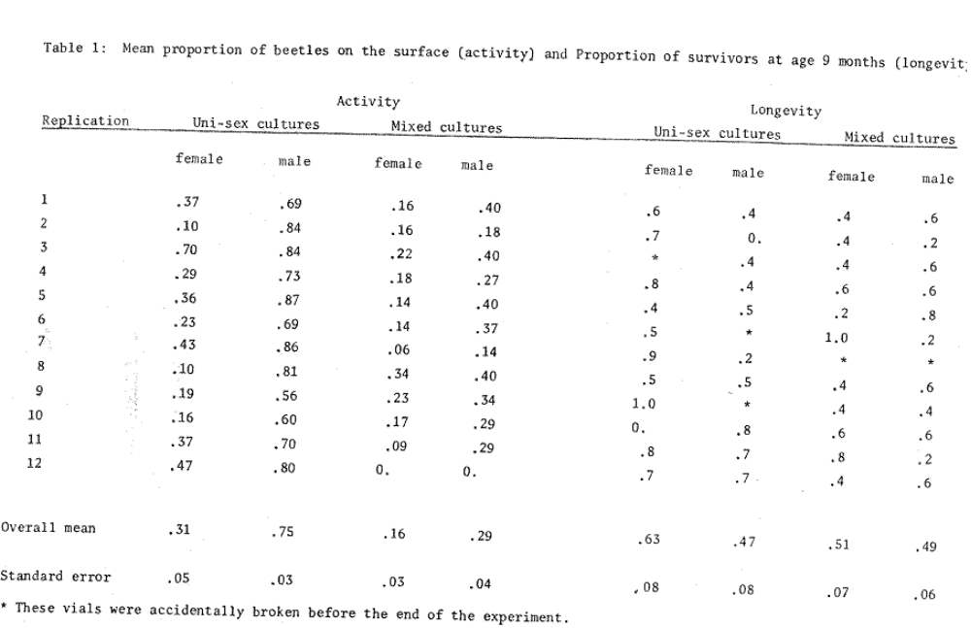
Julieta Ramos-Elorduy de Conconi*
Ma. Luisa Hernandez Ibarra*
Mario Ramirez-Martinez**
Jesus Siqueiros Beltrones-***

* Laser Ray Effect on Tribolium confusum Duv.

A B S T R A C T

Argon laser ray effect is study on Tribolium confusum Duv. It was observed that the mortality was in general proportional with time dosage. Larvae and Pupae were affected by the radiation faster than eggs or adults. 120 joules dose, with a power of 100 milliwatts causes practically 100% mortality after 40 days.

The most notable effects of laser radiation were dehydration, sclerotization, melanization, lack of movement and tethargy, anorexia, lengthening of life cycle, cessation of development or reproduction and death.

R E S U M E N

Se estudia el efecto de un rayo laser de Argon en cada uno de los estados del desarrollo de Tribolium confusum Duv.

En general, se observa que la mortalidad, es proporcional a la relacion dosis-tiempo. Las larvas y pupae, son mas rapidamente afectadas por la radiacion que los huevecillos y los adultos. En la dosis de 120 joules, con una potencia de 100 milliwatts se obtiene practicamente el 100% mortalidad a los 40 dias.

Los efectos mas sobresalientes de la radiacion laser fueron deshidratacion, esclerotizacion, melanizacion, inmobilidad, aletargamlento, anorexia, alargamiento del cicio de vida, Sloqueo del desarrollo, bloqueo de ja reproduction y muerte.

--------------------------------------------------------------
* Institute of Biology UNAM. Mex.
** Institute of Physics UNAM. Mex.
*** Research Centre of Materials UNAM. Mex.
Universidad Nacional Autonoma de Mexico (UNAM)
Apartado Postal 70-153 – Mexico 20, D.F.

Introduction

Today’s food crisis throughout the world and the necessity to preserve stored food products from insect infestation requires examination of many methods for the control of storage pests. Such methods should not impair the quality of the food that is treated.

The objective of this investigation was to determine the value of laser rays for the control of the confused flour beetle, Tribolium confusum Duv., an important pest of stored foods.

Argon ionized laser shows a continuous emission in the electromagnetic spectrum range that goes from green to ultraviolet. A laser ray has two biological effect : thermal and the electromagnetic energy of the laser impulse (1). The biological effects result in : biochemical changes induced by a transitory wave, vaporization or mechanical damage to cells, and photochemical effects (10).

Materials and Methods

Cultures of Tribolium confusum were prepared at the Biology Institute of the National Autonomous University of Mexico, on a wheat flour mixture with 5% of yeast, maintained at 28⁰c + 2⁰c and a relative humidity of 70%, approximately (2, 4, 5, 6). Radiation and dosimetry were performed at the Material Research Centre. For this purpose an Argon Laser Spectra Physics device (Model 165) was used which was adjusted to a wave length of 4880A; the power output was adjusted at 10 or 100 milliwatts. The output power was measured with a Spectra Physics Model 401-8.

A special device was designed to amplify the beam of the laser ray (Fig. 1).

Eggs, larvae, pupae and adults of Tribolium confusum were counted in lots of 30 individuals and placed in 15 ml. test tubes with 7 g. of wheat flour and brewer’s yeast (19:1), which was previously sterilized. Four replicates were used for each treatment and each control. A random block design was used in allocation of the insects to various treatments.

The laser dosage varied from 3 to 480 joules, time of exposure to he laser beam was 5, 10, 20, 40 and 80 minutes which provided doses of 3, 6, 12, 24 and 48 joules at 10 milliwatts power output and doses of 30, 60, 120, 240 and 480 joules at 100 milliwatts power output.

A Hewlett-Packard computer, model 21-14 was used for the statistical analysis.

Results

It was observed that mortality was generally proportional to the applied dosage (Tables 1 to 4). Mortality of eggs irradiated with 10 milliwatts was low. Even at high dosages (24 and 48 joules) after 40 days, 35% and 53.3 mortality occurred. Individuals irradiated at 100 milliwatts had a higher mortality at a dosage of 30 joules. After 10 days 58.9% mortality was obtained compared with 53.3% mortality at a dose of 10 milliwatts at 48 joules after 40 days. When the energy was increased to 120 joules survival approached 100% of mortality (Table 1).

The laser ray effect is demonstrated when eggs were treated at a dosage of 3-6 jouls after 20 days and for 12, 24 and 48 joules at 10 milliwatts, and for 120, 240 and 480 joules at 100 milliwatts after 10 days. There was high mortality of larvae after 10 days when the power was 10 milliwatts; and there was a 95.8% mortality at 48 joules after 20 days (Table 2).

When the power was increased from 10 to 100 milliwatts, we observed small changes in mortality at various times after treatment (Table 2).

The action of laser rays on larvae is rapid as shown after 10days at 10 milliwatts.

Dosages of 24 and 48 joules were applied to pupae with a power of 10 milliwatts and these were also affected after 10 days resulting in 90% and 93.3% of mortality, respectively; at doses of 3, 6 and 12 joules79.1%, 90% and 85.8% mortality was obtained after 40 days. At 100 milliwatts after 10 days mortality fluctuated from 83.8% to 99.2%; there was 100% mortality wih 240 joules after 20 days and with 120 joules after 30 days (Table 3).

A power of 10 milliwatts at 48 joules reduced survival in adults to 50% after 40 days. Survival of individuals at a power of 100 milliwatts was affected at 120 joules to give 100% mortality after 40 days (Table 4).

An F test applied to the data obtained always showed significant differences between the treatments and the controls. There was no significant differences between the controls and laser treatments applied at 10 milliwatts to eggs and pupae after 10 days.

Discussion

Eggs had clear difference in effect caused by irradiations as they were observed power was increased.

When the irradiation power varied, was not found the same differential effected both larvae and eggs.

Irradiated larvae showed several symptoms that varied from slight immobility and anorexia to complete dehydration, followed by changes in melanization.

Adults that developed from irradiated larvae or eggs, took more than twice as long to complete develop; there were no apparent differences between dosages.

Radiation caused dehydration of pupae and larvae, changes in coloration, and prolongation of development.

Adults showed a marked resistance to radiation. Females did not oviposit after treatment at 30 joules at 100 milliwatts, but at 10 milliwatts, all adults oviposited and eggs hatched except those from individuals irradiated at 48 joules.

Generally the most notable effects of laser radiation were :

- – Dehydration
- – Sclerozation
- – Melanization
- – lack of mobility
- – Anorexia
- – Prolongation of life cycle and blockage of development
- – Cessation of reproduction (there is no oviposition)
- – Eggs unable to survive since application of 48 joules (10 mw)
- – Death

It was been demonstrated that laser radiation can change configuration of protein molecules, and retard cell division (3). Cells may also lose their synchrony shortly after irradiation. Lasers also inhibit respiratory activity, it can be seen in the reduction of cytochrome B (7) and the production of secondary effects on RNA nuclear synthesis and destruction of cellular walls such as Spyrogyra (8) that can be a help in explaining the retardation of development when enzymatic life systems are modified.

Low dosages of laser radiation applied to adults extend longevity as is he case with gamma radiation.

Mortality of larvae was less than 100%, but most of the individuals did not complete development.

The wave length of this ray is within the visible spectrum which classifies it as a cold light, and it is assumed that such radiation would not have any adverse effect on treated food products. However, it will eventually be necessary to determine whether the radiation causes any changes in food quality.

The importance of food preservation suggests that the method may be used for pest control and further research is planned.

We are very grateful to Dr. F.L. Watters, Head of Cereal Crop Protection Section of the Canada Agriculture Research Station of Winnipeg for reading the manuscript and suggestions that he gave us.

T A B L E 1

Percentage mortality of eggs of Tribolium confusum exposed to laser rays at various energy levels.

Power (Milliwatts) | Energy (Joules) | Days after treatment
Power (Milliwatts) | Energy (Joules) | 10 | 20 | 30 | 40
0 (control) | 0 | 1.3 | 1.3 | 1.3 | 4.7
10 | 3 | - | - | 24.2 | 25.8
10 | 6 | - | - | 7.5 | 16.7
10 | 12 | - | 20.8 | 21.7 | 24.2
10 | 24 | - | 35.0 | 35.0 | 35.0
10 | 48 | - | 53.3 | 53.3 | 53.3
100 | 30 | 58.9 | 58.9 | 77.5 | 73.3
100 | 60 | 46.7 | 82.2 | 71.7 | 85.8
100 | 120 | 100 | 100 | 100 | 100
100 | 240 | 100 | 100 | 100 | 100
100 | 480 | 93.3 | 98.3 | 100 | 100

T A B L E 2

Percentage mortality of larvae of Tribolium confusum exposed to laser rays at various energy levels.

Power (Milliwatts) | Energy (Joules) | Days after treatment
Power (Milliwatts) | Energy (Joules) | 10 | 20 | 30 | 40
0 (control) | 0 | 23.3 | 25.6 | 25.0 | 25.0
10 | 3 | 82.5 | 84.2 | 84.2 | 84.2
10 | 6 | 87.5 | 90.8 | 90.8 | 93.3
10 | 12 | 92.5 | 95.0 | 95.0 | 95.5
10 | 24 | 87.5 | 92.5 | 92.5 | 92.5
10 | 48 | 77.5 | 95.8 | 95.8 | 95.8
100 | 30 | 90.0 | 93.3 | 95.0 | 96.7
100 | 60 | 82.5 | 84.2 | 85.8 | 89.1
100 | 120 | 88.3 | 90.0 | 96.7 | 99.1
100 | 240 | 87.5 | 94.1 | 95.8 | 100
100 | 480 | 87.5 | 95.0 | 99.1 | 100

T A B L E 3

Percentage mortality of pupae of Tribolium confusum exposed to laser rays at various energy levels.

Power (Milliwatts) | Energy (Joules) | Days after treatment
Power (Milliwatts) | Energy (Joules) | 10 | 20 | 30 | 40
0 (control) | 0 | 23.0 | 18.0 | 28.0 | 18.0
10 | 3 | 74.2 | 79.1 | 79.1 | 79.1
10 | 6 | 67.5 | 83.3 | 84.2 | 90.0
10 | 12 | 30.8 | 85.0 | 85.0 | 85.8
10 | 24 | 90.0 | 91.7 | 91.7 | 91.7
10 | 48 | 93.3 | 94.2 | 94.2 | 94.2
100 | 30 | 83.3 | 84.1 | 91.7 | 94.1
100 | 60 | 90.0 | 90.8 | 92.5 | 93.3
100 | 120 | 99.1 | 99.1 | 100 | 100
100 | 240 | 93.3 | 100 | 100 | 100
100 | 480 | 93.3 | 96.7 | 100 | 100

T A B L E 4

Percentage mortality of adults of Tribolium confusum exposed to laser rays at various energy levels.

Power (Milliwatts) | Energy (Joules) | Days after treatment
Power (Milliwatts) | Energy (Joules) | 10 | 20 | 30 | 40
0 (control) | 0 | 3.3 | 5.0 | 5.5 | 6.3
10 | 3 | 12.5 | 17.5 | 17.5 | 49.2
10 | 6 | 11.7 | 17.5 | 23.3 | 28.3
10 | 12 | 6.6 | 20.0 | 21.7 | 21.7
10 | 24 | 20.0 | 36.7 | 36.7 | 36.7
10 | 48 | 15.8 | 43.3 | 43.3 | 50.8
100 | 30 | 17.5 | 20.0 | 35.0 | 41.7
100 | 60 | 65.8 | 67.5 | 70.8 | 88.3
100 | 120 | 78.3 | 80.0 | 84.1 | 100
100 | 240 | 94.1 | 98.3 | 98.3 | 100
100 | 480 | 91.7 | 94.2 | 98.3 | 100

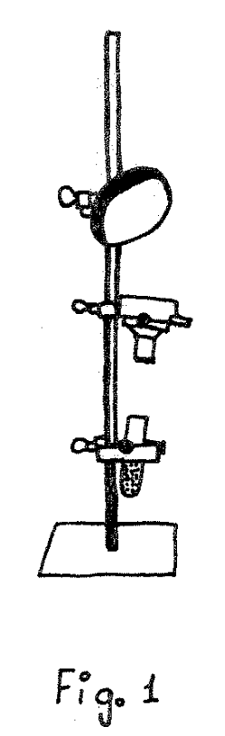

References

Chang, W.S.C. 1963. Laser and Applications. Ohio State Univ. Univ. Columbus Edit. 267 P.

Charbonneau, R. & Lenonde, A. 1960. Unidentified growth factors in brewer’s yeast. I. Necessity of these. Can. J. Zool. 38 : 87-90.

Heavens, O.S. 1966. Recent applications of laser. Br. J. Appl. Phys. 17 : 287-309

Howe, R.W. 1960. The effects of temperature and humidity on the rate of development and the mortality of Tribolium confusum. Ann. Appl. Biol. 48 : 363-376.

Khaliffa, A. & Badawy, A. 1955. The effects of nutrition of the biology of T. confusum, T. castaneum and Latheticus oryzae (Coleoptera : Tenebrionidae) Bull. Soc. Ent. Egypt 39 : 337-350.

Park, T. & Frank, M.B. 1950. The fecundity and development of the flour beetles T. confusum and T. castaneum at three constant temperatures. Ecology 29 : 368-374

Rounds, D.E., Uson, R.S. and Johnson, F.M. 1968. The effect of the laser on cellular respiration. Zeit. Zellfor. M. Krosk. Anat. 87 : 192

Sars, N.M. & Roth, C.A. 1963. Ruby laser as a Microsurgical Instrument. Science 141 : 46

Sokoloff, A. 1972. The biology of Tribolium with special emphasis on genetic aspects. Clarendon Press. Oxford 300 P.

Wolbarsht, M.L. 1971. Laser Applications in Medicine and Biology. Plenum Press, New York, London. 267 pp.

Rich, S.S., and A.E. Bell
Department of Animal Sciences
Purdue University
West Lafayette, Indiana

* The effect of stress environments on heterosis of larval weight in Tribolium castaneum.

Tribolium is widely recognized as a useful experimental model in the testing of quantitative genetic theory (Bell, 1974). Of major importance to quantitative genetics is the evaluation of breeding systems. Major efforts have been made in the comparison of two methods of selection within line or purebred selection (WLS) and reciprocal recurrent selection (RRS). When dealing with basically additive traits, WLS has proven to be superior to RRS (Bell and Moore, 1972), as predicted by theory. However, the outcome was reversed in a stress environment where non-additive genetic variation was predominant (Orozco and Bell, 1974). In a study preliminary to a further comparison of WLS and RRS, the effects of stress environments on percent heterosis (H) of larval weights of crosses among highly selected populations were measured.

Materials and Methods

The genetic material represented eight highly selected lines of Tribolium castaneum (McNew and Bell, 1976). Four lines reflected a history of continued WLS (5, 6, 7, 8), while the remaining four lines had a background of RRS (1, 2, 3, 4). Even-numbered lines originated from the Purdue “p” Foundation Population, and odd-numbered lines from the Purdue “b” Foundation Population.

A replicated factorial experiment was conceived, utilizing two densities, two environments, and sixteen crosses. The trait of interest was 13-day larval weight. Females used in egg collections were raised on the optimal environment (standard media, consisting of 95% whole wheat flour and 5% dried brewer’s yeast, by weight). The two environments being investigated were optimal (standard media) and stress (sterile flour). Two densities, 10 eggs / 1 g media and 10 eggs / 2 g media, were also tested for effects, on percent heterosis, calculated as

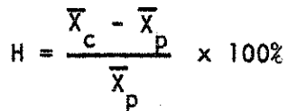
_ _
Where X_{c} and X_{p} represented crossbred and purebred means, respectively. The sixteen crosses were established as follows (male line x female line) :

1x1, 1x2, 2x1, 2x2
3x3, 3x4, 4x3, 4x4
5x5, 5x6, 6x5, 6x6
7x7, 7x8, 8x7, 8x8

Egg collections were maintained at 33⁰c and 70% relative humidity for 13 days. Of the ten eggs placed in each creamer, counts of the number of larvae resulting and their mass weight were recorded on day 13. Mean larval weights and percent heterosis were analyzed by analysis of variance with a model including the fixed effects of crosses, densities, and environments.

Results and Discussion

As shown in Table 1, there is an observable difference in the magnitude of percent heterosis between environments within each of the four blocks of crosses. Results of the analysis of variance on percent heterosis (Table 2) show that both crosses and environments are highly significant (P < 0.01), while there is no significant effect of density. Interactions are also shown to be non-significant. In all cases, the percent heterosis is higher in the stress environment that in the optimal environment.

In conclusion, it is apparent that Tribolium cultured in a stress environment shows marked increase in percent heterosis. The results possibly suggest that different gene systems are acting to control larval weight in different environments.

Literature Cited

Bell, A.E. 1974. Genetic modeling with laboratory animals. First World Congress on Genetics Applied to Livestock Production. Vol. 1 : 413-424.

Bell, A.E. and Moore, C.H. 1972. Reciprocal recurrent selection for pupal weight in Tribolium in comparison with conventional methods. Egypt. J. Genet. Cytol. 1 : 92-119.

McNew, R. and Bell, A.E. 1976. Comparison of crossbred and purebred selection for a heterotic trait in highly selected populations of Tribolium. Journal of Heredity 67 : 275-283.

Orozco, F. and Bell, A.E. 1974. Reciprocal recurrent selection compared to within-strain selection for increasing rate of egg lay of Tribolium under optimal and stress conditions. Genetics 77 : 143-161.

Table 1. Percent heterosis pooled over replications.

Density | Environment | Crosses
Density | Environment | 1, 2 | 3, 4 | 5, 6 | 7, 8
10 eggs / 1 g | Optimal | 20.1 | 19.1 | 9.4 | 3.9
 | stress | 56.5 | 36.9 | 30.4 | 13.7
10 eggs / 2 g | Optimal | 29.0 | 15.9 | 5.8 | 7.2
 | stress | 47.6 | 30.5 | 21.0 | 11.3

Table 2. Analysis of variance on percent heterosis

Source | df | MS
Crosses (C) | 3 | 1218.4 **
(1, 2 + 3, 4) vs (5, 6 + 7, 8) | 1 | 2396.4 **
residual | 2 | 629.4 **
Density (D) | 1 | 16.1
C x D | 3 | 6.9
Environment (E) | 1 | 2623.8 **
C x E | 3 | 144.5
D x E | 1 | 204.2
Residual | 19 | 29.9
Total | 31

** (P < 0.01)

Sander, K. and Schuch, W.¹
Biol. Institue (Zoologie) Der Universitat
D 78 Freiburg 1. Br.

* Syndromes and frequency of embryonic lethality in some mutants of Tribolium castaneum.

The alleles Be, Mo, Sa-2 and Spa of Tribolium castaneum cause egg stage lethality in the homozygous condition (Krause et al., 1962, Sokoloff, 1966 and Pers. Comm.). We checked eggs from matings of heterozygous individuals for the syndromes of lethality. The eggs were collected over 2 day periods and thereafter reared under tap water at 30⁰c. On subsequent days, eggs with visibly abnormal development were transferred to separate dished for further observation.
Table1. Results of embryonic development in different strains of Tribolium castaneum

Genotype of parents | Unspecific anomalies (frequency) | Eggs free from unspecific anomalies
Genotype of parents | Unspecific anomalies (frequency) | Number² | % specific anomalies | % normal larvae
Be / + | 0.032 | 1774 | 25, 4 | 74, 6
Sa⁻² / + | 0.067 | 2259 | 25, 0 | 75, 0
Mo / + | 0.179 | 632 | 32, 8 | 67, 2
Wild type¹ | 0.145 | 370 | - | 100, 0
Spa / + | 0.687 | 611 | 32, 2 | 67, 8
Wild type¹ | 0.177 | 682 | - | 100, 0

¹⁾ recombinants from the Mo and Spa strains, respectively.
²⁾ subsequent percentage calculated with this number = 100%

We established 3 classes of developmental results : normal development, unspecific anomalies and specific anomalies. The latter in each mutant represent a uniform class which can easily be distinguished from normal embryos and from the various anomalies (= unspecific anomalies) occurring in control eggs from wild type matings. Unspecific anomalies rated between 3% and 10% in both mutant and wild type strains, except the Spa strain where about 2/3 of all eggs developed anomalies classified as unspecific (Table 1). Of the eggs free from unspecific anomalies, close to 25% yielded specific anomalies in the Be and Sa-2 strains, while with the mutants Mo and Spa the percentage of supposedly specific anomalies was above 30% (Table 1).

¹⁾ The authors are indebted to Dr. A. Sokoloff for providing the mutant strains and for valuable advice, and to the Deutsche Forschungsgemeinschaft for financial support (SFB 46).

The anomalies classified as specific represent the following syndromes. In the Be strain, the segmental germ band becomes detached from the yolk; the latter than forms a longitudinal groove in which the germ band decays. The Sa-2 anomaly is indistinguishable from that found in the mutant Fta (Sander and Kul, 1977) : the appendage buds of the germ band become arrested so that a “legless” larva ensues. In the Mo strain the specific anomaly is failure of normal-looking larvae to hatch. The defect considered specific for the Spa strain becomes visible at or after dorsal closure. The embryo fails to stretch and thus does not double up within the egg case; the legs tend to stick out laterally and the head is frequently bent back on the dorsal side. Among the abnormal Spa embryos classified as unspecific, a large percentage developed an apparently normal germ band which then got distorted and shortened until a rather stubby and more or less scrambled cell mass resulted. This anomaly was much rather in the other strains.

Our data are compatible with the assumption that the specific anomalies observed in the Be and Sa-2 strains represent the syndromes associated with the homozygous condition of the respective mutant alleles. In the Mo and Spa strains, the yield of specific anomalies was significantly higher (p < 0.01) than expected on this assumption; the yield of specific anomalies in these mutants is close to 1/3 of the eggs not eliminated by unspecific anomalies. The reasons for this deviation were not established. In the Spa mutant some connection might exist with the high frequency of unspecific anomalies which was not found in wild type recombinants from this strain (Table 1). It should be noted that a Dermestes strain with similar embryonic anomalies also failed to segregate in easily explained ratios (Ede, 1964).

Literature Cited

Ede, D. 1964. An inherent abnormality affecting the development of the yolk plasmodium and endoderm in Dermestes maculatus. J. Embryol. Exp. Morph. 12, 551-562.
Krause, E., Shideler, D., and Bell, A.E. 1962. An autosomal dominant mutant in Tribolium castaneum with recessive lethal effects. Am. Naturalist 96, 186-188.
Sander, K. and Kuld, I. 1977. Stage and syndrome of lethality in Tribolium castaneum homozygous for Fta. TIB-20, 132-133.
Sokoloff, A. 1966. The genetics of Tribolium and related species. Adv. In Genetics, Suppl. 1, Academic Press, New York.

Sandahl, J. and Sokoloff, A.
Biology Department
California State College
San Bernardino, California

* A Gynandromorph in Tribolium castaneum.

In a previous communication Dawson, Sokoloff and Rodriguez (1965) reported the discovery of a sexually aberrant individual in Tribolium castaneum. As a pupa this individual possessed a pair of seemingly normal female genital lobes, and in addition a pair of small genital lobes resembling those of normal males. After eclosion this beetle proved to have both an ovipositor and an aedeagus. Furthermore, the beetle did not possess the characteristic sex pit and hairs present in the firs pair of legs of normal males. Hence, from this standpoint, the beetle resembled a female (since this secondary sex character is absent from the prothoracic legs of females). We now report the discovery of several gynandromorphs in a stock of Tribolium castaneum. The possibility that these gynandromorphs had a hereditary basis could not be demonstrated, but it can not be excluded. The five specimens in question were discovered in the process of sexing a large number of pupae from a stock of “confusum-like” (cf1). The cf1 mutant of T. castaneum had originally been discovered in backcross progeny of beetles irradiated to 4000 r. The cf1 mutants were introduced into vials as single-pairs to determine penetrance, and their progeny isolated by sex as pupae. In one vial some of the pupae had one female-like genital lobe on one side and a small male-like genital lobe on the other side. Altogether, from this single-pair mating, a total of five gynandromorphs were found. Of these, only two survived to the imago stage. The rest died in the pupa or at eclosion.

Examination of the imagoes revealed that they were female-like, with no sex-pit and hairs on the femur of the first pair of legs. These beetles were mated with 2 or 3 males, and two weeks later, when no progeny were evident, they were placed together with females. These matings also foiled. Finally these beetles were placed in alcohol, and dissected. Ovaries were found one on each side of the body, and they contained ripe eggs.

The ovipositor in these beetles was examined. Although it was not possible to extend it, nevertheless the topography on one side of the ovipositor was clear and unmistakable. Using the fringe of hairs which ornament the posterior border of the VIII sternite, the abdominal portion of segment IX appeared normal (compare A and B in Fig. 1). Distal to this the valvifer baculus and the plates of the coxite were present but somewhat distorted and misplaced on the left side of the ovipositor, but they were completely missing on the right side. The ovipositor normally bears a pair of styli, one on each side. Only the left stylus was present.

In Drosophila gynandromorphs are produced through the loss of one X chromosome from one of the products of cell division. If this event occurs during the first cell division, one half of the insect (with only one X) will develop as male and the other half (with two X chromosomes) as female. The loss of the chromosome may occur later, in which case the cell that received only one X would give rise to less than half of the body.

The cytological basis of this gynandromorph in Tribolium has not been examined, but it would seem that if a similar mechanism was the cause of its appearance, that the loss of the X chromosome must have occurred at a late stage, and involved only a small patch of cells destined to give rise to the sex organs.

Of the five specimens observed, two had male-like characteristics on the right and female characteristics on the left, and three had the reciprocal arrangement.

Despite a diligent examination of the culture no further cases of gynandromorphs were observed.

This investigation was supported by U.S. Army Research Office Grant DRXRO-CB-14447-L.

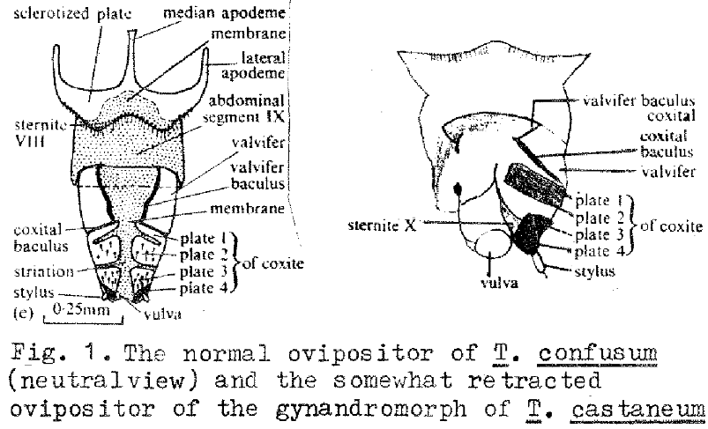
Sokoloff, A. and Spedding, J.
Department of Biology
California State College
San Bernardino, California

* Split prosternal process (Spp), a sex linked dominant mutation with possible lethal or semilethal effects in Tribolium anaphe.

A spontaneous mutation has been recorded in Tribolium anaphe which causes an elimination of the prosternal process in a manner similar to the split spinasternum (sss) mutant in T. castaneum reported by Hoy (1965).

Normally, the prosternal process extends posteriorly berween the coxal of the first pair of legs (Fig. 1A). In the mutant, the prosternal process is missing or split (Fig. 1B).

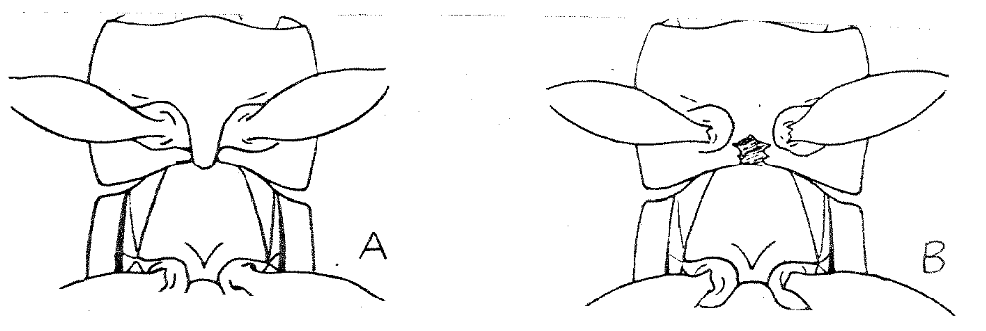

Preliminary crosses are summarized in Table 1. Crosses between a normal female and an Spp ♂ give normal males and Spp females. The reciprocal crosses (Spp/+ ♀ X + ♂) give about equal numbers of normal and Spp of both sexes. Crosses between a heterozygous Spp female and an Spp male produce only normal sons but both Spp males and Spp females.

The mutant, therefore is a sex-linked dominant, and it may have either semilethal or lethal effects. Further crosses and egg counts are needed.

Table 1. Results of various crosses involving normal and Spp in Tribolium anaphe.

Cross | Progeny
Cross | Normal |  | Spp
Cross | ♂ | ♀ | ♂ | ♀
+ / + ♀ X Spp ♂ | 31 | 0 | 0 | 34
Spp / + ♀ X + / + ♂ | 76 | 89 | 87 | 81
Spp / + ♀ X Spp ♂ | 91 | 0 | 76 | 107

Sokoloff, Alexander
Biology Department
California Sate College
San Bernardino, Ca. 92407

Evolutionary trends in Tribolium

Although the number of species o Tribolium is small (about 30 described species) several studies have attempted to establish evolutionary trends in these beetles.

Smith’s cytological investigations (1950, 1951, 1952a, b, 1953, 1960a, 1962) of karyotypes in at least 191 species, 127 genera, 66 families and 51 superfamilies in the Coleoptera led him to conclude that the primitive chromosome number in this order of insects is 9AA + X + y. Examination of the karyotype of flour beetles led him to conclude that T. castaneum with 9 pairs of autosomes, an X as large as one of the smaller autosomes and a minute y possesses the number of chromosomes regarded as the primitive number. T. confusum with 8 pairs of autosomes, a large X (referred to as neo-X, and a large Y (neo-Y) is a derived species. During its evolution a pair of autosomes were translocated to the X and Y forming the neo-X and neo-Y. The autosomal portion of the neo-Y became heterochromatinized (inactive) but the autosomal portion of the neo-X remained functional. However, the genes carried by the autosomal portion of the neo-X were now inherited in sex-linked fashion (see Sokoloff, 1972 for illustration). Sokoloff, Ackermann and Overton (1967) and Dawson (1968) have provided genetic evidence to support this portion of Smith’s hypothesis. T. destructor with 8AA + X + y is also a derived species, which arose when the autosomes translocated to the X and y were lost. The genetic evidence for this portion of Smith’s hypothesis is not available.

Hinton (1948) has revised and subdivided the genus Tribolium into five specis-groups, namely brevicornis, confusum, alcine, castaneum and myrmecophilum according to their geographic distribution, incorporating in the genus the species previously included in the genus Aphanotus. (see Sokoloff, 1972, for a complete review of his work). He has concluded that Tribolium (Aphanotus) brevicornis is the most primitive on the basis of the characteristics of the pronotum : “the apex of the pronotum has a distinct marginal line on the side which is continuous with he lateral marginal line. The apical marginal line appears to be a primitive feature retained in the brevicornis group but lost in all others, and constitutes the most important distinguishing features of the American species.”

The T. confusum species group is most closely related to the castaneum than to the brevicornis species group : the primitive members of the confusum and castaneum species groups are similar in appearance and both possess similar secondary sexual characteristics in the male. The confusum species group is divided into three sections, the confusum, giganteum and downesi sections. There is a close resemblance between T. confusum, T. anaphe and T. destructor. However, the males in the latter lack the sub-basal pit and associated brush of hairs present in the other two species on the ventral side of the front femur. The other sections are the giganteum and the downesi section which includes T. semile, T. sulmo, T. indicum, T. indicum f. seres, T. indicum f. ares, T. thusa and T. beccarii. The only species of these two sections we will consider here are T. downesi and T. giganteum since the writer has been able to examine only a single specimen each of these species.

The castaneum species-group has characteristically a very distinct and abrupt 3-segmentd club. It differs from the brevicornis group in having no margin on the apex of the pronotum, and from the confusum species-group in that the margins above the eyes are not ridged. It is the most variable of all species-groups, and according to Hinton it has already split into a number of very distinct secondary species-groups or sections. The only species-sections we will consider here is the castaneum section which includes T. madens, T. audax, T. freemani, T. castaneum and T. apiculum.

Hinton has therefore observed that 1) the apical marginal link of the prothorax as a primitive feature that tends to disappear in various species groups.

2) Members of some groups possess a sub-basal pit and associated brush of hairs which are present in the male and absent in the female. This is a primitive trait that disappears in the male. In some species these pits are replaced by tuberles.

3) The antennae may possess an abruptly swollen 3-segmented club (T. castaneum-group) or 5-segmental gradually tapering club (confusum-group, confusum section) or 7-segmental club (T. giganteum), or no club at all as in T. doolan.

4) The eyes are larger, closer to each other and less specialized (and therefore more primitive) in the downesi section than the confusum section.

5) The eye is either not ridged (castaneum-group) intermediate (alcine species group) or heavily ridged (confusum-group).

6) The pronotal punctures evolve toward coarser, more dense, and more evenly distributed pronotal punctures.

7) The elytra become more strongly carinate.

Roth and Willis (1951) have examined the antennae of several species of Tribolium, particularly in regard to the sensillae present in these appendages in T. brevicornis, T. madens, T. castaneum, T. parallelus, T. confusum and T. destructor. On the basis of sensillar form, Roth and Wills’ study shows that primitive Tribolium possessed simple basiconic sensillae and restricted to the lateral apical corners (except on the terminal segment) or the segments forming the club, a condition still retained in T. brevicornis. These sensillae gradually became more complex, with the peg organs changing from the primitive single pronged condition to peg organs consisting of several branches (from 2-7).

Thus T. brevicornis is regarded as the most primitive in regard to the basiconic sensillae. T. parallelus, in the same species group; is more advanced since it has more two-pronged than simple- and three-pronged sensillae, and on segments IX and X they are arranged more or less in the shape of a ring rather than being restricted to the corners. In the confusum species-group T. confusum is more primitive than T. destructor since in the latter there is a tendency to form multi-pronged sensillae. Finally, in the castaneum species-group T. madens is more primitive since it has more simple basiconic sensillae and on segments IX and X they are not organized in as complete a ring as those in T. castaneum. (For fuller details of these and other studies of evolutionary trends see Sokoloff 1972).

With the discovery of the confusum-like mutation in T. castaneum we examined the interocular distance of this mutant and all the species of Tribolium available in the Tribolium Stock Center. The measurements obtained were (A) the total width of the head at the level of the eyes and (B) the distance between the eyes at the same level of the head with an ocular micro-meter, and obtaining a ratio. This ratio was obtained by dividing B by (A-B)/2. (This ratio is the same as dividing the interocular space by one eye width). 10 males and 10 females of each species and strain were measured. The measurements were rounded to the nearest ocular unit. The results are shown in Table 1.

Within the castaneum-group T. castaneum clearly has the smallest distance between the eyes, the interocular distance being approximately one eye width. The two sibling species, T. audax and t. madens, have similar interocular distances (approximately 2 ½ eye widths).

In the confusum-group the only specimen available for T. downesi (not shown in the table) had an interocular distance of about 0.9 eye widths. T. anaphe is next with an approximate interocular distance equivalent to about ½ eye widths. T. confusum and T. destructor possesses a head with an interocular distance of about 2 eye widths, and the single specimen of T. giganteum about 2 ½ eye widths.

Finally, T. brevicornis has the greatest interocular space, equivalent to almost 4 eye widths.

If we accept the karyotype evidence for evolution as a starting point, then it follows that the primitive phenotype of the head, and more specifically the eye of Tribolium must be like that of Tribolium castaneum, with the eyes closely set on the ventral side, and with an intraocular space more or less equivalent to one eye width. Gradually the head has widened, with the result that the eyes are farther and farther apart. That this is under genetic control is suggested by confusum-like mutation of T. castaneum : this single gene can modify the head to assume a phenotype resembling that of present-day T. confusum. Nearly all the species examined in this species-group resemble T. confusum. The only species that falls in this respect is T. downesi and Hinton (1948) has already indicated that this is probably the primitive condition in this species-group.

The increase in distance between the eyes has resulted in an overall smaller eye, but this result has been accomplished without a (drastic) number of facets. (The number of facets of the compound eye of Tribolium castaneum wild type and the confusum-like mutant is about the same.)

Tribolium brevicornis is somewhat atypical, since its eyes are set farthest apart. It is possible that despite the primitivenss of the species-group the species T. brevicornis is among the most advanced within its group (just as T. confusum is among the most advanced within the T. confusum group). More data are needed for the brevicornis species-group.

It would appear from the evidence available that in the evolution of Tribolium two major events occurred: one was the genotypic change which allowed the evolution of a broader head, and wider-spaced compound eyes. This event must have occurred first, since wider-set eyes occur in several species-group. The other was the evolution of a derived species such as T. confusum from an ancestor karyotypically like T. castaneum as the cytological evidence presented by Smith suggests.

Acknowledgements – The assistance of Michael A. Sokoloff in this investigation is gratefully acknowledged. This investigation was supported by U.S. Army Research Office Grant DRXRO-CB-14447-L.

Ratio of interocular space and the ventral width of the compound eye in several species of Tribolium.

Species | Males |  |  | Females
Species | Mean + | S.E. | C.V. (%) | Mean + | S.E. | C.V. (%)
T. castaneum | 1.19 | 0.09 | 23.61 | 1.22 | 0.02 | 4.32
cf-like | 1.90 | 0.07 | 11.77 | 2.56 | 0.13 | 16.33
T. audax | 2.47 | 0.09 | 12.07 | 2.14 | 0.09 | 13.61
T. madens | 2.56 | 0.09 | 11.31 | 2.68 | 0.08 | 9.75
T. confusum | 2.20 | 0.05 | 7.38 | 2.09 | 0.08 | 11.58
T. anaphe | 1.63 | 0.04 | 7.13 | 1.54 | 0.04 | 8.34
T. destructor | 2.09 | 0.05 | 8.11 | 2.15 | 0.05 | 7.67
T. giganteum | 2.52
T. downesi | 0.92
T. brevicornis | 3.93 | 0.36 | 28.99 | 3.78 | 0.13 | 10.81

For each sex N = 10, except for the single specimens of T. giganteum and T. downesi

Sokoloff, Alexander and Raymond, Pamela D.
Biology Department
California State College
San Bernardino, California

* Relationship between body size and cell number in Tribolium.

The purpose of this investigation was to determine whether increase or decrease in size (expressed in body weight) following a mutational event or a selection procedure was the result of an increase in cell size or an increase in cell number. Samples of 10 beetles of each sex, strain and species were weighed individually, and both wings of each beetle mounted on a slide in paraffin oil. The wing length was determined by using an ocular micro-meter (1 unit – 0.215 mm) along the cubital vein of the membranous wing, from the fork of the cubitus and radius to the fork of the medial and cubital veins. The number of cells was determined by counting the bristles within a square of an ocular grid 0.000128 mm² in an area of the membranous wing near the fork produced by the medial and cubital veins.

The strains used in this investigation included the T. castaneum Berkeley synthetic strain, not marked with sooty; the Hi and Lo lines for high and low body weight by I.R. Franklin. Selection had been suspended in both lines since 1967; the sex-linked mutation pygmy (py) and the Giant (Gi) mutation discovered by Gall and Medrano. The T. confusum strains were the Berkeley Synthetic strain, and the autosomal recessive extra large (X1) mutation discovered by Vardell. The results are shown in Table 1.

These data are consistent with the hypothesis that increase in size or decrease in size resulting from both a mutation event and from the alteration of genotype resulting from selection toward a high or low body weight are correlated with an increase or decrease in cell size and not with an increase or decrease of cell number. These does not seem to be any influence of sex on these relationships.

On noteworthy feature of the data in this investigation is the fact that the Hi-line, which was about twice as heavy as the synthetic strain, on relaxation of selection, has gradually attained a weight comparable to that of the synthetic strain. On the other had the Lo line has retained its low body weight and compares well, at this point to the unselected pygmy mutant strain. (Note the similar investigation by Soliman and Rose in this issue of TIB).

This investigation was supported by U.S. Army Research Office Grant DRXRO-CB-14447-L.

Correlation between body weight, wing length and cell number in Tribolium (N = 10)

Tribolium castaneum

Male | Weight (mg) |  | Wing length* |  | Cell number**
Male | m + | S.E. | m + | S.E. | m + | S.E.
Synthetic + / + | 2.12 | 0.05 | 9.73 | 0.11 | 3.8 | 0.20
Giant | 3.14 | 0.07 | 11.07 | 0.12 | 4.0 | 0.21
Hi-line | 1.89 | 0.07 | 10.08 | 0.15 | 4.8 | 0.33
Lo-line | 1.48 | 0.06 | 8.77 | 0.15 | 5.1 | 0.28
pygmy | 1.02 | 0.03 | 8.13 | 0.06 | 4.8 | 0.25
Female
Synthetic + / + | 2.17 | 0.07 | 10.08 | 0.07 | 3.5 | 0.17
Giant | 3.03 | 0.13 | 11.33 | 0.12 | 4.1 | 0.32
Hi-line | 2.14 | 0.11 | 10.24 | 0.14 | 6.3 | 0.26
Lo-line | 1.17 | 0.07 | 8.76 | 0.09 | 4.6 | 0.22
pygmy | 1.46 | 0.06 | 8.21 | 0.06 | 4.7 | 0.16

Tribolium confusum

Male | Weight (mg) |  | Wing length* |  | Cell number**
Male | m + | S.E. | m + | S.E. | m + | S.E.
Synthetic + / + | 1.59 | 0.10 | 9.01 | 0.17 | 5.0 | 0.26
Extra large | 3.88 | 0.20 | 11.09 | 0.17 | 6.0 | 0.36
Female
Synthetic + / + | 2.24 | 0.04 | 9.45 | 0.12 | 5.2 | 0.29
Extra large | 5.68 | 0.16 | 11.77 | 0.13 | 4.9 | 0.23

* Wing length is expressed in ocular units where 1 ocular = 0.215 mm under 40X magnification.
** Cell number is expressed in number of cells found per square of an ocular grid where each square = 0.000128 mm² at a magnification of 1000X.

Soliman, M. Hani and Rose, S.
Department of Microbilogy and Genetics
University of New England
Armidale. N.S.W. 2351 Australia

An evaluation of the relationship between body size and cell number in Tribolium castaneum

Once formed, the membranous wing is only two cells thick, has a constant number of cells, each with one spine (Beck, 1962). Therefore, by counting the number of spines in a constant sample area, cell size of a wild and pygmy mutant strains of T. castaneum were compared. The actual square area measured was 0.00463 mm² which was magnified to 5 x 5 cm for easy counting of spines. Three areas were sampled, i.e. proximal (in the junction between the second and third anal veins), medial (between radiomedial cross vein and recurrent radius), and distal (along the same line in the remingium). Wing length, which is directly related to body size, was also measured. The total sample size for both strains N = 10.

The difference in wing length between the two genotypes was highly significant. The mean wing length of the wild type was 2.95 mm and of the pygmy 2.28 mm. Sokoloff (1972) reported that the length of the body of the wild strain is about 1.5 times longer than the pygmy mutant and it weighs twice as much.

There was a highly significant difference in cell number among the three positions. The proximal position appears to be extremely variable (Table). Although the pygmy mutant had a smaller cell size, i.e. larger cell number (230.6 cells) than the wild type (220.6), the difference was not significant probably due to the small sample size. Correlation between cell number of right and left wings was only significant for the wild type at the medial position (r = 0.722, P = 0.05). Also, at that position correlation between cell number and wing length was significant for the wild strain (r = - 0.41, P = 0.05). These results indicate that increasing wing length (body size) within or between strains is associated with increasing cell size. It is also suggested that total wing length and medial position should be used in future studies since they are less variable than other measurements.

References

Beck, J.S. 1962. Cell differentiation and radiopathology in the wing of Tribolium confusum. University of Califonia, Lawrence Radiation Laboratory Report No. 10211, pp. 122-59.

Sokoloff, A. 1972. The Biology of Tribolium. Vol. 1. Oxford University Press, London.

Table. Mean wing length and number of spines for wild type and pygmy mutant of Tribolium castaneum

 | Wild |  | Pygmy
 | Right  x + SE | Left  x + SE | Right  x + SE | Left  x + SE
Wing length (mm) | 2.95 + 0.04 | 2.96 + 0.04 | 2.38 + 0.02 | 2.28 + 0.02
Number of Spines
Distal | 203.7 + 8.2 | 214.6 + 4.4 | 202.8 + 2.9 | 212.6 + 4.9
Medial | 212.2 + 4.8 | 213.7 + 6.0 | 219.9 + 4.1 | 222.3 + 4.6
Proximal | 209.3 + 12.3 | 269.9 + 23.9 | 261.6 + 21.1 | 261.7 + 20.4

SONLEITNER, F.J.
DEPARTMENT OF ZOOLOGY
UNIVERSITY OF OKIAHOMA
NORMAN, OKIAHOMA

* Longevity and oviposition rate in Tribolium castaneum; Rubner’s hypothesis and natural selection

It was reported by Sonleitner (1961) that young adults exhibit decreased fecundity at high adults densities and that this depression of fecundity disappears in older adults, these older adults having even higher fecundities than single pairs. Although data only extended to 99 days of adult age, Mertz (1971) theorized that later in life those individuals living under high densities might make up their egg production so that the lifetime total was comparable to that of single pairs.

Data on two sets of single pairs extending over the entire adult life span are relevant to the above discussion. These beetles were obtained from egg farms and larval cultures kept at low densities at 29⁰c and 70% relative humidity in stone ground whole wheat flour with 5% Brewer’s yeast added. The pupae were separated according to sex and the single pairs set up in shell vials with 8 grams of medium upon emergence of the adults. Eggs were recovered and counted at three day intervals. The eggs collected on days 15-39, 75-99, and 141-165 of adult age were kept in syracuse dishes and the number hatching recorded.

The relevant treatment difference between the two sets was that in the “fresh” set adults were transferred to new fresh medium every three days while in the “conditioned” set, the adults were returned to the same medium in which they were living. Extra replicates were kept of both treatments to supply males to those pairs where the male died before the female, and, at 12 day intervals, to supply medium to replace that lost by the repeated sifting in the “conditioned” set, restoring the amount to 8 grams. This medium was replaced by fresh medium only once – on day 123.

In the conditioned set, the medium accumulated a slight degree of wastes and ethylquinone conditioning which depressed the fecundity of those pairs relative to that of the fresh set until day 102 after which the relationship was reversed. The pairs in the conditioned set lived much longer than those in the fresh set and produced, on the average, the same total number of eggs per female. These figures are reported in Table 1 while the age-specific 1_{x} (probability of survival to age x) and E _{x} (shown as eggs per female per day) are graphed in Figure 1.

Table 1. Means and standard errors of population statistics for two groups of single pairs of adult Tribolium castaneum.

Statistics | Treatment |  | t test (0.05 level)
Statistics | fresh (N = 52) | conditioned (N = 51) | t test (0.05 level)
Mean total egg production per female lifetime : | 1459 + 60.2 | 1510 + 73.3 | non-sig.
Mean adult female life span (days) : | 134 + 6.4 | 174 + 9.7 | sig.
Net reproductive rate (R₀) : | 641 + 24.0 | 631 + 26.8 | non-sig.
Innate capacity for increase (r_{m}) : | 0.1271 + 0.00042 | 0.1231 + 0.00043 | sig.
Finite rate of increase (ג) : | 1.1355 + 0.00048 | 1.1310+ 0.00048 | sig.
Exponential generation time (T_{e} – days) : | 50.87 + 0.297 | 52.38 + 0.344 | sig.

To compute the estimates of r_{m}, the innate capacity for increase and other related statistics given in Table 1, the adult 1_{x} and E_{x} values were modified in the following ways. Adult ages were adjusted by 1.5 days to relate them to the midpoint of the 3 day observation periods. An additional 29 days was added to represent the egg to adult period observe in the cultures yielding the adults. Since larval survival in the absence of cannibalism was observed to be 100% (sonleithner, 1972), no adjustment of adult 1_{x} values was made. The E_{x} values were converted to m_{x} values (live daughters produced per three days) by dividing by 2 to allow for 1:1 sex ratio and multiplying by a fertility or egg hatching proportion, f_{x}. This was based on regression analyses of the egg hatch proportion observed which gave the following equation :
fresh : fx = 1.068506 – 0.002326x
conditioned: fx = 1.001799 – 0.001666x

where x is now the age of the beetle since oviposition. These lines accounted for approximately 95% of the day-to-day variation in mean egg hatching proportions. Although the two equations are not significantly different, the trend in fx is similar to that shown by Ex values, lower for the conditioned beetles in early adult life and higher for them later. The resulting statistics reported in Table 1 are : R₀ = Σ 1xmx; r_{m}, the value satisfying the equation Σ e_{x}m_{x} = 1; ג = e^{r}; and Te = log_{e}R₀/r_{m}. Their standard errors were estimated of r_{m} are similar to previous estimates for Tribolium (Leslie and Park, 1949; Mertz, 1969; Park et al., 1964). The differences between the two groups are small, even when they are statistically significant.

The apparent constancy of the total egg production and R₀ of the two groups resulting from the interplay of lowered egg laying rate coupled to longer life span supports the idea of Rubner’s hypothesis (Allee et al., 1949, pp. 113, 403). This hypothesis merely describes the phenomena in terms of a vague and general idea of “constant total life force” so that there appears to be an inverse relation between “rate of living” and longevity. Usually the rate of living (metabolic rate) is experimentally manipulated by changes in temperature (ex : Alpatov and Pearl, 1929). Here the rate of living, as measured by egg laying rate, was changed by an accumulation of medium conditioning which, under population density. Another example where Rubner’s relation was observed when crowding reduced the “rate of living” is reported by Frank et al. (1957) in Daphnia. An evolutionary explanation for Rubber’s relationship under these conditions can be based on the remarks of Mertz (1971, pp. 370-373, 380-381) who pointed out that under crowded conditions leading to a steady-state population size, differences in generation time of genotypes become unimportant. If they have the same net reproductive rate Ro, they will remain in a genetic equilibrium. If the population is declining (r < 0), genotypes with longer generation times will have a smaller negative r and possess a selective advantage. Thus, an density effects push r towards zero and negative values, it is advantageous for individuals to spread their reproductive effort over a longer period of time in such a way as not to diminish their net reproductive rate, just as the Tribolium adults described here were observed to do.

Data on the 1st 99 days of the “fresh” pairs previously appeared in Sonleitner (1961, Table 1). That publication is an abridgment of a University of Chigo PhD. dissertation in which data on the total egg production and life span of these two sets of pairs appears. Additional analyses, the cal of r_{m}, etc. were done on the IBM System 370/158 computer at the Merrick Computation Center of the University of Oklahoma in the summer of 1977.

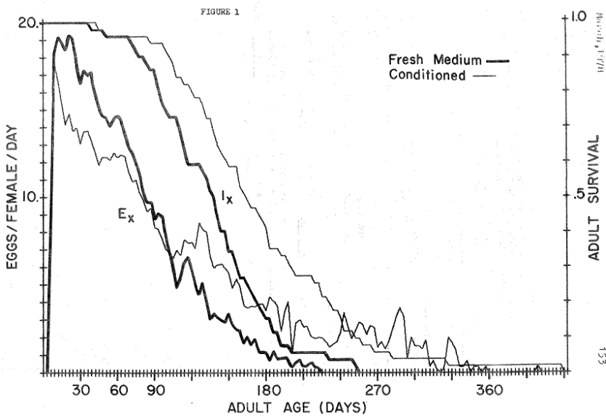
Literature cited :

Alpatov, W.W., and R. Pearl. 1929. Experimental studies on the duration of life. Influence of temperature during the larval period and adult life on the duration of life of the imago of Drosophila melanogaster. Amer. Natur. 63 : 37-67.

Allee, W.C., A.E. Emerson, O. Park, T. Park and K.P. Schmidt. 1949. Principles of Animal Ecology. W.B. Saunders Co. Phila.

Frank, P.W., C.D. Boll, and R.W. Kelly, 1957. Vital statistics of laboratory cultures of Daphnia pulex DeGeer as related to density. Physiol. Zool. 30 : 287-3.

Leslie, P.H. and T. Park. 1949. The intrinsic rate of natural increase of Tribolium castaneum Herbst. Ecol. 30 : 469-477.

Mertz, D.B. 1969. Age-distribution and abundance in populations of flour beetles. Experimental studies, Ecol. Monogr. 39 : 1-31.

________, 1971. Life history phenomena in increasing and decreasing populations. In : Statistical Ecology. Vol. II. Sampling and modeling biological populations an population dynamics. G.P. Patil, E.C. Pielou and W.E. Waters (eds.) The P State Univ. Press, University Park, pp. 361-399.

Mosteller, F. and J.W. Tukey. 1968. Data analysis, including statistics. In : Lindsey, G. and E. Aronson. The handbook of social psychology, 2nd Ed. Vol. I Research methods, pp. 80-203

Park, T., P.H. Leslie and D.B. Mertz, 1964. Genetic strains and competition in populations of Tribolium. Physiol. Zool. 37 : 97-162.

Sonleitner, F.J. 1961. Factors affecting egg cannibalism and fecundity in populations of adult Tribolium castaneum Herbst. Physiol. Zool. 34 : 233-255.

_________, 1972. Observing growth and development of Tribolium castaneum larvae without handling. Tribolium Information Bulletin : 15 : 99-102.

SVERDLOV, ELIYAHU AND WOOL, DAVID
DEPARTMENT OF ZOOLOGY,
THE GEORGE S. WISE CENTER FOR LIFE SCIENCES,
TEL-AVIV UNIVERSITY,
TEL-AVIV, ISREAL

* Isozymes of Tribolium

The purpose of the present report is to describe isozyme systems in several strains of T. castaneum and T. confusum.

MATERIALS AND METHODS

The strains used in the present study were as follows: T. castaneum: wild type (Purdue) (CS++), black (CSbb), both obtained from Stony Brook, N.Y. in 1970. Extra urogomphi (eu++, eubb), both derived from a mutation discovered in our laboratory (Wool and Mendlinger, 1973). Pearl (pe) and Paddle (pd) were received from the Tribolium Stock Center, San Bernardino, Calif. In 1975. CTC 12 and Kano C were received from the Pest Infestation Control Laboratory at Slough, England, in 1976. CSbb-S and CSbb-F, carrying electrophoretic markers, were derived from the CSbb stock (Sverdlov, Wool and Cohen, 1976). T. confusum: black (McGill) was received from Stony Brook, N.Y. in 1970. Extra large (XL) was received from U.S.D.A. at Savannah, Georgia, in 1975 (Vardell and Brower, 1975).

GELS AND BUFFERS

7% polyacrylamide slab gels were used with a continuous, 0.1M Borate buffer system, pH 8.2. Staining procedures were adapted with modification from Brewer (1970) and Shaw and Prasad (1970), and the most successful ones are listed in Table 1.

Isozyme bands were numbered in the order of anodal migration, the fastest being given number 1.

The description given below is based on the eectrophoresis of a minimum of 100 individuals for each of the unsuccessful staining procedures, and more than 1500 for each successful one.

In a part of the study, the alimentary canal was dissected from larvae and adults, and electrophoresed separately. The relative activity of enzymes was measured as described in Cohen, Sverdlov and Wool, 1977.

RESULTS

The isotyme patterns of different strains within the two species were similar in many cases, although differences in frequency of some isozomes were detected. The two species, however, were different in many isozomes, and similarities were few. The implications of such differences between two closely-related species will be treated in detail elsewhere.

ONTOGENETIC DIFFERENCES

The ontogenetic pattern of Esterase in T. castaneum activity was described previously (Cohen, Sverdlov and Wool, 1977). The absence of Est-1 activity in the pupa was confirmed in T. confusum too (although Est-1 in the two species is not likely to be the same enzyme). Several other isozymes were inactive in the pupal stage of both species, while active in the larva and the adult; Acid phosphatase (ACHP-1 and ACPH-2), and Amylase (Amy-1, Amy-2 and Amy-3).

ORGAN-RELATED ACTIVITY

Many of the isozymes, in particular the faster-migrating ones, were located in the beetle alimentary canal and not detected in homogenates of the rest of the body. This is true for Esterase 1 and 2, Acid phosphatase 1 and 2, and Amylase 1, in both species (again, enzymes marked by the same number in the two species are different in many respects, and may not be in the same enzyme).

SEX RELATED POLYMORPHISM

ACPH-2 in T. castaneum readily appeared in females after staining for 30 min. or less. In males it was mostly absent. It appeared in some cases, but after staining for 1x hour or more. This behavior resembles the activity of a gene on the x chromosome, which is present in double dose in the female.

Aldehyde oxidase (A0) activity usually appeared as two thin bands. In some cases only one was present. Offpsring of crosses between carriers of 1 and 2 bands showed a significantly higher proportion of 1-band beetles among the males:

one band two bands
males 27 103
females 5 129

(p < 0.01 by a G-test of independence, Sokal & Rohlf, 1969) but the explanation for this is not clear.

With general protein staining, we detected a strong non-enzymatic protein band which was present in females but not in males. We suggest that this may be related to egg production, perhaps a yolk protein.

CONFIRMED GENETIC VARIATION IN T. CASTANEUM

We detected a large number of variant bands in individual beetles. In many cases we tried to breed from the offspring of such parents and get pure mutant lines, as well as study the inheritance pattern. Most of these attempts were unsuccessful, not because the beetles failed to reproduce, but because we could not detect the variant in F1 and F2. We doubt that these were all genetic variants.

In T. castaneum, all strains showed Est-1 Fast and Slow bands migrating to the same distance. In CSbb and eubb, individuals were found which lacked the F bank (had a “null” allele at this locus). We derived a pure-breeding “null” strain from these individuals (CSbb-S). In other CS strains, individuals lacking of F band are extremely rare.

Another locus with confirmed genetic variation in T. castaneum is ACPH-1. Most individuals carry a monomorphic band at this locus. A few were found with a faster band. Hybrids between the two had a 3-band pattern, indicating possible determination by one gene with two alleles, the middle band representing a hybrid enzyme.

We do not yet have convincing genetic data for T. confusum esterases and phosphatases, and only fragmentary data for other isozymes. This work is still in progress.

DISCUSSION

Yeh and Schienberg (1974) discovered differences in migration distance between several isozymes in T. castaneum using 5 staining systems and disc electrophoresis. We were unable to stain successfully for the 5 enzymes reported by them (ADH, LDH, ODH, IDH and G-6-PD). Differences in techniques are sufficiently large to account for this discrepancy. These authors did not use those systems which we found useful.

Not all methods are equally successful, and we encountered many problems which seem to be of a general nature. Some enzymes, notably esterases, have a broad substrate specifically in the laboratory. We found in the present study that several staining methods, designed in the literature for detecting different enzymes, give identical staining patterns. Examples are Glu-DH and ODH, which often stain exactly like A0. The most disturbing problem we found was a strong staining larval and pupal protein band, which was the same in many staining systems (SDH, HBDH, IDH, GluDH, Glycerol-DH, LDH and others). The Est-1F band of CS is active also with a-Naphthyl phosphate at the acid pH used for staining ACPH and appears on many phosphatase gels, as well as on gels for LAP, where the substrate is L-Leucyl B-Naphthylamide-HC1.

Another problem is associated with esterases in the T. confusum “extra large” strain (XL). Est-2 in this mutant is extremely active and even in very dilute concentration covers a wide area on the gel, and so obscures any other bands which may be there.

The majority of the enzymes we could study were located in the alimentary canal. It is no wonder, since electrophoretic techniques detect mainly water-soluble enzymes. Many isozymes were absent in the pupal stage. This may be because the alimentary canal is being reconstructed in the pupa. Our study of esterases (Cohen, Sverdlov and Wool, 1977) indicates that the bands reappear in the pupa before adult eclosion.

Acknowledgement: This work was supported in part by the Israel Commission for Basic Research.

References

Brewer, G.J., 1970. An Introduction to Isozyme Techniques. Academic Press

Cohen, E., E. Sverdlov and D. Wool, 1977. Expression of esterases during ontogenesis of the flour beetle Tribolium castaneum (Tenebrionidae, Coleoptera). Biochem. Genet. 15 : 253-264.

Shaw, C.R. and R. Prasad, 1970. Starch gel eectrophoresis of enzymes – a compilation of recipes. Biochem. Genet. 4 : 297-320.

Sokal, R.R. and F.J. Rohlf, 1969. Biometry. Freeman.

Sokoloff, A. 1966. The Genetics of Tribolium and related species. Academic Press.

Sverdlov, E., D. Wool and E. Cohen, 1976. Esterases of some Tribolium strains. Tribolium Inform. Bull. 19 : 120-125.

Vardell, H.H., and J.H. Brower, 1975. Extra-large Tribolium confusum : A new autosomal recessive mutant. Can. J. Genet. Cytol. 17 : 609-613.

Wool, D. and S. Mendlinger, 1973. The eu mutant of Tribolium castaneum Herbst. Environmental and genetic effects of penetrance. Genetica 44 : 496-504.

Yeh, F.S.H. and E. Scheinberg, 1974. Electrophoretic separation of enzymes of individual flour beetles, Tribolium castaneum, on polyacrylamide gels. Analytical Biochemistry 62 : 321-326.

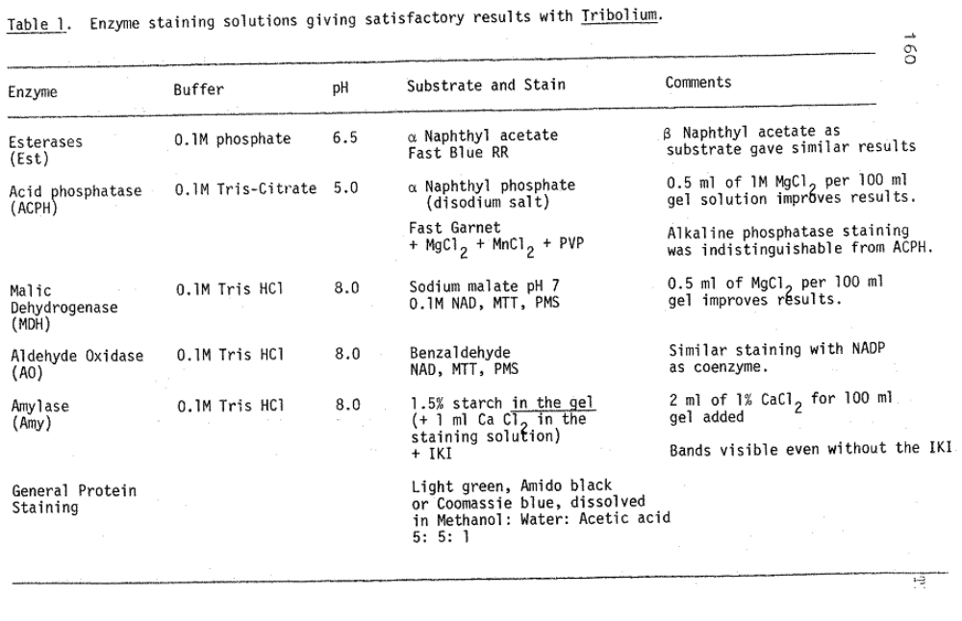

WRIGHT, V.F., HAREIN, P.K. AND DE LAS CASAS, E.
DEPARTMENT OF ENTOMOLOGY, FISHERIES AND WILDLIFE
UNIVERSITY OF MINNESOTA
ST. PAUL, MINNESOTA

* Development and Reproduction of Tribolium confusum on Wheat Media of Different Nutritional Value.

Tribolium confusum is most often reared in whole wheat flour supplemented with 5% brewer’s yeast. This medium is considered optimal. It produces large pupae and adults in a minimum time. A review of the literature concerning yeast supplementation is found in Sokoloff (1974).

In conjunction with our studies on storage fungi and stored-product insects, two kinds of wheat media were used as controls : commercial whole wheat flour and flour from autoclaved whole wheat. Thirty larvae (12 + 12 hrs old) were placed on 5 g of each medium, both with and without the yeast supplement. Data was taken on larval weight after 20 days, pupal weight for each sex, % adult survival and number of progeny from these adults after thirty days. Three replications of 5 pairs of these adults were placed on similar larval media and 5 matching pairs were placed on whole wheat flour and yeast. This transfer of adults from suboptimal to an optimal medium would determine whether the original medium had any permanent effect on the reproductive capabilities of the adults.

Autoclaved wheat has its nutritive value altered by heat, especially because the B vitamins are destroyed. As might be expected, the larval period was prolonged (37-67 days). Larval weights on this medium were drastically reduced (Table 1). Even pupal weights were diminished. But the simple addition of yeast to autoclaved flour gave weights similar to that in the optimal medium. Survival on autoclaved wheat flour was 20% lower than on the other 3 media. Adults, when placed on autoclaved flour, had low numbers of progeny. However, when placed on whole wheat flour and yeast, the number of progeny was the same as on the optimal medium. Autoclaved four plus yeast and whole wheat flour without yeast were also suboptimal media for reproduction. Adults reared in these media but placed in whole wheat flour and yeast showed an increased number of progeny over their peers.

Stock culture adults reared on whole wheat flour and yeast were sexed as pupae and pairs placed on all the above media. Although they were reared on an optimal medium, they produced fewer progeny when on the suboptimal media as adults.

We concluded that the adult food is most important for egg production. What the adults eats affects the number of eggs laid. This was also found to be true by Wright et al. (1976) in a study with toxic metabolites of select fungi. Adult T. confusum had to have a particular toxin in the medium before the number of progeny was affected. Rearing larvae on the sublethal concentration of toxin did not cause reduction in progeny if adults were given an optimal medium. These reproduction responses apparently are not passed to the adults through metamorphosis. Wright et al. (1976) suggested that adults fed a toxic medium were actually eating less and the effects were caused by starvation. Feeding on suboptimal media is also a kind of starvation and similar effects might be expected on reproduction.

Table 1. Life cycle data for T. confusum reared on different wheat media.

Medium | Larval weight at 20 da (mg) | Pupal weight (mg) |  | % Survival | Number of progeny/5 pr after 30 da
Medium | Larval weight at 20 da (mg) | ♀ | ♀ | % Survival | Original medium | wwf + yeast
Whole wheat flour + yeast^{a/} | 3.4 | 3.4 | 3.1 | 93 | 260 | --
Whole wheat flour w/o^{a/} | 3.1 | 3.4 | 2.9 | 94 | 135 | 260
autoclaved flour + yeat^{b/} | 3.0 | 3.5 | 2.9 | 97 | 145 | 180
autoclaved flour w/o^{b/} | 0.2 | 3.2 | 2.6 | 73 | 165 | 230

a/ 18 repetitions of 30 insects each

b/ 9 repetitions of 30 insects each

Literature cited

Sokoloff, A. 1974. The biology of Tribolium. Vol. 2. Oxford at the Clarendon Press.

Wright, V.F., E. De las Casas, and P.K. Harein. 1976. The response of Tribolium confusum to the mycotoxins zearalenone (F-2) and T-2 toxin. Environ. Entomol. 5 : 371-4.

BELL, A.E.
DEPARTMENT OF ANIMAL SCIENCES
PURDUE UNIVERSITY
LAFAYETTE, INDIANA

* On the control of acaroid infestations in Tribolium cultures

Four Tribolium castaneum stocks introduced into our laboratory in 1974 was observed to be heavily infested with small mites, identified as belonging to the family Pymotidae and were most likely Acarophenax tribolii (Cross, 1965).

A similar infestation, described previously by Allen (1967), was brought under control with the acaricide Morestan. The specific treatment recommended was to place the beetles in flour treated with 300 ppm Morestan and cultured at a temperature of 20⁰c. After 10 days the beetles were removed and placed in clean flour to establish a new culture free of mites.

Under our laboratory conditions, most of the beetles exposed to 300 ppm Morestan were dead after 10 days; however, beetles survived 150 ppm morestan and mite free cultures resulted.

Adult beetles from the mite infested cultures were exposed to either of two levels of Morestan (Chemagro Division of Baychem Corp., Box 4913, Kansas City, MO.) in standard medium (95% wheat flour and 5% brewer’s yeast) : (1) 300 ppm by weight, and (2) 150 ppm by weight. The beetles were held in these treated cultures at 24⁰c. 70% relative humidity, for 10 days, removed and placed in a new Morestan treated cultures for another 10 days. After the second 10-day treatment the beetles were removed and placed in sterile standard medium, and cultured at approximately 33⁰c, 70% relative humidity. After 20 days under these optimal conditions each culture was checked for adult survival and reproduction in terms of larvae or pupa.

Nearly all of the adults beetles were dead after 10 days in treated flour containing 300 ppm Morestan. The beetles in 150 ppm Morestan showed some gross manifestations of toxicity (e.g. sluggish and lack of mobility) but most survived the treatment and reproduced satisfactorily. Apparently, all mites were destroyed since the Tribolium stocks have subsequently remained free of mites for three years.

Literature cited

Allen, William W. 1967. Acarophenax tribolii – a parasitoid of Tribolium. T.I.B. 10 : 87-88.

Cross, A.E. 1965. The genetic relationship of the family pyemotidae (Acarina : Trombidiformes). University of Kansas Science Bull. 45 (2) : 275 pp.

NOTES-TECHNICAL

HUBER, I. 1978
DEPT. OF BIOLOGY
FAIRLEIGH DICKINSON UNIVERSITY
MADISON, NEW JERSEY 07940

* Rearing of spider beetles

About five years ago, I was given a small number of spider beetles by a colleague who found tem in the bottom of a sack of rat food. They were living on the powdery portion of the rat chow pellets and I have maintained them on ground-up dog chow pellets (Purina brand) ever since. The rearing chamber in which they are kept is maintained at about 85 deg. F. and the humidity is kept elevated by a furnace type humidifier and an exhaust fan which blows moist air into the room. (The main purpose of the room is as an insectary for cockroach rearing). The beetles are kept in ½ pint milk bottles with about 5 cm. of medium in each. Three or four times per year the beetles were transferred to fresh medium. A stock of these beetles is being sent to Dr. A. Sokoloff to be placed in the Tribolium Stock Center. A sample is also being submitted to Dr. T.J. Spilman for identification.

