TRIBOLIUM INFORMATION BULLETIN

Number 27

July, 1987

Note ……………………………………………………………………………… ii

Acknowledgements ……………………………………………………………. iii

Announcement ………………………………………………………………….. iv

Stock Lists …………………………………………………………………………

Notes-Research …………………………………………………………………..

The linkage relationship and relative position of diminished eye in Tribolium confusum Duval.
Aaron Brownlee and Alexander Sokoloff …………………………………

Biomass selection at different stages of Tribolium castaneum life. M.C.
Fuentes and M.P. Tagarro ……………………………………………….

Effect of maize flour on sex-ratio, formation and duration of various stages of the red flour beetle, Tribolium castaneum (Herbst) (Coleoptera; Tenebrionidae). Muhbub Hasan and M. Khalequzzaman.

Growth of Tribolium anaphe (Coleoptera; Tenebrionidae) on Lathyrus Sativus flour, Mahbub Hasan and Ataur Rahman Khan …………………

Flight ability of Tribolium freemani Hinton.
O. Imura ……………………………………………………………………..

Sexual maturation of Tribolium freemani Hinton.
O. Imura ……………………………………………………………………..

Effectiveness of silica aerogel against the merchant grain beetle, Oryzaephilus mercator Fauvel.
S.R. Loschiavo …………………………………………………………..

Evaporation of carbon tetrachloride-carbon bisulfide grain fumigant through paper and plastic films. S.R. Loschiavo and N.D.G. white ……….

Population biology of Tribolium freemani Hinton (Coleoptera; Tenebrionidae). M. Matsumura and T. Yoshida …………………………

Growth of Tribolium confusum duval larvae (Coleoptera; Tenebrionidae) on barley and rice flours. Abdul Mazid and Ataur Rahman Khan ……….

Linkage group assignment of “antenna bifurcada” (ab). Fernando Nunez and Indiana Bustos ……………………………………………

“Ojo blanco” (obl), a new marker gene for linkage group IV in Tribolium castaneum. Fernando Nunez ……………………………………..

Autoclaving of beans (Phaseolus vulgaris) to improve their nutritive value for Tribolium larvae. Wen Flora Pao, Pran Vohra and F.H. Kratzer ………….

Phenotypic differentiation of Tribolium castaneum Hbst. cI strain. Tadensa Prus and Miroslawa Prus …………………………………….

A search for incompatibility strains in T. castaneum. A. Sokoloff, L. Shimeld and P. O’Neal. …………………………………………………..

Notes-Technical ………………………………………………………………..

Fabrication of sieve frame for collecting Tribolium. Peter Backer, Joe Borelli and Pran Vohra. ……………………………………………….

A simple, economical, and escape-proof plastic device to detect insects in stored grain.
Dr. F. Madrid and S.R. Loschiavo ……………………………………..

Notes-Research

Brownlee, Aaron and Alexander okoloff
Biology Department
California State University
San Bernardino, California – 92407

THE LINKAGE RELATIONSHIP AND RELATIVE POSITION OF DIMINISHED EYE IN TRIBOLIUM CONFUSUM DUVAL

Recently, five mutant markers (pearl (p), bleck (b), thumbed (thu), ebony (e) and dijoined (dj) were used to determine the linkage relationship of diminished eye (de) in T. confusum. Diminished eye was discovered in 1972 and reported by Blackman in TIB # 22 (p. 60, 1982). The de mutant resembles the Bar eye (Be) mutant in T. castaneum (Herbst), in that the facet area of the eye is smooth and slit-like. The de trait also appears as a normal eye reduced in size. A description of p, b, thu, e, dj and Be can be found in Sokoloff, 1977.

Diminished eye is linked with pearl on chromosome # 2. Diminished eye and pearl are approximately 31.23 + 1.5 units apart in heterozygous ♂♂and 38.48 + 3.3 units) apart in heterozygous ♀♀ Testcross results can be seen in Table 1. The calculated Chi Square values are X_{L} = 127.26 for the heterozygous ♂and X_{L} = 11.77 for heterozygous ♀

Three point crosses involving de are being carried out and will be reported at a later date.

REFERENCES

- Blackman, D.G. 1982. Section on New Mutants. Tribolium information Bulletin 22 : 80.

- Sokoloff, A. 1977. The Genetics of Tribolium and Related Species. Advances in Genetics, Academics Press, New York.

TABLE 1.
Backcross progeny from T. confusum (A) de +/+ p ♀ x de pl de p ♂ and (B) the reciprocal cross from 15 successful matings (numbers in parenthisis are decimal fractions of the Total)

Phenotye | Cross
Phenotye | A | B
+ + | 26 (0.264) | 158 (0.175)
+ p | 155 (0.470) | 388 (.430)
de + | 49 (0.148) | 233 (0.256)
de p | 39 (0.118) | 124 (0.137)
Total | 330 | 903

Biomass Selection at Different Stages of Tribolium castaneum life.

M.C. Fuentes and M.P. Tagarro
Departmento de Genetica. INIA, Madrid.

For the question of biomass selection, a character associated to a series of fitness characters, such as fecundity, fertility, precocity, etc, several studies have been undertaken focused on comparing different selection methods which maximized the response to selection. Thus FAIRFULL et. al. (1977) compares quadratic indices, lines indices, direct biomass selection, offspring number selection and body weight selection measured at pupal stage, DOOLITLE et. al. (1972) studies the mater with nice; offspring number, new-born weight, etc, comparing also different selection methods.

The purpose of the present investigation is to see in which moment of the life of an organism a greater response is obtained when selecting for biomass; whether it’s at an early, medium or advanced stage. Therefore two experiments were carried out. In the first one Tribolium castaneum at larva state, line (L), was selected for biomass; seeing the obtained results another experiment was programmed for which 3 lines were made. For line (5L) biomass was selected at a larva stage after applying an stabilizing selection regarding body weight, taking 50-60% of the population around the average; line (P) was selected for biomass at pupal stage and line (A) selected for biomass at adult stage.

The reason for creating line (5L) is because of the relative small response to selection obtained in line (L) which seemed to be produced by selecting indistinctly very heavy larvas from small offspring number families and lighter larvas from greater offspring number families and therefore body size could drive the total biomass to oscillations if both extremes were mated; that’s why we tried to remove extremes weights in order to get a greater answer.

Experiment (1) was carried out with line “consejo” which has been “in paralxia” for 25 years in our laboratory and experiment (2) with “Jerez” line which has been “paralxia” for 5 years in our lab too.
In both experiments 24 hrs. offspring was collected, biomass weight of larvas was measured 13 days after coupling, lines (L) and (5L), at pupal stage we measured biomass weight 21 days after coupling, line (P) and at adult stage we did it 32 days after. In all of lines, the offspring number was controlled too.
Population size was of 132 couples for experiment (1) and of 100 for experiment (2). Selection Pressure was 223. Environment conditions were : 33 + 0.5⁰c and 20 + 2% Hr. For both experiments 7 generations for selection and two identical repetitions tion-spaced were done.

Figure (1) gives you obtained responses for which generations averages of each line have been shown, average is been calculated for both repetitions too.

In main terms we can say “jerez” population has more weight than “conejo” one and the line which seems to have greater response is line (P). To study the average response per generation regression line for responses within generations was calculated, the values obtained are shown in Table 1.

TABLE 1 : Intercept and regression coefficients with its standard deviation and the weight gained with regards to initial weight percentage.

POPULATION | INTERCEPT | REGRESSION C. | ST. DEVIATION | % GAIN / GENERATION
Consejo (l) | 33.05 | 0.98 + | 0.31 | 3%
Jerez (SL) | 29.18 | 0.33 | 0.55 | 1%
Jerez (P) | 29.14 | 2.18 ** | 0.57 | 7%
Jerez (A) | 23.24 | 1.21 * | 0.44 | 5%

+ Significant at 10% level
* Significant at 5% level
** Significant at 1% level

The results show that the line which proportionally gains more weight due to selection is line (P). On the other hand line (5L) selected to increase larva weight after carrying out an stabilizing selection for body weight has shown a much worse response than line (L) for which selection was not carried out.

In Table 2, we show heritabilities obtained by regression to the parents mean and carried out heritabilities, taken as regression the response in the accumulated differential of selection.

Table 2 : Heritability estimates obtained by offspring / parents regression and the realized one.

POPULATION | h² REGRESSION | h² REALIZED
Consejo (L) | 0.22 + 0.09 | 0.10 + 0.05 +
Jerez (5L) | 0.18 + 0.08 | 0.05 + 0.08
Jerez (P) | 0.29 + 0.08 * | 0.18 + 0.05 *
Jerez (A) | 0.13 + 0.09 | 0.11 + 0.04 *

+ Significant at 10% level
* Significant at 3% level

At the same time correlated response for the character offspring number was studied, results are shown on Figure 2.

Average increase for offspring / fanlly character was calculated by generation means regression , which are sown on Table 3.

Table 3 : Intercepts, regression coefficients and standard errors for offspring number per family character.

POPULATION | INTERCEPT | REGR. COEFFICIENT | STAND. ERROR | GAIN %
Consejo (L) | 13.48 | 0.42 | 0.23 | 3%
Jerez (5L) | 14.09 | 0.20 | 0.19 | 1%
Jerez (P) | 13.93 | 0.65 * | 0.23 | 5%
Jerez (A) | 12.63 | 0.38 | 0.22 | 3%

* Significant at 3% level

These values indicate that there has been some response correlated to offspring number and the line with the greater response is pupal biomass selected line.

These results demonstrate that a better response to selection is obtained when it is applied at pupal stage, followed by selection applied at adult stage and the least response comes from selection applied at larva stage. If we think about the bigger influence of environment and maternal factors, which decrease heritability, we come to the conclusion that our results are reasonable. On the other hand the previous stabilizing selection didn’t help to improve response to selection at larva stage, probably due to the decrease in genetic and phenotypic variance that the stabilizing selection produces as Robertson (1956), Tantawy and Tayel (1978), Bulmer (1976), Soliman (1982), etc. have reported.

Correlated response to offspring number is also bigger when biomass is selected at pupal stage than at the rest of stages. In this case is also self-defeating the stabilizing selection.

All of these leads us to believe that in spite of the difficulty that selection for such a complex trait as biomass raise, a 7% gain per generation over initial weight can be obtained making the selection at pupal stage, which is very acceptable response and which supports Fairfull et. al. (1977) results who found that direct selection of pupal biomass had as good an answer as that of a quadratic index that included offspring number and pupal body weight, therefore we deduce that for the calculus complexity it takes is not worth it to apply an index for such selection.

Figure 1 : Biomass means in each generation for lines L, 5L, P and A.
Also both replications mean.
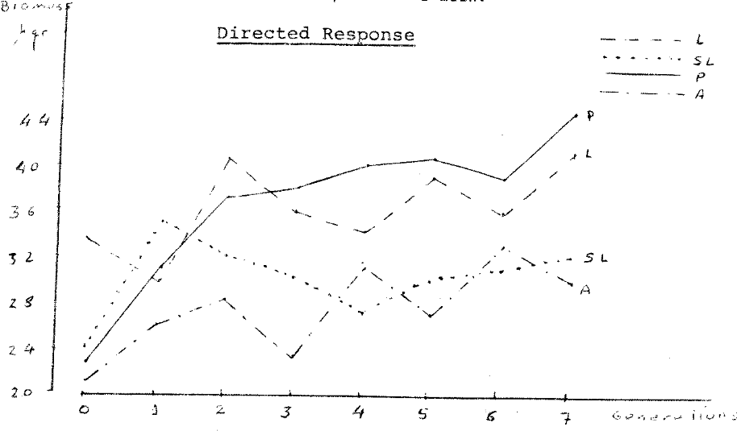

Figure 2 : Offspring number means in each generation for lines L, 5L, P
and A. Also both replication mean.

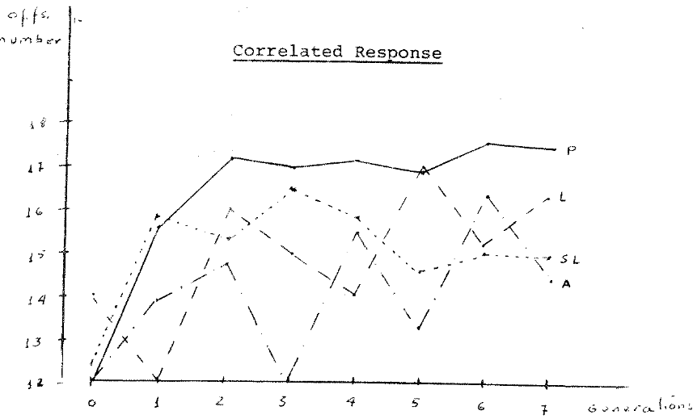
BIBLIOGRAPHY

BULMER, M.G. 1976 -- The effect of selection on genetic variability; a simulation study. Genetic. Res. Camb : 101-117.

DOOLITLE, D.P., WILSON, S.P. AND L.L. HUSERT, 1972 – A comparison of multiple trait selection, methods in the mouse. Jour. Hered. 63 : 366-372.

FAIRFULL, R.W., FRIARS, G.W. AND J.W. MILTON, 1977 – An empirical comparison of selection methods for the improvement of biomass. Theor. Appl. Genet. 50 : 193-198.

ROBERTSON, A., 1956. – The effect of selection against extreme deviants based on deviator or an homozygosis. J. Genet. 54 : 236-248.

SOLIMAN, M.M., 1982. -- Bidiretional and stabilizing selection for developmental time and correlated response in reproductive fitness in Tribolium castaneum. Tineor. Appl. Genet. 63 : 111-116.

TANTAWY, A.O. AND A.A. TAYEL, 1978. – Studies on natural populations of Drosophila, X. Effects of disruptive and stabilizing selection on wing length and the correlated response in D. meianogaster. Genetics 63 : 121-132.

Mahbub Hasan and M. Khalequzzaman
Department of Zoology,
Rajshahi University,
Rajshahi, Bangladesh.

* Effect of Maize flour on the sex-ratio, formation and duration of various stages of the red flour beetle, Tribolium castaneum (Herbst) (Coleoptera: Tenebrionidae)

The red flour beetle, Tribolium castaneum is widely distributed all over the globe and is found on almost every kind of stored products, especially cereals and their products. Maize has good status among the cereal crops. It ranks after wheat and rice as the third most important food in the world. It is used directly as food for human consumption and as a feed grain for animals. Maize contains 77% starch; 2% sugar; 9% protein; 5% fat; 5% pentosan and 2% ash (Purseglove, 1972).

In nature most animals give birth to equal numbers of males and females following the typical Mendelian sex-ratio of 1:1. Sex-ratios influence the number of offspring of animals and play an important role in the maintenance of species. However, some organisms show considerable distortion of the typical sex-ratio. The environment has been found to control sex-ratios in a number of invertebrates (Banta & Brown, 1929 a, b; Chistie, 1929; Clausen, 1939; Flanders, 1939; Ellenby, 1954; Mackauer, 1976 and Khan and Bhuiyan, 1983). It is well known that survival rates and developmental periods affect the intrinsic rate of increase of pests. The rate of infestation due to a pest is directly linked with its sex-ratio and offspring production. As a stored product maize flour is attacked with a number of insect pests. The present work aims at finding out the effect of maize flour on the production of sex as well as its bearing on the formation and durations of various stages of T. castaneum.

The insects were originally received from the Pest Infestation Control Laboratory, Slough, England. The beetles have been cultured for about one year in the Dept. of Zoology, Rajshahi University. About 800 beetles were collected from the culture and placed on a thin layer of wholemeal flour previously passed through a 60-mesh sieve in a deep Petri dish (9.5 cm diameter). On the next day the contents were passed through a 18-mesh sieve to separate the adults and then through a 60-mesh sieve to collect the eggs. The eggs were placed in a Petri dish (9 cm diameter) and incubated at 30⁰c. Neonate larvae 200 for each food were transferred to glass jars (25.40 x 11.43 cms) containing 200 gm of wholemeal flour (control); maize flour and a mixture of both in equal proportions with the aid of a sable hair brush. The jars were secured with fine cloth. Larvae were checked at intervals for pupation. Pupae were sexed by microscopic examination for the exogenital processes of the female pupae (Halstead, 1963). The larval period was recorded, sexed pupae were put on separate Petri dishes for adult emergence. The pupal period was then recorded. All the experiments were conducted at 30⁰c.

1. Address for correspondence

Maize flour produced no significant effect on the sex-ratios of T. castaneum. This flour significantly reduced the production of adults (P<0.001) (Table-1). The same results were obtained by Khan and Bhuiyan (1983) working on the effect of gram, pea and red lentil flours on T. confusum. Moreover, maise flour lengthened both larval and pupal periods of the beetle significantly (P<0.001) (Table-2). A lengthened larval period was also noted by Khan and Bhuiyan (1983). Sokoloff et. al. (1966) tested flours of maize (C), rice (R), soyabean (S), whole wheat (W), a mixture of maize, rice soyabean and whole wheat (M), white wheat (WW) and brown rice (BR) with and without a supplement of brewer’s yeast and observed that with T. castaneum and T. confusum, the ranking of productivity in decreasing order was M, W, C, BR, R, WW and S. But the performance on all media was somewhat increased by the addition of yeast.

Geier (1966) states that one way to control insect pests is to modify intrinsically favourable habitats in such a way that they no longer provide adequate environments for the population of the pest involved, e.g. by providing unsuitable sources of food. The significantly lowered production of T. castaneum adults on the maize flour will eventually reduce the rate of infestation due to curtailed feeding and reproduction. In addition, higher larval and pupal periods of the insect on maize flour will evidently lower the number of generations per year and this will consequently reduce the rate of infestation. These results seem very much promising in days when there is a growing concern over the control of nutritionally.

The authors express sincere thanks to the Chairman, Department of Zoology, Rajshahi University, for providing necessary laboratory facilities.

Literature Cited :

Banta, A.M. and Brown, L.A. 1929a. Control of sex in Cladocera. I. Crowding the mothers as a means of controlling male production. Physicl. Zool. 2 : 80-92

Banta, A.M. and Brown, L.A. 1929b. Control of sex in Cladocera. III. Localization of the critical period for control of sex. Proc. Natn. Acad. Sci. U.S.A. 15 : 71-81.

Chistie, J.R. 1929. Some observations on sex in the Mermithidae, J. exp. Zool. 53 : 59-76.

Clausen, C.P. 1939. The effect of host size upon the sex-ratio of hymen-opeterous parasites and its relation to methods of rearing and colonization. J.N.Y. Ent. Soc. 47 : 1-9.

Ellenby, C. 1954. Environmental determination of sex-ratio of plant parasite nematode, Nature. London. 174 : 1016-1017.

Flanders, S.E. 1939. Environmental control of sex in hymenopterous insects Ann. Ent. Soc. AM. 32 : 11-26.

Geier, P.W. 1966. Management of insect pests. Ann. Rev. Ent. 11 : 471-490.

Halstead, D.G.H. 1963. External sex differences in stored-products Coleoptera. Bull. Ent. Res. 54 : 119-134.

Khan, A.R. and Bhuiyan, A.R. 1983. Effect of foods on sex-ratios of the flour beetle, Tribolium confusum. Entomologia exp. Appl. 34 (1) : 126.

Machuer, M. 1976. An upper boundry for the sex-ratio in a haplodiploid insect. Can. Ent. 1399-1402.

Purseglove, J.W. 1972. Tropical Cross Monocotyledons. Longman Gr. Ltd. London. pp. 316.

Sokoloff, A.; Franklin, I.R.; Overton, L.R. and HO, F.K. 1966. Comparative studies with Tribolium (Coleoptera : Tenebrionidae) – I : Productivity of T. castaneum (Herbst) and T. confusum Duv. on several commercially available diets. J. Stored Prod. Res. 1 : 295-311.

Table – 1

Effect of maize flour on the sex-ratio and formation of various
stages of T. castaneum.

Foods | No. of larvae | No. of male pupae obtd. (percentage) | No. of female pupae obtd. (percentage) | Total pupae obtd. (percentage) | t-val. | Total adults obtd. (percentage) | d-val.
a. Whole-meal flour (control) | 200 | 103 (57.22) | 77 (42.78) | 180 (90.00) | 1.96 | 175 (87.50) | --
b. Maize flour | 200 | 76 (51.01) | 73 (48.99) | 149 (74.50) | 0.25 | 143 (71.50) | 4.00
c. Mixture of whole-meal maize flours | 200 | 85 (53.46) | 74 (46.54) | 159 (79.50) | 0.87 | 155 (77.50) | 2.50

Table – 2

Effect of maize flour on the larval and pupal periods of T. castaneum.

Foods | Larval period (day) |  |  |  |  | pupal period (day)
Foods | No. of obs. | Mean + SD | 95% conf. limits |  | * CV% | No. of obs. | Mean + SD | 95% conf. limits |  | * CV%
Foods | No. of obs. | Mean + SD | Lower | Upper | * CV% | No. of obs. | Mean + SD | Lower | Upper | * CV%
Whole-meal flour (control) | 180 | 17.69 + 1.42 | 17.48 | 17.90 | 8.03 | 175 | 5.19 + 0.37 | 5.13 | 5.25 | 7.13
Maize flour | 149 | 19.82 + 1.90 | 19.51 | 20.13 | 9.59 | 143 | 6.28 + 0.61 | 6.18 | 6.38 | 9.71
Mixture of Whole-meal + maize flour | 159 | 18.00 + 2.07 | 17.69 | 18.31 | 11.50 | 155 | 5.45 + 0.49 | 5.37 | 5.53 | 8.99

* CV – coefficient variance.

Mahbub Hasan and Ataur Rahman Khana
Department of Zoology
Rajshahi University,
Rajshahi, Bangladesh.

** Growth of Tribolium anaphe (Coleoptera : Tenebrionidae) an Lathyrus sativus flour.

Tribolium anaphe is an Ethiopean beetle originally found in Africa infesting groundnuts and Hinton (1948) considered it to be a potential pest of stored commodities in the tropics.

In many parts of the world the flour of the pulse; Lathyrus sativus is taken as an important ingredient of diet and is liable to the attack of insects. This pulse contains a neurotoxin, β – N – axalyl – aming – l – alanine, which is responsible for a serious disease of the spinal cord called lathyrism in man and livestock when more than 50% the diet contains this pulse. One way to control insect pests is to modify intrinsically favourable habitats in such a way that they no longer provide adequate environments for the pest population involved, e.g. by providing unsuitable sources of food (Geier, 1966). The present investigation is an attempt to determine the effect of L. sativus flour on T. anaphe.

A large number of beetles (T. anaphe) were collected from a culture maintained at the Department of Zoology, Rajshahi University, Bangladesh and were put on a thin layer of wholemeal flour previously passed through a fine sieve. Eggs, collected on the following day, were incubated 30⁰c for hatching. Neonate larvae (150 for each food medium) were transferred to jars (25.4 x 11.4 cms) containing 100 gm of wholemeal (control) and L. antivus flours each with the aid of a sable hair brush. The mouths of the jars were secured with a fine, netted cloth tied with a rubber band. The growth of T. anaphe larvae was determined at two stages : after 10 day and after attaining maturity. The weight of various stages was taken on an electric balance, the length with the aid of a scale and the headcapsule width using a micrometer (40x). Insects were carefully checked for pupation. Freshly formed pupae were cleaned and the percentage of pupation recorded. They were now transferred to separate Petri dishes for adult emergence. The percentage of adult recovery was noted and the pupal period determined. All the experiments were conducted at 30⁰c.

L. sativus significantly reduced mature larval, pupal and adult weight, headcapsule width and body length (P<0.05) (Table-1). This pulse flour significantly increased the larval and pupal periods of the beetle (P<0.001) (Table-2). L. sativus flour produced no significant distortion of the typical Mendelian sex-ratio of 1:1 in T. anaphe. However, this flour significantly reduced adult recovery (d=4.13, P<0.001) (Table-3).

Recently there is a growing concern over pest control through nutritional regulations. Pratt et.al. (1972) gave a comprehensive review and a prospectus of pest control programmes based on nutritional principles. The significantly reduced recovery of T. anaphe adults on L. sativus flour will eventually reduce the rate of infestation due to curtailed feeding and reproduction. Besides increased larval and pupal periods of this beetle will lower the number of generations per year which will consequently reduce the rate of infestation. All these seem very much promising from the point of nutritional regulation of the pest.

Thanks are due to the Pest Infestation Control Laboratory, Slough, England, for supplying the beetled used in this investigation. The authors remain grateful to Dr. M. Sayedur Rahman, Chairman, Department of Zoology, Rajshahi University, Bangladesh, for providing necessary laboratory facilities.

Literature Cited

Geier, P.W. 1966. Management of insect pests. Ann. Rev. Ent. 11 : 471-490

Halstead, D.G.H. 1963. External sex differences in stored-products Coleoptera. Bull. ent. Res. 54 : 119-134.

Hinton, H.E. 1948. Bull. ent. Res. 39 : 13-55.

Pratt, J.J. Jr.; House, H.L. and Mansingh, A. 1972. Insect control strategies based on nutritional principles : a prospectus. In : “Insect and mite nutrition”, pp. 651-658. North – Holland, Amsterdam.

Table-1
Effect of L. sativus flour on the growth of T. anaphe.

Foods | No. of obs. | Mean weight + SD (mg) | Mean headcapsule + SD (mm) | Mean length + SD (mm)
Wholemeal flour | 30 | 0.39 + 0.09 | 0.27 + 0.04 | 2.68 + 0.46
(A)
L. sativus flour | 30 | 0.23 + 0.05 | 0.19 + 0.09 | 2.09 + 0.32
Wholemeal flour | 30 | 5.16 + 0.47 | 0.77 + 0.05 | 6.50 + 0.22
(B)
L. sativus flour | 30 | 2.93 + 0.34 | 0.63 + 0.06 | 5.47 + 0.26
Wholemeal ♂ flour♀ | 30 | 4.76 + 0.51  5.04 + 0.47 | 0.83 + 0.07  0.86 + 0.04 | 5.35 + 0.25  5.61 + 0.32
(C)
L. sativus ♂  flour ♀ | 30 | 1.98 + 0.26  2.16 + 0.29 | 0.71 + 0.05  0.72 + 0.04 | 4.85 + 0.34  4.92 + 0.22
Wholemeal ♂  flour ♀ | 30 | 3.39 + 0.38  3.64 + 0.31 | 0.86 + 0.07  0.89 + 0.06 | 5.17 + 0.26  5.47 + 0.89
(D)
L. sativus ♂  flour ♀ | 30 | 1.76 + 0.42  1.99 + 0.39 | 0.75 + 0.05  0.79 + 0.04 | 4.32 + 0.38  4.61 + 0.39

A – 10 day larvae; B – Mature larvae; C – Pupae and D – Adult.
Table-2

Effect of L. sativus flour on the larval and
pupal periods (days) of Tribolium anaphe.

Foods | Larval period (day) |  |  |  |  | pupal period (day)
Foods | No. of obs. | Mean + SD | 95% conf. limits |  | * CV% | No. of obs. | Mean + SD | 95% conf. limits |  | * CV%
Foods | No. of obs. | Mean + SD | Lower | Upper | * CV% | No. of obs. | Mean + SD | Lower | Upper | * CV%
Whole-meal flour | 131 | 20.17 + 1.20 | 19.97 | 20.37 | 5.95 | 120 | 6.07 + 0.57 | 5.97 | 6.17 | 9.39
L. sativus flour | 99 | 38.15 + 3.69 | 37.42 | 38.88 | 9.67 | 86 | 7.21 + 0.69 | 7.07 | 7.35 | 9.57

C.V.* - coefficient of variance

Table-3
Effect of L. sativus flour on the sex ratio and formation
of various stages of T. anaphe.

Foods | No. of larvae | % male | % female | X² - values | % pupae | % adults | d-value
whole-meal flour | 150 | 45.80 | 54.20 | 0.70 | 87.33 | 80.00 | 4.13
L. sativus flour | 150 | 56.57 | 43.43 | 1.73 | 66.00 | 57.33 | 4.13

IMURA, O.
STORED-PRODUCT ENTOMOLOGY LABORATORY
NATIONAL FOOD RESEARCH INSTITUTE
YATABE, TSUKUBA
305 JAPAN.

* Flight ability of Tribolium freemani Hinton.

Flight ability is an important trait of insect species, especially in relation to their dispersion. Among Tribolium species, T. castaneum flies (Good, 1936) and T. confusum (Good, 1936) and T. brevicornis (Mulder & Sokoloff, 1982) do not. The present study aims at determining the flight ability of T. freemani at an experimental condition.

Clear plastic boxes (30 cm x 30 cm x 30 cm) which has a shelf of stainless steel wire lattice held 15 cm above the bottom of the box were used as a flying chamber. Ten glass Petri dishes (5.5 cm dia. by 2 cm deep) were placed on the shelf of each box. In each Petri dish, a filter paper (5.5 cm. dia) was placed and a 50-100 days old virgin female or male was placed on it. Ten gram wheat feed in a glass dish (12 cm. dia by 2.5 cm deep) was placed on the bottom of the box as an attractant. The boxes were examined daily and the number of adults on the bottom of the box and the wheat feed dish was recorded. When the petri dish became empty owing to the adult flight, a substitutional individual was placed in it. Since the adults can not crawl up on the glass wall, any adult found on the bottom and the wheat feed dish was considered to have flown. The experiments were carried out for 7 days in a dark or a lightened room at 30 + 0.5⁰c and 70 + 10% r.h. There were 6 replications for each sex and light condition and nonparametric Mann-Whitney’s U-test was employed on the results (Sokal & Rohlf, 1963).

Table 1. Incidence of flying in dark and lightened conditions in Tribolium freemani.

Light condition | Adult sex | No. of adults scored * | Probability of flight / day / individual
Light condition | Adult sex | No. of adults scored * | X + s.d.
Dark | Female | 4 | 0.0143 | 0.0128
 | Male | 1 | 0.0024 | 0.0058
Lightened | Female | 7 | 0.0167 | 0.0021
 | Male | 2 | 0.0048 | 0.0117
Pooled | Female | 11 | 0.0155 | 0.0167
 | Male | 3 | 0.0036 | 0.0089

* Total number of adults which made a flight in 6 replications.

The results indicate that both female and male can fly but their inclination for flying is not strong (Table 1). Although mean probabilities of flight / day / individual for females and those of the lightened condition were larger than those for males and those of the dark condition, respectively, the differences in observations between the groups were not significant (P>0.05). However, when data of both dark and lightened conditions were pooled, the probability of flight for females was significantly larger than that for males (P<0.05), indicating that females were more inclinable to flying than males.

Although there is no observation for flight ability of T. castaneum which is directly comparable with that of T. freemani, the propensity for flight of the latter seems lower than that of laboratory strains of the former. Dawson (1977) stated that “natural” population of T. castaneum seldom fly. If so then the lower propensity for flight in T. freemani might be partly due to the fact that this species is a less domesticated one. However, I actually observed that once adults of T. freemani flew off they could fly well. Ziegler (1978) inferred that T. castaneum, which can fly well, is better suited to locate and exploit widely dispersed temporal habitats than T. confusum, which lacks flight ability. Since the growth and reproduction rates of T. freemani are much reduced under crowded conditions (Nakakita, 1982; Imura, unpublished), the flight ability for dispersion may have a significant role in the life of T. freemani to avoid sib condition.

References

Dawson, P.S. 1977. Life history strategy and evolutionary history of Tribolium flour beetles. Evolution 31 : 226-228.

Good, N.E. 1936. The flour beetles of the genus Tribolium.
U.S.D.A. Tech Bull. 498 : 1-57.

Mulder, G. and Sokoloff, A. 1982. Observations on the population of Tribolium brevicornis Le Conte (Coleoptera, Tenebrionidae). III. Preliminary comparisons between feral and domesticated populations. J. Adv. Zool. 3 : 33-45.

Nakakita, H. 1982. Effect of larval density on pupation of Tribolium freemani Hinton (Coleoptera: Tenebrionidae). Appl. Ent. Zool. 17 : 269-276.

Sokal, R.R. and Rohlf, F.J. 1969. Introduction to biostatistics. Freeman and company, San Francisco.

Ziegler, J.R. 1978. Dispersal and reproduction in Tribolium: the influence of initial density. Environ. Entomol. 7 : 149-156.

IMURA, O.
STORED-PRODUCT ENTOMOLOGY LABORATORY
NATIONAL FOOD RESEARCH INSTITUTE
YATABE, TSUKUBA,
305 JAPAN.

* Sexual maturation of Tribolium freemani Hinton.

Insects require a period for sexual maturation after adult eclosion, which differs depending on the species and environmental conditions. The time of onset of sexual maturity may also reflect the life history of the insect species. Dick (1937) reported that oviposition commenced about 8 days after adult eclosion in Tribolium confusum. Erdman (1962, 1964) found that male of T. confusum and Tribolium castaneum were fertile within 24 and 48 hours, respectively, whereas females of T. confusum and T. castaneum were not fertile before the day 6 and 4, respectively. Dawson (1964) carried out more precise experiments and confirmed that T. confusum female could be fertilized in 17-20 hours and lay viable eggs 114-126 hours after adult eclosion, whereas T. castaneum females could be fertilized in 0-3 hours and lay fertile eggs 96-108 hours after adult eclosion. The average pre-oviposition period in Tribolium destructor was 16 days (Reynolds, 1944). This preliminary study was undertaken to elucidate the sexual maturation of T. freemani adults.

T. freemani pupae were sexed and maintained separately to obtain virgin adults. Twenty five virgin female and male adults eclosed within 24 hours were mated individually to 40-60 days old virgin adults of opposite sex. Eggs laid by each pair were collected daily and viability of the eggs was examined on a double-sided sticky tape (Imura & Nakakita, 1984). Oviposition and viability of eggs for another group of 25 virgin adult females of 40-60 days old which were not allowed to mate were examined daily for 5 days. All examinations were carried out using glass vials (2 cm diam. by 7.5 cm deep), each containing 500 mg of a medium (a mixture of wheat flour and brewer’s yeast in a ratio of 19:1 parts by weight) in a dark room at 30 + 0.5⁰c and 70 + 10% r.h.

The virgin adult females of 40-60 days old laid eggs without insemination (average daily egg product per female was 1.8 + 1.9 (s.d.)), but none of 222 eggs laid did not hatch. In the newly eclosed female adults mated to the aged-males, the first female laid a viable egg on day 8 and 92% of females initiated laying viable eggs by the day 19, however two females were never fertilized during the whole experimental period of 31 days (Fig.1). The mean age of initiation of viable egg laying in the newly eclosed females was 12.5 + 2.2 days, excluding the two unfertilized females. On the other hand, the first aged-female mated to the newly eclosed male was fertilized on the second day and by day 14, 100% of the females was fertilized by the new males (Fig.1). The mean age of fertilization by the newly eclosed males was 6.7 + 2.4 days.

Notes-Research

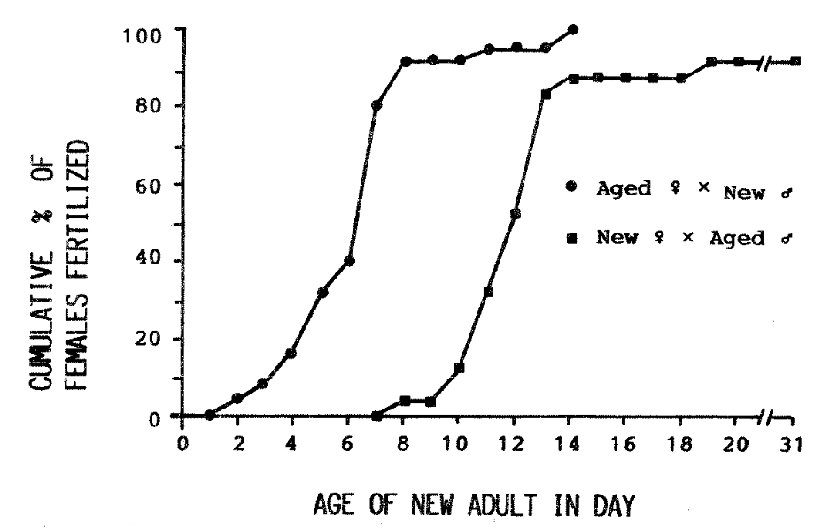

Fig.1. Cummulative percentage of females which laid viable eggs in pairs of different female x male age combinations of Tribolium freemani.

The results indicate that T. freemani females take longer time for sexual maturation than T. castaneum and T. confusum (Dawson, 1964) and probably mature sexually earlier than T. destructor (Reynolds, 1944). The onset of sexual maturity of T. freemani males was similar to that of T. castaneum (Erdman, 1964). Such precedence of sexual maturity in males is commonly observed in many insect species (Ross, 1965). The sperm transferred in later copulations predominated in the fertilization of eggs over sperm already in the spermatheca in T. castaneum (Schlager, 1960). If this phenomenon is common in Tribolium species, then the early sexual maturity and repeated matings in males would be advantageous for their reproductive success. On the other hand, the high cost of producing female gametes may retard the sexual maturity with migration (Dingle, 1972). Environmental conditions such as temperature (Erdman, 1964) and food quality (Reynolds, 1944) affect the sexual maturation of Tribolium species.

References

Dawson, P.S. 1964. Age at sexual maturity on female flour beetles, Tribolium castaneum and T. confusum. Ann. Entomol. Soc. Amer. 57 : 1-3.

Dick, J. 1937. Oviposition in certain Coleoptera. Ann. Appl. Biol. 24 : 762-796.

Dingle, H. 1972. Migration strategies of insects. Science 175 : 1327-1335.

Erdman, H.E. 1962. Beginning of reproduction determined by age of the female flour beetle, Tribolium confusum (Coleoptera: Tenebrionidae). Naturwissenschaften 49 : 428.

Erdman, H.E. 1964. Sexual precocity of the male flour beetle, Tribolium castaneum Hetbst, and the influence of temperatures on reproduction during early adult life. Can. Ent. 96 : 656-659.

Imura, O. and Nakakita, H. 1984. The effect of temperature and relative humidity on the development of Tribolium freemani Hinton (Coleoptera: Tenebrionidae). J. stored Prod. Res. 20 : 87-95.

Reynolds, J.M. 1944. The biology of Tribolium destructor Uytt. I. Some effects of fertilization and food factors on fecundity and fertility. Ann. Appl. Biol. 31 : 132-142.

Ross, H.H. 1965. A textbook of entomology. John Wiley and Sons, Inc., New York.

Schlager, G. 1960. Sperm precedence in the fertilization of eggs in Tribolium castaneum. Ann. Entomol. Soc. Amer. 53 : 557-560.

Effectiveness of Silica aerogel against the merchant grain beetle, Oryzaephilus mercator Fauvel.

S.R. Loschiavo
Agriculture Research Station
195 Dafoe Road
Winnipeg, Manitoba, Canada
R3T 2M9

1. Silica aerogel was highly effective against adults of the merchant grain beetle, Oryzaephilus mercator Fauvel exposed for as short a time as 5 sec, even when passed through an air stream after exposure. Those rinsed in water or provided with food after exposure had a high rate of survival.
This material, applied by an environmentally safe method, was found effective against this species even on deposits up to 42 days old. It was effective also against adults of the confused flour beetle for at least 35 days but only after a 24-hr exposure to the heavier of two concentrations used.

Evaporation of a carbon tetrachloride-carbon bisulfide grain fumigant through paper and plastic films

S.R. Loschiavo and N.D.G. White
Agriculture Research Station
195 Dafoe Road
Winnipeg, Manitoda, Canada
R3T 2M9

2. Several materials used to hold gas inside bagged commodities or to seal cracks in windows and doors of buildings during fumigation were tested to determine their retention of an 80:20 carbon tetrachloride : carbon bisulfide mixture. The loss through kraft paper up to 5 plies in thickness ranged from 78 to 95% in 3 days. The loss through 1, 2 and 5 plies of kraft paper gum-tape was about 40, 21, and 11%, respectively, during the same period. The 3-day loss through 2, 4, and 6 mil plastic was 15, 11, and 9% respectively, and through Saran wrap (Dow Chemical, Toronto, Ontario), 3#. Saran wrap was the thinnest, (30 microns) and the most effective material. Commercial pest control operators would probably obtain better results if they used plastic materials instead of gummed kraft paper for sealing cracks and holes prior to fumigating large installations.

Matsumura, M. and Yoshida, T.
Laboratory of Applied Entomology
College of Agriculture
Okayama University
Okayama 700
Japan

* Population biology of Tribolium freemani Hinton (colleoptera: Tenebrionidae)

The Kashmir flour beetle, Tribolium freemani Hinton was described by Hinton (1948) from a single adult female specimen which was captured in 1890’s at Hispar in Kashmir, India. After an absence of about nine decades, the species was rediscovered in 1978 in Japan (Nakakita et al, 1981), and some biological characteristics have been studies by the several authors (Nakakita et al, 1981; Nakakita, 1982; Imura et al, 1982; Imura and Nakakita, 1984).

In the present note the population biology, adult survivorship (l_{x} curve) and age specific fecundity (m_{x} curve), was determined for Tribolium freemani.

The experiments were carried out in a darkened incubator maintained at 30⁰c and 70-80% R.H. using the vials, 5-0 mm height and 25 mm in diameter. Each pair of the beetle was placed in the vial with 5 gm of whole wheat flour supplemented with 5% dried yeast. The food was renewed every day. The survivorship of adult was observed and the number of eggs deposited was counted every day.

Fig. 1 shows the survivorship curve and the age-specific fecundity. Table 1 shows the population parameters of the beetle. Mean adult longevity of the beetle was extremely long; over 500 days. Males lived longer than females. The pre-oviposition period was relatively long and the average number of eggs deposited per female per day was relatively small. The reproductive ability was relatively low; the value of the intrinsic rate of natural increase (r_{m}) was 0.048 per day.

Table 1. Population parameters of the Kashmir flour beetle, Tribolium freemani
---------------------------------------------------------------------------------------------------------
Pre-oviposition period (Mean + S.E. in days) 16.2 + 1.6
Total number of eggs per female (Mean + S.E.) 1332.8 + 124.1
Female adult longevity (Mean + S.E. in days) 538.8 + 38.1
Net reproductive rate, R_{o} 575.0
Intrinsic rate of natural increase, r_{m} 0.048
Mean generation time in days, T 132.1
--------------------------------------------------------------------------------------------------------

Hinton H.E. (1948) A synopsis of the genus Tribolium Macleay, with some remarks on the evolution of its species-groups (Coleoptera : Tenebrionidae). Bull. ent. Res. 39 : 13-55.

Imura O., Basuki and H. Nakakita (1982). Changes in size and weight during development of Tribolium freemani Hinton (Coleoptera : Tenebrionidae). Appl. Ent. Zool. 17(2) : 281-283.

Imura O. and H. Nakakita (1984). The effect of temperature and relative humidity on the development of Tribolium freemani Hinton (Coleoptera : Tenebrionidae). J. stored Prod. Res. 20(2) : 87-95.

Nakakita H., Imura O. and R.G. Winks (1981) Hybridization between Tribolium freemani Hinton and Tribolium castaneum (Herbst), and some preliminary studies on the biology of Tribolium freemani (Coleoptera, Tenebrionidae). Appl. Ent. Zool. 16(3) : 209-215.

Nakakita H. (1982). Effect of larval density on pupation of Tribolium freemani Hinton (Coleoptera : Tenebrionidae). Appl. Ent. Zool. 17(2) : 269-276.

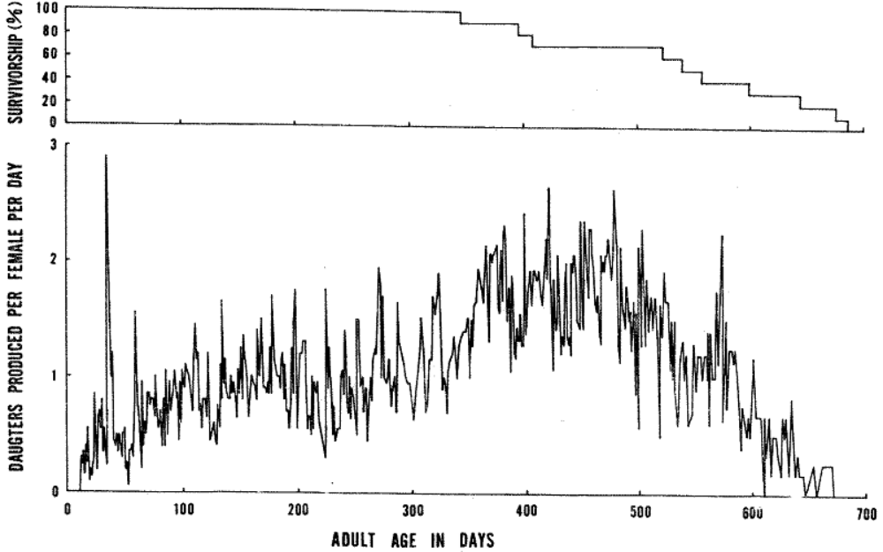

Fig.1. Survivorship curve and age-specific fecundity curve for Tribolium freemani.

Abdul Mazid and Ataur Rahman Khan
Department of Zoology
Rajshahi University
Rajshahi
BANGLADESH

* Growth of Tribolium confusum Duval. Larvae (Coleoptera : Tenebrionidae) on barley and rice flours

The confused flour beetle, Tribolium confusum Duval is a serious pest of cereals and cereal products and is cosmopolitan in distribution. Wheat (Triticum aestivum), barley (Hordeum vulgare) and rice (Oryza sativa) are major cereals of the world and constitute the chief sources of carbohydrates. The larvae of T. confusum are the most destructive stage of the life-cycle. The present work deals with the effect of barley and rice flours on this pest.

Adult T. confusum were originally collected from a flour mill of a local market and were cultured on wholemeal flour in the Department of Zoology, Rajshahi University, Bangladesh. Beetles from the culture were put on a thin layer of wholemeal flour in a Petri dish for oviposition. Eggs were collected on the following day and were incubated. Newly hatched larvae, 200 for each food, were transferred to glass jars (15.4 x 8.4 cms) containing whole-meal, barley and rice flours with the aid of sable hair brush. The jars were securd at the top with a fine-netted cloth tied with a rubber band. The growth of T. confusum larvae was assessed at two stages : after 10 days and after attaining maturity. Larvae were sieved out from the food media and adhered flour particles were cleaned with a brush. They were individually weighed on an electric balance. The larval length was determined with a scale and the head-capsule width using an eye-piece micrometer (40 X). Mature larvae from various flours were separately kept in Petri dishes and were carefully observed for their pupation. After pupation the larval period of the insect on each food was carefully noted. All the experiments were carried out at 27 + 1⁰c.

The effect of barley and rice flours on different aspects of growth T. confusum larvae is shown in Table 1. Barley and rice flours incurred a deleterious effect on the insect by decreasing the 10-day larval length (P<0.01) and the mature larval weight, length and headcapsule width (P<0.01). Haque (1983) also observed lower larval weight, length and headcapsule width of T. confusum grown on rice flour. Barley flour significantly lowered and rice flour significantly lengthened the larval periods of the beetle (P<0.001). Haque (1983) also noted increased larval periods of T. confusum grown on rice flour.

In recent years, there is a growing tendency over the control of insect pests through nutritional regulations owing to a number of serious drawbacks produced by chemical insecticides. One way to control insect pests is to modify intrinsically favourable habitats in such a way that they no longer furnish adequate environments for the populations of the pest concerned, e.g. by providing unsuitable sources of food (Geier, 1966). Pratt et al. (1972) gave a comprehensive review and prospectus of insect pest control strategies based on nutritional principles. More nutritious foods give a better growth of pests, which in its turn, will produce a greater rate of infestation on foods. The significantly lower growth of T. confusum on barley and rice flours is promising in this connection. In addition, the higher larval period of the insect on rice flour will reduce the number of generations of T. confusum per year and this will consequently reduce rate of infestation.

Similar results were obtained by Sokoloff et al. (1966) in their comparative studies of productivity of T. castaneum and T. confusum on several commercially-available diets including rice and brown rice.

The authors wish to thank Professor M. Altaf Hossain (II) and Dr. M. Sayedur Rahman, Department of Zoology, Rajshahi University, for providing necessary laboratory facilities. It is a pleasant duty to extend sincere thanks to Professor M. Quaisuddin, Department of Biochemistry, Rajshahi University, for permitting to use the balance installed there.

References

GEIER, P.W. (1966). Management of insect pests. Ann. Rev. Ent. 11 : 471-490.

HAQUE, A.A.T.M. (1983). A survey of stored products beetles of Rajshahi District and effect of different varieties of rice on the confused flour beetle, Tribolium confusum Duval. (Coleoptera : Tenebrionidae). M.Sc. thesis, Rajshahi University. 60 pp.

PRATT, J.J., Jr., HOUSE, H.L. and MANSHING, A. (1972). Insect control strategies based on nutritional principles : a prospectus. In “Insect and mite nutrition”, pp. 651-668.
North-Holland, Amsterdam.

SOKOLOFF, A., FRANKLIN, I.R., OVERTON, L.F. AND HO, F.K. (1966). Comparative studies with Tribolium (Coleoptera : Tenebrionidae). I. Productivity of T. castaneum (Herbst) and T. confusum Duv. on several commercially-available diets. J. stored Prod. Res. 1 : 295-311.

Table 1 Growth of Tribolium confusum on barley and rice flours

Characters | Foods
Characters | Wholemeal flour Mean + SD (No.) | Barley Flour Mean + SD (No.) | Rice flour Mean + SD (No.)
A. Larval Weight (mg)
a. 10-day old larvae | 0.49 + 0.16 (35) | 0.53 + 0.12 (35) | 0.47 + 0.11 (35)
b. Mature larvae | 2.80 + 0.23 (35) | 2.32 + 0.29 (35) | 2.30 + 0.25 (35)
B. Larval length (mm)
a. 10-day old larvae | 3.62 + 0.43 (35) | 3.21 + 0.27 (35) | 3.21 + 0.44 (35)
b. Mature larvae | 4.83 + 0.25 (35) | 4.62 + 0.29 (35) | 4.46 + 0.32 (35)
C. Larval headcapsule width (mm)
a. 10-day old larvae | 0.94 + 0.10 (35) | 0.91 + 0.11 (35) | 0.94 + 0.07 (35)
b. Mature larvae | 1.45 + 0.11 (35) | 1.37 + 0.09 (35) | 1.38 + 0.08 (35)
D. Larval period (days)
 | 22.30 + 1.97(164) | 20.23 + 2.71 (154) | 24.05 + 7.05 (186)

LINKAGE GROUP ASSIGNMENT OF “ANTENA BIFURCADA” (ab)

Fernando Ninez and Indiana Bustos
Departamento de biologia
Universidad Nacional de Colombia
Bogoti, De.E.
Apartado aereo 23227

A mutant in T. castaneum with coincident phenotypic manifestations as those of “branched” (Dawson, 1962) and “spikes on trochanters and antennae” (Sokoloff, 1966), was discovered in the Tribolium lab., Department of Biology, National University of Colombia (Bogoti). The mutant strain was selected along a work of five years. A noticeable characteristic of the gene is that it produces whole sterility in homozygote males (Viequez & Ninez, 1985), being semi-lethal in both sexes.

Linkage test-crosses indicate that the gene is located in the second linkage group. “Bifurcated antenna” recombine with “pearl” with a frequency of 29 + 0.7%. These results were obtained from coupling backeresses and F₂ coupling and repulsion over a total of 8776 descendants. The map position of the ab locus in the second linkage group has not been determined as yet.

BIBLIOGRAPHY CITED

DAWSON, P. 1962: Preliminary report on a possible phemodeviant is T. castaneum. TIB 5 (section on new mutants).

VASQUES, W.y.F. Nunes 1985: Estudies genetics en Tribolium castaneum II. Mutants “antenna bifurcada”. BOL. DPTO. EIOL., U.N. 2 (6) : 9-22

SOKOLOFF, A. 1966 : The genetics of Tribolium and related species. ADV. GENET., supl. 1

“OJO BLANCO” (obl), A NEW MARKER GENE FOR LINKAGE GROUP IV IN Tribolium castaneum

Fernando Nunez
Departamento de Biologia
Universidad Nacional de Colombia
Bogota, D.E., A.A. # 23227

During 1982, in a culture bottle of a synthetic wild strain, several lilght-eyed adult mutants were discovered. The colour of the eyes varies from a pearl-like tone to a brownish one (2.5 YR 5/8 according to the Munsell table). The mutant has been successfully reared along five years in our laboratory. It is a recessive autosomic spontaneous mutation with excellent viability and complete penetrance (Arrieta, L. 1986). The Linkage test-crosses were positive with “sooty”. The calculated distance was 15.64 + 0.92 cm. This distance was worked out from backcrosses in repulsion and coupling phases. Of which, 1630 descendants from the coupling and 2843 from the repulsion phase were obtained. Neither discrepancy of recombination between the two sexes, nor between the two phases were found.

It is probable that the mutant would be a re-occurrence of the white mutant of Eddleman & Bell (1963). These observations will be published elsewhere.

Bibliography cited.
Arrieta, L. 1986 : Relaciones de ligamiento em Tribolium castaneum (Herbst.) Tesis de pre-grado, Dpto, Biologia, Universidad Nacional de Colombia. Bogota.

Eddleman, H. and A. Bell 1963 : Four New eye color mutants in Tribolium castaneum. Genetics 48 : 888 (Abstr.)

* AUTOCLAVING OF BEANS (PHASEOLUS VULGARIS) TO IMPROVE THEIR NUTRITIVE VALUE FOR TRIBOLIUM LARVAE

Wen Flora Pao, Pran Vohra and F.H. Kratzer
Department of Avian Sciences, University of California,
Davis, CA 95616

ABSTRACT

Beans (Phaseolus vulgaris) need to be autoclaved for 2 hours to overcome their antinutrient properties for Tribolium larvae. Varietal differences exist in the nutritional values of beans to support the optimal growth of Tribolium larvae.

INTRODUCTION

Beans (Phaseolus vulgaris), an important source of dietary protein for animals and humans, also contain antinutritional proteinous substances such as antienzymes (1) and lectins (2) which can be inactivated by autoclaving (3). Raw beans significantly reduced the growth of larvae of Tribolium castaneum and increased their mortality. If the beans were autoclaved for 30 minutes at 127⁰c (21 p.s.i), the growth rate of larvae was improved and mortality was reduced (4, 5). The present study was undertaken to determine the time needed for autoclaving to obtain the optimum growth of the Tribolium larvae.

MATERIALS AND METHODS

A sample of red kidney beans was purchased from a local market and has been designated as the commercial sample. This variety was used to test the optimal time needed for heating to improve its nutritive value. The beans (Phaseolus vulgaris) were ground in a Moulines Regal coffee mill to pass through a 100 mesh screen. Aliquotes of the finely ground samples of beans were autoclaved in 1 cm layers in dishes at 124⁰c (pressure of 18 p.s.i) for 8, 15, or 30 minutes, 1, 1.5 or 2 hours and then mixed in the diets for bioassay with Tribolium larvae. Tribolium castaneum were maintained on a stock diet of 90% unbleached white flour and 10% brewer’s yeast in an incubator at 33 + 1⁰c and 70 + 5% relative humidity. The protein content of the test and the control diets was 12.5%. The larvae were hatched from a 24-hour egg collection. At 6 days of age, about 40 larvae per diet were transferred onto test diets. The test diet in the studies on optimum time for autoclaving contained 10% brewer’s yeast, 35% commercial bean powder and 55% corn starch. At 10 days of age, 10 larvae of about same weight per replicate were transferred onto their respective diets. Each diet was tested in triplicate. The final larvae weights were determined on the 14th day after egg collection. The growth of larvae on the stock diet was used as control in each assay. An optimum time of 2 hours was needed for autoclaving in these studies (Experiment 1).

The effect of supplementation of diets containing this commercial bean with methionine, lysine and tryptophan on the growth of Tribolium was also tested (Experiment 2).

Two red kidney bean varieties (Nos. 2602 and DRK), and 4 of white varieties (7813, 79125, 79129 and 79131) were obtained from the Department of Agronomy, University of California at Davis. The crude protein content of the samples was determined by multiplying the Kjeldahl nitrogen by 6.25. The protein content of the commercial variety was 23%, and of varieties 2602 and DRK was 17.1%. The 4 white varieties had 14.9% crude protein.

One of the red bean variety from Davis (2602) was incorporated after autoclaving for 2 hours at levels of 35%, 47.6% and 55.8% to provide 10.45%, 12.5% and 14.5% protein in the test diets which were bioassayed with and without amino acid supplementation (Experiment 3).

The protein content of test diets in the experiment comparing the 6 varieties was adjusted to 14%. These diets were also tested with and without amino acid supplementation (Experiment 4).

The data on average larval weight on the different test diets were subjected to analysis of variance for any significant differences (6). The significant data were compared by least significant difference (LSD).

RESULTS AND DISCUSSION

Table 1. The effect of duration of autoclaving of a commercial red kidney bean on the growth of Tribolium larvae (Experiment 1)

Dietary treatment | Ave. Larval weight, mg
Series 1
Control (wheat flour, 90% + 10% yeast) | 1.91
Kidney beans, raw | 0.78
Kidney beans, autoclaved 8 min | 0.93
Kidney beans, autoclaved 15 min | 0.87
Kidney beans, autoclaved 30 min | 1.08
Series 2
Control | 2.21
Kidney beans, raw | 0.77
Kidney beans, autoclaved 1 hour | 1.24
Kidney beans, autoclaved 1.5 hours | 2.19
Kidney beans, autoclaved 2 hours | 2.35

Statistical analysis
Series 1 Series 2
Mean square 0.626 1.489
Mean square error 0.024 0.038
LSD (P<0.05) 0.14 0.27
Our unpublished studies indicated that the growth of Tribolium larvae fed ground beans heated in a hot air oven at 100⁰ for 24 hours was better than on raw bean diet, but still inferior to the growth of those fed the control diet. In the present studies with moist heat, the larval weight increased significantly and reached that of the control diet as the time of autoclaving of kidney beans was increased from 8 minutes to 1.5 hours. No further significant (P<0.05) improvement occurred by increasing the autoclaving time to 2 hours.

The commercial bean diets may have a deficiency of methionine (7). Also, overheating may reduce the availability of lysine (8). These possibilities were tested and the data are presented in Table 2.

Table 2. The effect of supplementation of commercial red kidney bean diets with methionine and lysine on the growth of Tribolium larvae (Experiment 2)

Dietary treatment | Ave. Larval weight, mg
Series 1
Control (wheat flour + yeast) | 1.95
Kidney beans, autoclaved 2 hr | 2.25
Kidney beans, autoclaved 2 hr + 0.05% met | 2.24
Kidney beans, autoclaved 2 hr + 0.05% lys | 2.52
Kidney beans, autoclaved 2 hr + 0.1% lys | 2.50
Kidney beans, autoclaved 2 hr + 0.05% met + 0.1% lys | 2.22
Kidney beans, autoclaved 2 hr + 0.05% met + 0.2% lys | 2.27
Kidney beans, autoclaved 2 hr + 0.1% met | 1.94
Kidney beans, autoclaved 2 hr + 0.1% met + 0.1% lys | 2.26
Kidney beans, autoclaved 2 hr + 0.1% met + 0.2% lys | 2.34
Series 2
Control (Wheat flour + yeast) | 2.20
Kidney beans, raw | 0.90
Kidney beans, raw + 0.1% met + 0.2% lys | 0.93
Kidney beans, raw + 0.2% met + 0.4% lys | 0.95
Kidney beans, autoclaved 1 hr + 0.2% met + 0.4% lys | 1.50
Kidney beans, autoclaved 2 hours | 2.27
Kidney beans, autoclaved 2 hr + 0.2% met | 2.15
Kidney beans, autoclaved 2 hr + 0.4% lys | 2.40
Kidney beans, autoclaved 2 hr + 0.1% met + 0.2% lys | 2.37
Kidney beans, autoclaved 2 hr + 0.2% met + 0.4% lys | 2.29

Statistical analysis
Series 1 Series 2
Mean square 0.111 1.274
Mean square error 0.073 0.022
LSD (P<0.05) N.S. 0.14

No significant difference was observed in any of the diets by analysis of varience in Series 1 to support the growth of larvae in Experiment 2. No significant differences were found in the average body weights of larvae on any of the treatments except autoclaving in the 2nd series of this experiment.

Raw beans were not improved by a supplementation of amino acids for the growth of Tribolium larvae when the diet contained about 12.5% crude protein. A significant improvement in the larval growth to reach the same level as on the control diet was observed if the beans were autoclaved for 2 hours. No further significant (P<0.05) improvement in larval growth was observed by supplementing the beans autoclaved for 2 hours with methionine and lysine, individually or together. When supplemented with lysine and methionine, beans autoclaved for 1 hour supported larval growth intermediate between no treatment and 2 hour autoclaving. It appears that these amino acids were not deficient in autoclaved beans for meeting the needs of the Tribolium larvae. However, these data may not be projected to other animal species.

An improvement in growth of chicks has been observed if diets containing 35% of the Chief variety of beans were supplemented with 0.04% tryptophan (9). The data on the effect of supplementation of tryptophan on the larval growth using the bean variety 2602 are given in Table 3.

Table 3. Effect of lysine, methionine and tryptophan supplementation of red kidney bean variety 2602 autoclaved for 2 hours on the growth of Tribolium larvae (Experiment 3)

Dietary treatment | Ave. Larval weight, mg
Control | 2.36
Red Kidney beans, 35% | 1.97
Red Kidney beans, 35% + 0.1% met + 0.2% lys | 2.38
Red Kidney beans, 35% + 0.1% met + 0.2% lys + 0.1% try | 2.61
Red Kidney beans, 47.6% | 2.19
Red Kidney beans, 47.6% + 0.1% met + 0.2% lys | 2.38
Red Kidney beans, 47.6% + 0.1% met + 0.2% lys + 0.1% try | 2.35
Red Kidney beans, 55.88% | 2.12

Statistical analysis

Mean square 0.115
Mean square error 0.035
LSD (P<0.05) 0.20

Growth of Tribolium larvae was significantly improved by the addition of methionine and lysine and further improved by the addition of tryptophan when beans were used at a level of 35% of the diet to provide about 10.5% crude protein. However, if the level of the beans was increased to 47.5% to provide about 12.5% protein with or without supplementation with methionine and lysine, no further improvement in larval growth was observed by addition of tryptophan. An increase of bean level to 55% was of no advantage for larval growth. The results with a dietary level of 12.5% protein in Tables 2 and 3 with two different bean samples are in agreement. The addition of 0.1% methionine and 0.1% lysine to the diet containing 12.5% protein did not improve the larval growth. The improvement was noticed with a level of 10.5% protein in Experiment 3.

The growth rate of larvae was different for different varieties of beans and for heat treatment. When the beans were fed raw, poor growth was observed with all varieties and mortality was observed with varieties 7813, 79125 and 79129 of small white beans. The nutritional value of 6 varieties of beans was improved by autoclaving (Table 4), but none of these, except DRK, supported as good growth of larvae as the control diet. The color of the beans or their protein content was not the determinant of their nutritional value. A white variety (79125) was significantly inferior to the other white or colored varieties after autoclaving.

Table 4. The growth of Tribolium larvae fed diets containing 6 varieties of beans raw, and autoclaved for 2 hours and supplemented with amino acids (Experiment 4)

Bean Variety | % in Diet | Raw | Bean treatment and supplement |  |  |  | Mean without raw
Bean Variety | % in Diet | Raw | ------------------- Autoclaved ----------------- |  |  |  | Mean without raw
Bean Variety | % in Diet | Raw |  | + 0.2% lys + 0.1% met | + 0.2% lys | + 0.4% lys | Mean without raw
Ave. larval weight, mg
2602 | 55.1 | 0.20 | 1.47 | 1.62 | 1.57 | 1.19 | 1.46 b
DRK | 55.1 | 0.25 | 1.89 | 1.40 | 1.54 | 1.22 | 1.39 b
7813 | 63.3 | 0.18 (2) | 1.31 | 1.37 | 1.65 | 1.29 | 1.41 b
79125 | 63.3 | 0.15 (6) | 1.10 | 1.21 | 1.41 | 1.02 | 1.19 a
79129 | 63.3 | 0.16 (11) | 1.44 | 1.33 | 1.45 | 1.14 | 1.34 ab
79131 | 63.3 | 0.16 | 1.42 | 1.34 | 1.79 | 1.24 | 1.45 b
Control |  | 1.91 | 2.0 | 2.01 | 2.11 | 1.77 | 1.97 c
 |  | 0.43 | 1.45 b | 1.47 b | 1.65 c | 1.27 a

Statistical analysis (2 way) omitting raw beans
DF Mean squares
Treatments 3 0.510
Varieties 6 0.723
Treatments x varieties 18 0.021
Error 56 0.027
LSD (P<0.05) treatments 0.14
LSD (P<0.05) varieties 0.18

Varieties: 2602, red kidney bean; DRK, dark red kidney bean; 7813, 79125, 79129 and 79131, small white beans.

Number of larvae dead out of a total of 30 in 3 replicates are in paranthesis.

When autoclaved beans were supplemented with methionine and lysine (Table 4), variety 2602 gave significantly better larval growth than any of the others. With the addition of 0.2% lysine alone, variety 79131 resulted in significantly better growth of larvae than any of the other varieties. The variety 79125, on the other hand, proved significantly inferior to the varieties 7813 and or the unsupplemented 79125. When lysine was increased to 0.4%, variety 79125 proved inferior to 3 of the other 5 varieties.

A significant improvement in the growth of larvae is confirmed when beans were autoclaved, according to the 2-way analysis of variance. An addition of 0.2% lysine to the autoclaved beans caused a significant improvement in larval growth which was lost by addition of 0.1% methionine. An addition of 0.4% lysine to autoclaved beans caused a significant depression in larval growth than when compared to autoclaved beans alone. Variety 79125 was inferior to all varieties except 79129. In none of these tests was the growth of the larvae fed different varieties of beans as good as on the control diet.

It may be concluded that autoclaving for about 2 hours may be needed to overcome the antinutrients in beans to support the optimal growth of Tribolium larvae. Varietal differences exist in the nutritional quality of beans. Methionine and lysine supplementation of raw beans was ineffective, indicating that poor amino acid availability is not the cause of poor growth of Tribolium with raw beans. Some of the experimental varieties had more growth depressing properties than the variety available in the supermarkets. The autoclaved experimental varieties were improved by supplementation with lysine alone. The variety 2602 was improved by supplementation with lysine, methionine and tryptophan if incorporated at a 35% level when tested in a diet containing 10.5% CP. These amino acids were not needed when the dietary protein level was 12.5% and the level of this variety was 47%.

REFERENCES

1. Liener, I.E. and Kakade, M.L. Protease inhibitors. In Toxic Constituents of Plant Foodstuffs (I.E. Liener, editor), Academic Press, New York, 1980, p.7

2. Jaffe, W.G. Hemagglutinins (Lectins). In Toxic Constituents of Plant Foodstuffs (Liener, I.E., editor), Academic Press, New York, 1980, p.73

3. Antunes, P.L. and Sgarbieri, V.C. Effect of heat treatment on the toxicity and nutritive value of dry bean (Phaseolus vulgaris var. Roshina G2) proteins. J. Agric Food Chem. 28, 935 (1980).

4. Shariff, G., Penz, Jr., A.M. and Vohra, P. Nutritional improvement of beans (Phaseolus vulgaris) by autoclaving or water extraction for Tribolium castaneum larvae. Nutr. Reports Int. 24, 1087 (1981).

5. Wyckoff, S., Vohra, P. and Kratzer, F.H. Improvement of nutritional value of common beans (Phaseolus vulgaris) by autoclaving or extraction. J. Sci. Fd. Agric. 34, 612 (1983).

6. Steele, R.G.D. and Torrie, J.H. Principles and Procedures of Statistics with Special reference to the Biological Sciences. McGraw-Hill, New York, 1960.

7. Almas, K., and Bender, A.E. Effect of heat treatment of legumes on available lysine. J. Sci. Good Agric. 31, 448 (1980).

8. Tobin, G., and Carpenter, K.J. The nutritional value of the dry bean (Phaseolus vulgaris) : A literature review. Nutr. Abst. And Reviews, Ser. A. 48, 919 (1978).

9. Penz, Jr., A.M., Earl, L., Kratzer, F.H. and Tucker, C. Availability for chicks of tryptophan from autoclaved beans. Nutr. Int. Reports, 27, 161 (1983).

Prus. Trade and Miroslawa Prus.

Department of Ecological Bioenergetics, Institute of Ecology, Polish Academy of Sciences, Dziekanow Lesny, 05-092 Lomianki, Poland

* Phenotypic differentiation of Tribolium castaneum Hbst cI strain

Introduction

Recently, our laboratory is dealing with the problem of performance of life history strategy by two species of Tribolium: T. castaneum and T. confusum. The long-term goal of this research is evaluation of position of these two species on r---k continuum (Stearns, 1980). To avoid the excess of variation in populational features, two strains representing each species were chosen: cI strain of T. castaneum and bIV strain of T. confusum (Park et al. 1961). From cI strain two substrains were separated in our laboratory (Prus 1976), which are being used as an experimental tool to attack the main problem. They can be distinguished by number of larval instars: 6 – instar and 7 – instar group. The similar differentiation was observed in T. confusum bIV strain (Bijok, 1984). For life history studies the substrains are tested in respect of such features as time of development, maximum weight in larval stage, fecundity, egg hatchability (fertility), and mean individual egg weight. After some laboratory experience the material for experiments is derived from these two substrains by the method of time shifting in the appearance of pupae. In order to look for differences, a short time experiment was performed, aimed at description of the above listed features in T. castaneum cI substrains.

Material and methods
All experiments were carried out in standard conditions: 29⁰c, 75% relative humidity, medium: 95% of wheat flour and 5% of brewer’s yeast. On the basis of differences of time development in two substrains 6- and 7- instar individuals were separated from substrains as pupae appearing on 19-20th day of larval development (6-instar) and 24th day (7-instar). Two days after eclosion the experiment on fecundity and egg hatchability was started in four series. Individuals were mated according to the following scheme: (1) 6-instar female x 6-instar male, (2) 6-instar female x 7-instar male, (3) 7-instar female x 7-instar male, (4) 7-instar female x 6-instar male. These pairs were placed each into 8g of medium for 30 days. At each census eggs were separated, counted, weighed as total and left over in Petri dishes to batch. Number of hatched larvae was determined under binocular microscope. First stage of experiment had five replications in each series and consisted of 160 samples (4 series x 4 replicates x 10 time moments). The second experiment with 10 replications in each series consisted of 400 samples (4 series x 10 replicates x 10 time moments). When elaborating results, the significance of effects was tested with analysis of variance.

Results and discussion

Comparison between substrains within each sex of cI strain showed that both males and females of 6-instar group develop faster than those of 7-instar group (23.8 vs 26.3 dava). The difference is statistically significant (Table I). This is in accordance with earlier results (Prus. 1976), although absolute figures are somewhat different. The present values are a little lower, but in general they follow the earlier observed pattern.

Subsequent stages of larval development appear more or less uniformly in both substrains up to VI instar. There is additional VII instar in the second group which lasts about two days in males and three and a half days in females. This is the stage which prolongs the whole development in this substrain (Table II).

From the individual cultures of both substrains growth curves were drawn (Fig. 1 and 2). For purpose of convenience the values were arranged in two ways. The first way involved ignorance of stage and only age (in days) was plotted on abscissa. However such approach causes additing of weights of different stages which is an error especially when examining the energetic requirements of species tested (Fig. 1). To avoid such error, technical operation was made consisting of calculation of weight of real stages in the middle of their duration and plotting these values on the graph basing on duration of subsequent stages (Fig. 2). Thus time was ignored and this graph was based primarily on stages.

From Figures 1 and 2, one can see that, depending on what approach is used, the energetic parameters such as production, consumption, and respiration will differ. In our bioenergetic studies we choose the second way of calculation (Bijok, 1986).

Similarly the two substrains differ in maximum individual weight achieved by larvae. Both males and females of 7-instar group are heavier than those of 6-instar group with significant difference (Table III).

Analyzing fecundity of theses substrains, it was observed that series (3) has highest fecundity and series (4) – the lowest one. Such pattern was observed in the two experiments (Table IV).

Hatchability was generally higher in the second experiment, however it did not reflect the pattern observed in the first experiment. The highest values of hatchability were observed in series (1) and (4). The earlier postulated hypothesis that 6-instar form has been maintained for a rather long time in the population was due to the fact that higher fecundity of 7-instar individuals was counterbalanced to higher hatchability of progeny resulting from matings between substrains. The results of second experiment corroborated partly this hypothesis i.e. that 7-instar group showed the highest fecundity (Table IV).

The significance of effect of time, series, and interaction between them on fecundity and hatchability is presented in Table V. Both time and series showed significant effect on fecundity and hatchability, except for the series effect on the latter. This holds for both experiments.

Mean weight of eggs laid by pairs in four series of the first experiment are given in Table VI. They oscillate around overall mean of 48.76 µg wet weight. Since the analysis of variance of the material supplied in the first experiment showed no significant effect of series i.e. substrains and their combinations, this characteristic was not examined further.

It would be interesting to examine other populational features of these substrains such as longevity and mortality which may be responsible, together with the examined features, for the constant maintenance of two pools of phenotypes in the population of T. castaneum and T. confusum strains. Their existence seems to be responsible for shifting the species along r---k continuum, with property of being 6-instar representative pushing the life strategy towards “r” and that of being 7-instar representative – towards “K” type.

Summary

Phenotypic differentiation of such features as duration of development, maximum larval weight, fecundity, and hatchability in two substrains, were investigated. Statistical tests showed significant differences in all these features between substrains. The existence of substrains within Tribolium strains will be used for interpretation of life strategy performance by Tribolium populations.

References

Bijok, P. 1984. On heterogeneity in bIV strain of Tribolium confusum Duval. Tribolium Information Bulletin, 24, 89-96.

Bijok, P. 1986. Energetic budget of Tribolium confusum Duval bIV strain in its developmental cycle. Ph. D. Thesis. Institute of Ecology, PAS, pp. 88.

Park, T., Mertz, D.B., Petrusewicz, K. 1961. Genetic strains of Tribolium: Their primary characteristics. Physicl. Zool., 34, 62-80.
Prus, T. 1976. On heterogeneity in cI strain of Tribolium castaneum Hbst. Tribolium Information Bulletin, 19, 97-104.

Stearns, S.C. 1980. A new view of life-history evolution. Oikos, 35, 266-288.

Table I. Comparison of developmental time between sexes and substrains (days)

 | 6-instar | t-test | 7-instar
males | 24.00 + 1.34  n = 22 | t = 3.69  P < 0.001 | 25.62 + 0.96  n = 13
t - test | t = 0.96  P > 0.05 |  | t = 2.84  P > 0.001
females | 23.55 + 0.93  n = 11 | t = 7.33  P < 0.001 | 26.84 + 1.26  n = 21
average | 23.85 + 1.22  n = 33 | t = 8.15  P < 0.001 | 26.35 + 1.25  n = 34

Means and standard deviation: n – replicates; P – Probability

Table II. Mean time of appearance of subsequent developmental stages from the
moment of hatching of larva (days)

Stage | 6-instar | substrain | 7-instar | substrain
Stage | males | females | males | females
Larva II | 1.0 | 1.2 | 1.2 | 1.4
Larva III | 4.5 | 4.3 | 4.7 | 4.2
Larva IV | 6.7 | 7.2 | 7.0 | 7.0
Larva V | 9.3 | 9.2 | 9.6 | 9.4
Larva VI | 13.7 | 12.8 | 12.5 | 12.4
Larva VII | -- | -- | 15.9 | 15.3
Prepupa | 16.2 | 15.9 | 17.8 | 18.8
Pupa | 18.2 | 17.9 | 19.8 | 20.8
Adult | 24.0 | 23.6 | 25.6 | 26.8

* Values are weighed means of appearance of a given stage in a series of individual cultures

Table III. Comparison of maximum body weight (micrograms) between sexes and substrains.

 | 6-instar | t-test | 7-instar
males | 2282 + 206  n = 22 | t = 8.42  P < 0.001 | 2893 + 193  n = 13
t - test | t = 1.73  P > 0.05 |  | t = 2.56  P > 0.001
females | 2248 + 211  n = 11 | t = 6.78  P < 0.001 | 2871 + 252  n = 21
average | 2271 + 205  n = 33 | t = 11.25  P < 0.001 | 2879 + 229  n = 34

Means and standard deviation: n – replicates; P – Probability

Table IV. Fecundity and egg hatchability in four series of experiments.

Series | Combination females x males | Fecundity eggs / female.72h |  | Hatchability per cent
Series | Combination females x males | I | II | I | II
(1) | 6 / 6 | 50.8 | 55.9 | 53.9 | 67.6
(2) | 6 / 7 | 50.7 | 55.1 | 59.5 | 65.0
(3) | 7 / 7 | 57.5 | 57.9 | 57.5 | 65.2
(4) | 7 / 6 | 53.6 | 53.6 | 61.2 | 68.9

I, II – subsequent experiments

Table V. Significance of time, substrain, and interaction effects on fecundity and hatchability (analysis of variance)

Experiment | I |  |  | II
Replications | 160 |  |  | 400
Source of variation | time | series | interaction | time | series | interaction
F e c u n d i t y
Significance | s | s | s | s | s | ns
F | 11.38 | 7.48 | 15.72 | 6.80 | 6.85 | 1.86
P = 0.005 | 2.62 | 4.28 | 2.62 | 2.62 | 4.28 | 2.62
H a t c h a b i l i t y
Significance | s | ns | s | s | ns | s
F | 3.81 | 1.29 | 3.44 | 6.92 | 0.35 | 4.54
P = 0.005 | 2.74 | 4.28 | 2.74 | 2.62 | 4.28 | 2.62

Table VI. Average individual weight (micrograms wet weight) of eggs in four series *

Series | (1) | (2) | (3) | (4)
Mean + SD | 49.79 + 2.08 | 48.33 + 1.41 | 47.67 + 1.12 | 49.25 + 1.10
CV % | 26.49 | 18.42 | 14.92 | 14.17

* Weights uncorrected for flour coating.

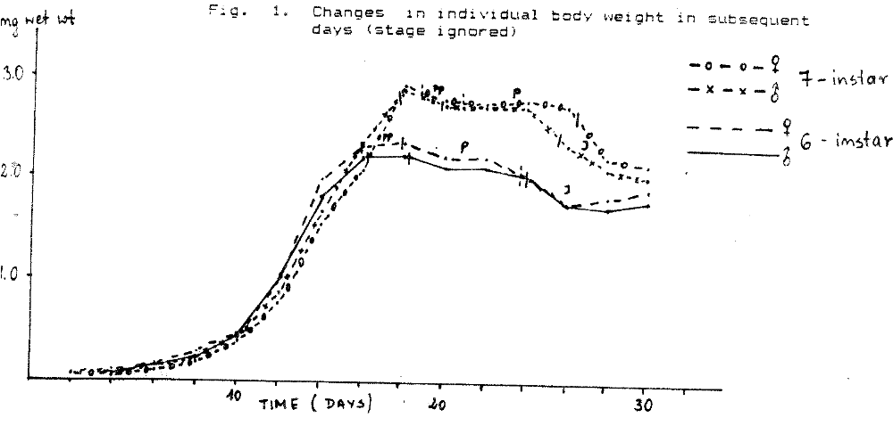

Fig. 2 Changes in individual body weight of subsequent stages (time ignored)

Mean weight of egivent stage in marked in the middle of the stage duration

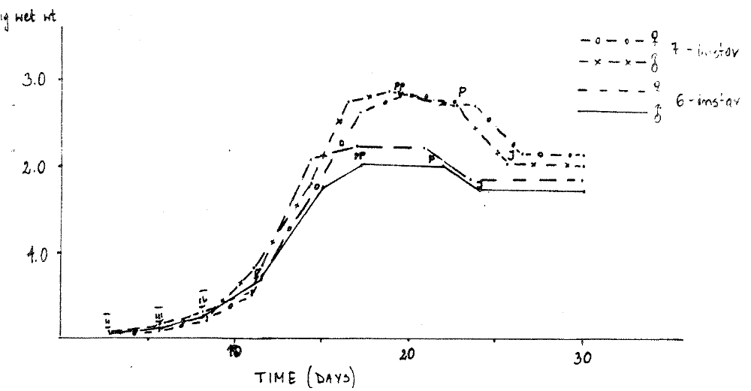

Sokoloff, A., Shimeld, L. and O’Neal, P.
Biology Department
California State University
San Bernardino, CA 92407

* A search for incompatibility strains in T. castaneum.

Stanley (1961) reported that females of the McGill black T. confusum strain were reproductively incompatible with two other strains: b females, when crossed with b males from the same strain, produce abundant progeny. The same females, mated to unrelated non-b males produced many eggs, but they proved to be sterile. b males successfully fertilize females from any source, producing abundant offspring. b females crossed with hybrid males (obtained by crossing black males with females of other strains are also reproductively incompatible. Sokoloff (1966) was able to corroborate these observations in early crosses after obtaining Stanley’s strain, but later crosses did not show the reproductive incompatibility. Subsequently Stanley’s strain was lost. Cawthon and Mertz (1975) discovered a similar phenomenon in an inbred genetic strain of T. confusum referred to as bI. The trait exhibited a cytoplasmic pattern of inheritance: bI females laid sterile eggs when mated with F₁, F₂ and F₃ backcross hybrid males obtained by crossing bI males with Chicago strain females.

Wade and Stevens (1985) in 1979 tested the mating compatibilities of 12 strains of T. confusum. One strain, b-circle A, also referred to as the Illinois strain, while interfertile with the bI strain, produced no progeny when b-Circle A females were crossed to males from any other source.

A few years later Wade and Stevens found that females were interfertile with males of other strains; but b-Circle a males were no longer compatible with bI females. Females from the b-Circle strains are completely infertile with males from all other tested strains except bI.

Wade and Stevens summarize these observations as follows :

1. bI females are incompatible with males of wild populations from geographically dispersed portions of the species distribution.

2. b-circle shows mating incompatibility similar to that previously reported for the lab bI and McGill black strains.

3. Strains that show incompatibility with other strains are completely infertile; and

4. Reproductive compatibility can be naturally acquired (b-circle A), but when this occurs the strain is no longer interfertile with other incompatible strains.

This reproductive incompatibility can be cured by raising the beetles in tetracycline and other antibiotics, so Wade and Stevens conclude that

(1) most strains of T. confusum harbor a microorganism whose loss can induce a non-genetic partial reproductive isolation from other infected strains.

(2) infected males are not reproductively compatible with cured females, but infected females can successfully reproduce with either cured or infected males.

(3) Furthermore, the number of offspring produced by cured and uncured pairs are not significantly different.

In the survey of five laboratory and nine recently collected strains of Tribolium castaneum Wade and Stevens failed to find any reproductive incompatibility, and they failed to induce it by rearing adults in 0.1% tetracycline for 20 days.

The purpose of this investigation was to determine whether any of the wild type strains maintained at the Tribolium Stock Center exhibit this kind of reproductive incompatibility.

Materials and Methods

The following wild type strains were used:

A = Chicago
B = Davis
C = Florida
D = McGill
E = Pest Infestation Lab
F = Calif. State College,
San Bernardino *
G = Sacramento
H = Texas
I = Yucaipa, CA
J = Veracruz
K = Berkeley synthetic, marked with s
L = Berkeley synthetic, no body color
markers
M = Origin unknown
N = UPF (Purdue Foundation via New
York)
O = San Bernardino, CA
P = CS-4 an inbred strain from T. Park’s
research
Q = Veracruz small
R = Veracruz reared in association with
b-circle T. of for 3 generations.

* a strain found in the biology stockroom, in a brewer’s yeast container.

Male and female pupae from each stock were separated as to sex until use.

Intra-strain crosses are represented by AA, BB, CC, ….. RR.

Interstrain crosses were carried in reciprocal fashion, and the code gives females first. Thus, AB is A female x B male, while BA is B female x A male.

Wherever possible 10 replicates were crossed. Each pair of beetles was introduced into a one-gram vial about 2/3 filled with unbleached flour.

Results

Table 1 shows the fraction of successful matings. (The numerator shows the number of vials in which progeny were found and the denominator, the number of vials for that mating set up.)

Although the table shows that some combinations of crosses were not carried out because of the lack of sexed beetles when the experiment was set up (strain L = the Berkeley synthetic strain not marked with body color genes; R- is one of the Veracruz strains) generally there were other strains from the same source to fill the gap, so all of the partial matings with those strains could have been omitted altogether.

Conclusion

This study with at least 15 different strains of T. castaneum from different sources, plus the nine strains of T. castaneum investigated by Wade and Stevens seems to indicate that the reproductive incompatibility observed in T. confusum is not a general phenomenon in Tribolium. However, future investigations in flour beetles should keep this phenomenon in mind.

Fraction of successful intra- and inter-strain matings (Most of the crosses had 10 replicates. A few had either 3 or 5 replicates. A dash (-) indicates those crosses were not done)

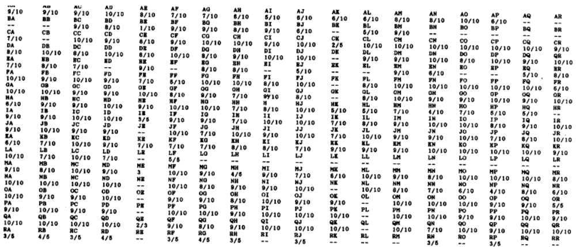

Notes-Technical

FABRICATION OF A SIEVE FRAME FOR COLLECTING TRIBOLIUM

Peter Backer, Joe Borelli and Pran Vohra

Department of Avian Sciences, University of California

Davis, CA 95616

We have been unable to buy brass ring frames to assemble the sieves needed for sifting Tribolium beetles, larvae or eggs from the stock diet. We decided to fabricate the ring frames from white polyvinyl plastic pipes readily available in any hardware store. Two pieces of pipe were needed. For the inner ring, a 4.0 cm long section was cut from a pipe with a 11.4 cm external diameter and 10.4 cm internal diameter. A 2 cm long piece of a pipe with an internal diameter of 11.4 cm and external diameter of 12.0 cm served as the outer ring. The thickness of a length (2.5 cm) of the inner ring was reduced by 0.01 cm by uniform milling of the outer surface so that when the silk bolting was in place, the outer ring would slide easily but tightly over the end. The overall dimensions are given in the sketch. The fabrication of this ring frame is inexpensive and relatively easy. As the internal surface of polyvinyl plastic ring is more rough than of brass rings, the beetles may climb the sides. It may be possible to overcome this drawback by polishing the internal surface to a more smooth finish.

Notes-Technical
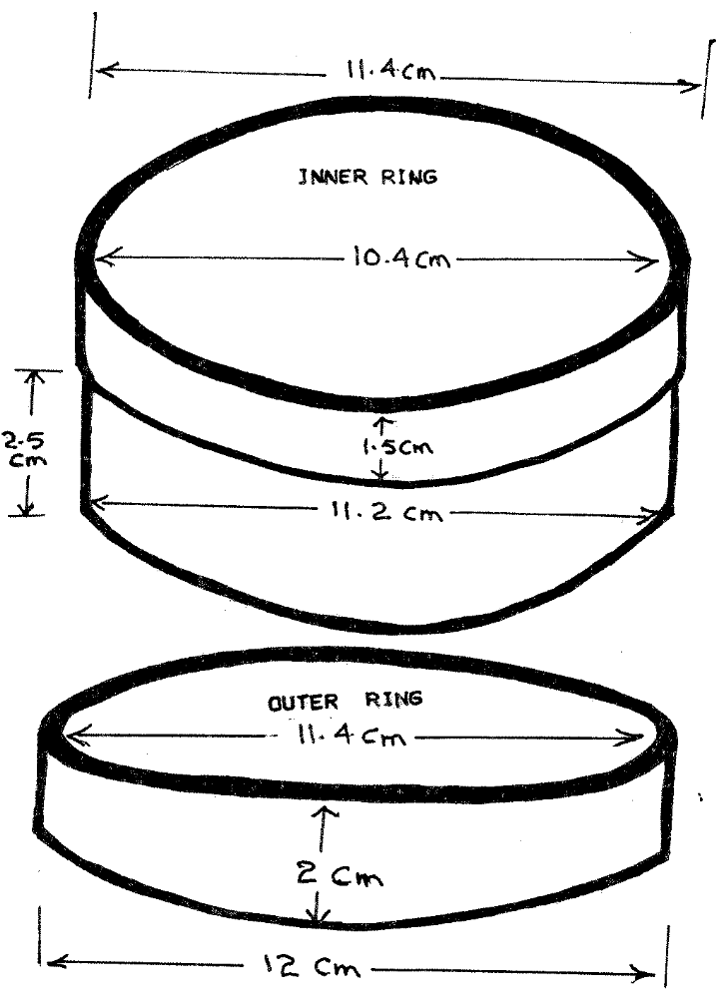
DIAGRAM FOR FABRICATION OF A SIEVE FRAME

Notes-Technical

A simple, economical, and escape-proof plastic device
to detect insects in stored grain

A new plastic trap to detect insects in stored grain has been developed by Canadian entomologists. It is a new version of a metal one originally designed in 1967 at the Agriculture Canada Research Station Winnipeg and improved in 1973. These were described in the Canadian Entomologist 99 : 1160-1163, 1967, and 105 : 437-440, 1973. The unique escape-proof feature of these traps allows the user to leave them inserted in grain for any desired period. Thus, the longer it is left in the stored commodity, the greater is the probability of insect detection.

The new plastic version is simpler in design and more economical to produce than the original trap. Producers and grain handlers could use them in quantity to monitor their stores.

The presence of primary grain feeding beetles in the traps indicates the need for fumigation. The presence of fungus beetles indicate that the grain may be going out of condition and that immediate remedial action is necessary. In this situation, fumigation is not sufficient because, although it will kill the beetles, it will not stop the deterioration process caused by storage micro-flora. The recommended procedure is to physically move the grain to dissipate heat, break up lumps, and if necessary, dry the grain. This is monumental task for producers or handlers with large volume storages but is a preferable alternative to facing a total loss. The use of the traps as early detection devices would help to minimize or prevent losses.

A licence to produce and sell the plastic traps has been granted by Canadian Patents and Development Ltd. to :

Dr. F. Madrid, President
Agribiotech International Inc.
35 Mount Allison Bay
Winnipeg, Manitoba, Canada
R3T 3L4

For further information, contact Dr. Madrid or the undersigned.

S.R. Loschiavo
Research Station, Agriculture Canada
Winnipeg, Manitoba, Canada

